AI-Assisted Radiology Reporting Workspace:
Retrieval-Grounded Chest X-ray Report Generation
with Human Oversight
by
Borhan Uddin
22101540
Sumaiyah Mosabber
23301698
Halimaya Sadia
22101931
A project submitted to the Department of Computer Science and Engineering
in partial fulfillment of the requirements for the degree of
B.Sc. in Computer Science
Department of Computer Science and Engineering
Brac University
September 2026
© 2026. Brac University
All rights reserved.
Declaration
It is hereby declared that
- The project submitted is my/our own original work while completing degree at Brac University.
- The thesis does not contain material previously published or written by a third party, except where this is appropriately cited through full and accurate referencing.
- The thesis does not contain material which has been accepted, or submitted, for any other degree or diploma at a university or other institution.
- We have acknowledged all main sources of help.
Student’s Full Name & Signature:

_______________________________
Borhan Uddin
22101540
_______________________________
Sumaiyah Mosabber
23301698
_______________________________
Halimaya Sadia
22101931
Approval
The project titled “AI-Assisted Radiology Reporting Workspace: Retrieval-Grounded Chest X-ray Report Generation with Human Oversight” submitted by
- Md. Borhan Uddin (22101540)
- Sumaiyah Mosabber (23301698)
- Halimaya Sadia (22101931)
has been accepted as satisfactory in partial fulfillment of the requirement for the degree of B.Sc. in Computer Science.
Examining Committee:
Supervisor:
(Member)

_______________________________
Md. Shahriar Rahman
Lecturer
Department of Computer Science and Engineering
Brac University
Head of Department:
(Chair)

_______________________________
Dr. Sadia Hamid Kazi
Chairperson
Department of Computer Science and Engineering
Brac University
Ethics Statement
This project used the publicly available IU/Indiana chest X-ray collection, which is de-identified at the report level by its providers. No patient was recruited, no new clinical data was collected, and no identifiable patient information was handled at any point.
A privacy-preserving masking stage removes burned-in text from every image before it is embedded or stored, and only the masked copy is ever written to permanent storage. Uploaded filenames are read once for their extension and never retained anywhere, because a filename may itself carry a patient name.
The clinical labelling model used for evaluation is governed by the Stanford Academic Software License Agreement (Docket S20-295, 2020-10-15), which permits internal academic non-commercial use, requires citation of Smit et al. (2020), and forbids redistribution. The checkpoint is therefore held outside the project repository and has never been committed to it or included in any submission bundle.
The system is a clinical decision-support tool and not a diagnostic authority. No output it produces is a diagnosis. No radiologist has validated any output, no clinical evaluation was performed, and no medical-device regulatory process was entered. The system must not be used for clinical care in its current form, and no claim in this report should be read as suggesting otherwise.
Abstract
Radiology reporting is constrained not by the cost of acquiring a chest radiograph but by the availability of a radiologist to interpret it — a constraint felt acutely outside metropolitan Bangladesh. This project built and evaluated RadAssist, a locally deployable, evidence-grounded chest X-ray reporting workspace that drafts a report for a qualified reader to review, edit and sign.
The system trains nothing. An uploaded frontal radiograph is admitted through thirteen file and image checks, has any burned-in text masked before it is embedded, and is encoded by a frozen BiomedCLIP encoder into a 512-dimensional vector. That vector retrieves the five most similar studies from a leakage-controlled knowledge base of 2,462 training-split cases, whose real reports — together with a similarity-weighted label vote — ground a locally hosted 8-billion-parameter language model in drafting a seven-field report in English or Bengali. The complete stack peaks at 7,125 MiB of 16,376 MiB on one consumer GPU and produces a report in 4.50 s on average (n=477). The delivered system comprises 26 API operations, 15 frontend routes and 672 passing automated tests.
Evaluation followed a pre-registered, gated discipline in which the decision rule was committed before any output existed to score, and the results are reported symmetrically. A four-encoder comparison adopted BiomedCLIP while reporting one criterion as inconclusive, and showed the originally proposed DenseNet121 classifier retrieving below a random baseline — which reversed the architecture from classification to retrieval. One evaluation tier was discarded after BERTScore scored randomly paired reports at 0.8403 against 0.8420 for real ones, failing its own validity bar. An evidence ablation’s pre-registered primary endpoint did not clear at either sample size (+0.0256, 95% CI [−0.0198, +0.0710], n=477), and no substitute metric was promoted. An accuracy experiment testing a larger model and a prompt checklist found that neither beat the incumbent.
The project’s central finding came from a defect in its own output. A live report asserted another patient’s impression, copied verbatim from a retrieved neighbour, referring to a prior study that did not exist. Measurement showed this was systemic: 35.0% of 477 reports used comparison language with no prior study, 23.5% of scorable impressions reproduced a neighbour’s impression exactly, and 4.6% contradicted themselves. Crucially, retrieval was working — the failure lay in a prompt that rendered other patients’ text without an attribution boundary and forbade only invention, thereby rewarding copying. An explicit attribution boundary reduced comparison language to 2.7% and self-contradiction to 0.8% while the clinical guardrail improved (+0.0636, CI excluding zero); the alternative explanation that the system merely writes less was refuted on four independent tests, decisively by recall rising where truncation would lower it.
The limitations are stated as plainly as the results. Absolute clinical accuracy is low (findings macro-F1 0.1511). The remediation passes every automated criterion but is not finally adopted, because a pre-registered blinded manual read has not been performed. A residual defect survives in the opposite direction, with 27 of 477 reports (5.7%) stating an abnormality in their findings and calling the study normal in their impression, covered by no check. Bengali output is shipped and has never been evaluated. No clinician has used the system or assessed any output it has produced, and no regulatory process was entered. The contribution is therefore a credible feasibility demonstration with an unusually complete evidence trail — including its negative results — rather than a deployable clinical product.
Keywords: Retrieval-Augmented Generation; Radiology Report Generation; BiomedCLIP; Clinical Decision Support; Evidence Grounding; Hallucination Mitigation; Pre-registered Evaluation; Bilingual Reporting; Low-Resource Deployment; Chest X-ray.
Dedication

To our parents, whose support made this possible,
and to the clinicians who will decide whether work like this
is worth having.
Acknowledgement
Firstly, all praise to the Great Allah for whom our project has been completed without any major interruption.
Secondly, to our advisor Md. Shahriar Rahman sir for his kind support and advice in our work. He helped us whenever we needed help.
And finally to our parents, without whose throughout support it may not have been possible. With their kind support and prayer we are now on the verge of our graduation.
Table of Contents

If the entries below appear empty, open the document in Word and press Ctrl+A then F9 to update all fields.
List of Figures
Figure 3.1 Use cases as actually implemented, grouped into six areas. One human actor, the doctor; Ollama and ChromaDB as secondary actors. The second note box lists what is deliberately not drawn, so that absence cannot be mistaken for oversight.
Figure 4.1 System architecture as implemented. Read it as four rings: the browser, the FastAPI process (API → services → domain ← infrastructure), the shared/ package, and the external processes and stores. The dashed arrows are the structural claim: services and infrastructure both point inward at the domain layer, which depends on nothing.
Figure 4.2 The machine-learning pipeline: upload → admission → PHI masking → BiomedCLIP encoding → modality gate → vector store → k-NN retrieval → label voting. White diamonds are decisions that really exist in the code; dashed edges are rejection paths. The projection threshold is marked in the figure itself as a post-hoc value.
Figure 4.3 The retrieval-augmented generation pipeline. The node marked what the model gets is the one that matters most: the prompt carries the five neighbours’ findings and impression text plus the voted labels, and the image itself never reaches the language model.
Figure 4.4 Activity flow, part 1: upload → admission → masking → embedding → modality gate → retrieval → support band → persistence. Dashed mid-grey nodes are rejection paths; each corresponds to a specific HTTP status.
Figure 4.5 Activity flow, part 2: questionnaire → prompt → LLM → structural retry → semantic validation → consistency → persist as AI draft. The dashed box hanging off the violations state records a decision that does not exist: a recorded violation triggers no retry. Drawing it as an absence rather than a live branch is the point.
Figure 4.6 Activity flow, part 3: the doctor’s loop — read, edit, regenerate, finalize, print. FINAL is a one-way door: after finalizing, an edit is refused with HTTP 409, ownership or not.
Figure 4.7 Sequence of a single report generation across seven participants. The numbers after a call are the line at which control passes on.
Figure 4.8 Entity relationships, part 1: the report lifecycle core — doctors, patients, retrieval sessions, retrieved evidence and reports.
Figure 4.9 Entity relationships, part 2: the four satellite tables — comparisons, explanations, the report audit log and the upload rejection log. The three core tables are repeated with key columns only, as join anchors.
Figure 4.10 The page-based flow across all 15 frontend routes, with Generate → Report → Evidence at the centre. The dashed box records that the earlier single-screen workspace is superseded.
Figure 5.1 Local deployment: three processes started by hand on one Windows host, with their ports, GPU residency and storage locations. The warning boxes list what this deployment does not have.
Figure 6.1 Phase 0 encoder bake-off with both pre-registered gates and their class-stratified paired bootstrap confidence intervals. Marker convention: a filled marker means the interval excludes zero; a hollow marker means it does not. The Gate 2 Recall@5 marker is hollow.
Figure 6.2 Phase 20 generation quality, Tiers 1–3, with 95% bootstrap confidence intervals — including the BERTScore random-baseline line that Tier 2 fails to clear.
Figure 6.3 Phase 21 arms A/B/C on the primary endpoint and the three contrasts. The pre-registered C−B primary endpoint is hollow — its interval includes zero — at both sample sizes. The n=100 and n=477 bars are different case sets and are not comparable row-wise.
Figure 6.4 Phase 22 Gate A: every endpoint, v1.1 against v1.2, with paired confidence intervals. Rates and scores share one axis — each row must be read on its own, and the bars are not comparable across rows. The impression ROUGE-L guardrail marker is hollow.
Figure 6.5 Phase 22 post-hoc micro precision and recall, and per-label detail with supports. Everything in this figure is post-hoc, not pre-registered. Seven of the fourteen labels have support below 10 and are omitted from the per-label panel as unreliable.
Figure 7.1 The public landing page — the first screen a new user meets.
Figure 7.2 Doctor registration: full name, email, BMDC number and password.
Figure 7.3 Sign in with email and password. A successful sign-in lands on the queue.
Figure 7.4 The queue: every report this doctor owns, newest first, each with its patient, date and status chip.
Figure 7.5 Find a patient by code or name before starting an examination.
Figure 7.6 Registering a new patient: name, date of birth and gender. The system assigns the patient code.
Figure 7.7 The patient profile: demographics and every prior study, in chronological order. This list is what makes comparison possible later.
Figure 7.8 New examination: the film drop target before an image is chosen.
Figure 7.9 A film selected with the projection declared. Start examination stays disabled until a projection is picked.
Figure 7.10 Generation in progress: four steps with live per-step timings — uploading, retrieving similar cases, clinical questionnaire, generating the report.
Figure 7.11 The clinical questionnaire, offered after retrieval. Its questions are conditioned on the retrieved findings. It can be skipped, and skipping can be made your default.
Figure 7.12 All four steps complete. In this captured run: upload 0.1 s, retrieval 1.0 s, questionnaire skipped, generation 3.9 s. This is one observation on one machine, not a benchmark — the measured distributions are in §6.9.
Figure 7.13 The report page. Summary first: impression and recommendation, the validation block and the consistency verdict are all visible without opening anything, with the masked film on the left.
Figure 7.14 violations: a check found a problem — here a temporal-check violation on a report with no prior study. This is the actionable state.
Figure 7.15 not_run: nothing was assessed. A pre-v1.2 report, shown with three validation warnings. This is not a pass.
Figure 7.16 Show full report: all seven fields — Examination, Clinical History, Technique, Findings, Impression, Recommendation, Disclaimer.
Figure 7.17 The Evidence tab: the five retrieved neighbour cases and their similarities.
Figure 7.18 The Agreement tab: retrieval support, top-1 and mean similarity, and how many retrieved cases agree on the primary finding.
Figure 7.19 Retrieval support reading Below threshold, at a top-1 similarity of 88.3%. Treat the draft with extra care when you see this.
Figure 7.20 The Alternatives tab: the labels that did not win the vote.
Figure 7.21 The explainability screen: suggested questions, and the cases in context with their similarities.
Figure 7.22 An answered question: the impression, the evidence strength, and the findings the answer rests on.
Figure 7.23 Comparison: both films side by side with their impressions, and the resolved / persistent / new split.
Figure 7.24 Print / Save as PDF: a one-page document with the header, all seven fields, and the validation and consistency blocks.
Figure 7.25 Settings: profile fields and workspace defaults. Settings is the profile screen — there is no separate profile route.
Figure 7.26 A Bengali report: the interface and the report body are both in Bengali, and the consistency block reads “checks not run” with the reason given in Bengali.
Figure 7.27 The queue in the light theme. Dark is the product’s native theme; light is a separately derived palette, not an inversion.
Figure 7.28 The report page in the light theme. Every colour pair was measured for contrast over its real backdrop in both themes.
List of Tables
Table 1.1 Project objectives, their delivered status, and where the evidence appears.
Table 2.1 Commercial reporting systems reviewed, and the specific design property each contributed.
Table 2.2 Each element of the research gap, and where this report addresses it.
Table 3.1 Functional requirements as delivered, each traced to its implementation.
Table 3.2 Non-functional requirements, their targets and measured outcomes.
Table 3.3 Requirements not delivered, and why.
Table 3.4 Primary use cases and their preconditions.
Table 3.5 GPU residency of the production stack, measured on an NVIDIA RTX 4070 Ti SUPER (16,376 MiB).
Table 3.6 The six challenges that shaped the delivered system, and how each was addressed.
Table 3.7 Standards and regulatory requirements reviewed, and their status here.
Table 3.8 Phase schedule as executed. Dates are the first and last commit of each phase.
Table 3.9 Tooling and resources used.
Table 3.10 Risk register: risks that materialised, their mitigation, and residual risk.
Table 3.11 Development cost components, and what the project recorded about each.
Table 4.1 The post-generation checks, and which of them can stop a report.
Table 4.2 Every decision point in the flow, and whether it blocks.
Table 4.3 Alternative designs, how each was verified, and what decided it.
Table 4.4 Dataset counts after each filtering step.
Table 5.1 Host environment, read from the running machine on 2026-09-23.
Table 5.2 Runtimes, with the command each version was read by.
Table 5.3 Models: identity, quantisation and licence.
Table 5.4 Key package versions, read from the running interpreter via importlib.metadata.
Table 5.5 The three processes and their ports.
Table 5.6 Measured contrast ratios on the report screen, composited over real backdrops.
Table 5.7 The 21 Protocol interfaces and what implements each.
Table 5.8 Services, their single responsibility, and their input and output types.
Table 5.9 The upload lifecycle, step by step, with the point at which control passes on.
Table 5.10 The generation lifecycle, step by step.
Table 5.11 Gate thresholds, with the rule that selected each.
Table 5.12 LLM, upload and check configuration values.
Table 5.13 The four consistency states and what each licenses a reader to conclude.
Table 5.14 Behaviour when a component is unavailable.
Table 5.15 Exception to HTTP status mapping.
Table 5.16 What is recomputed and what is not.
Table 5.17 Security gaps, stated plainly.
Table 5.18 Every API endpoint: method, path, purpose and shape.
Table 5.19 Test suites, executed on 2026-09-23 rather than counted from source.
Table 6.1 The evaluation phases, their questions, case sets and verdicts.
Table 6.2 Phase 0 encoder bake-off: macro-averaged retrieval metrics.
Table 6.3 The three pre-registered gates and their verdicts. n = val split queries against the 2,462-study training KB.
Table 6.4 Gate B threshold calibration. n = 300 per projection, from a 600-study set.
Table 6.5 Phase 20 Tier 1: n-gram overlap against reference text. n = 460.
Table 6.6 Phase 20 Tier 2: BERTScore against a random mismatched-pairs baseline. n = 460.
Table 6.7 Phase 20 Tier 3: CheXbert clinical-label agreement. n = 460.
Table 6.8 The three arms. Arm C is the v1.1 production configuration.
Table 6.9 The pre-registered primary endpoint, at both sample sizes.
Table 6.10 Secondary C−B contrasts at n=477. Exploratory: a family, not independent confirmations.
Table 6.11 Phase 22 diagnosis: prevalence of the three defects in v1.1, arm C, n=477.
Table 6.12 The four confirmed root causes. RC1–RC3 are independently sufficient; RC4 explains why none was caught.
Table 6.13 Gate A: the three gating criteria. Paired, n=477.
Table 6.14 Gate A secondary and descriptive endpoints. These do not gate.
Table 6.15 The trigger case re-tested. n = 1 case, 3 runs, qualitative. This proves nothing about rates.
Table 6.16 Phase 23: the four variants. n = 150 each; all completed, zero structural failures.
Table 6.17 Phase 23 clinical-label results. V0 leads on 23 of 24 cells.
Table 6.18 Which design choices the evidence supports, and which it does not.
Table 6.19 Structural failure rates in every phase that measured one. Never pooled — each states its own n.
Table 6.20 Key achievements and the evidence for each.
Table 7.1 What must be present before the system will start.
Table 7.2 The four consistency states and what each one licenses you to conclude.
Table 7.3 Capabilities the system does not have, and why.
Table 8.1 Work that unblocks a claim the current evidence cannot support.
Table 8.2 System enhancements, and why each was out of scope here.
Nomenclature
The following list describes abbreviations and terms used in this report.
Term | Meaning
AI | Artificial Intelligence
AP | Anteroposterior — a frontal chest radiograph projection
Argon2id | A memory-hard password hashing function
BiomedCLIP | A biomedical multimodal image–text model; the frozen image encoder used here
BLEU | Bilingual Evaluation Understudy — an n-gram overlap metric
BMDC | Bangladesh Medical and Dental Council
CDSS | Clinical Decision Support System
CE | Clinical Efficacy — metrics comparing extracted clinical labels
CheXbert | A BERT-based automatic labeller over 14 chest X-ray conditions
ChromaDB | The vector database holding the retrieval knowledge base
CI | Confidence Interval
CNN | Convolutional Neural Network
CORS | Cross-Origin Resource Sharing
CT | Computed Tomography
CXR | Chest X-ray
DICOM | Digital Imaging and Communications in Medicine
F1 | The harmonic mean of precision and recall
Gate A / B / C | This project’s pre-registered evaluation stages: A evaluated the grounding fix; B would calibrate the transplant threshold; C would act on a violation. B and C are unstarted.
HL7 / FHIR | Health-care data interchange standards
IU X-ray | The Indiana University chest X-ray dataset used throughout
JWT | JSON Web Token
k-NN | k-Nearest Neighbours
LLM | Large Language Model
macro-F1 | F1 averaged per label, weighting each label equally
METEOR | A word-overlap metric incorporating stemming and synonymy
micro-F1 | F1 pooled over all label decisions; dominated here by the most frequent label
MRI | Magnetic Resonance Imaging
nDCG | Normalised Discounted Cumulative Gain — a graded ranking metric
Ollama | The local runtime serving the language model
OCR | Optical Character Recognition
PA | Posteroanterior — a frontal chest radiograph projection
PACS | Picture Archiving and Communication System
PHI | Protected Health Information
Protocol | A Python structural interface, satisfied without inheritance
RAG | Retrieval-Augmented Generation
RBAC | Role-Based Access Control
Recall@k | The proportion of queries with a relevant item in the top k results
ROUGE-L | A longest-common-subsequence overlap metric
SDG | Sustainable Development Goal
SQLite | The embedded relational database holding clinical records
Transplant | This project’s term for text copied from a retrieved neighbour into a report
Temporal language | Comparison wording (“stable”, “unchanged”) implying a prior study
ViT | Vision Transformer
VRAM | Video RAM — GPU memory
WCAG | Web Content Accessibility Guidelines

Chapter 1 Introduction
This chapter establishes why an evidence-grounded chest X-ray reporting assistant is worth building for a setting like Bangladesh, what specific gap this project addresses, and what was actually delivered against the objectives set out at the proposal stage. It closes with the scope the system was held to and the challenges that were met in the course of building it. Where the objectives changed between the proposal and the delivered system, the change is stated here and its evidence is given in Chapter 6.

1.1 Background
Bangladesh, having a population of more than 170 million, is facing a healthcare paradox where a significant disparity exists in the availability of diagnostic services among developed and underdeveloped areas, especially due to the scarcity of expert radiologists and advanced medical facilities in non-metropolitan areas. The patients in remote areas are left with no options other than travelling long distances to avail radiology diagnostic service, which increases medical costs and delays treatment, resulting in severe complications and fatality. [TO CONFIRM: the population figure is carried from the P2 report, which cited no source for it; no source is recorded in P1, P2 or this project’s repository.]
Medical imaging plays an important role in modern healthcare by enabling accurate diagnosis, and the chest radiograph is the most common imaging examination performed worldwide. It is cheap, fast, low in radiation dose, and available on equipment that a district-level facility can realistically own. That same ubiquity is what creates the reporting bottleneck: acquiring a chest film requires a radiographer and a machine, but interpreting one requires a radiologist, and it is the radiologist who is scarce. A system that reduces the time a qualified reader spends producing the written report, without removing that reader from the loop, therefore attacks the part of the pipeline that is actually constrained.
Large Language Models (LLMs) have shown great potential in analysing clinical material and generating clinical reports (Gu et al., 2021; Singhal et al., 2022). Some vision–language models can assist in producing radiology reports by analysing images, which can reduce the manual effort of the radiologist. However, generative models often suffer from hallucinations, producing incorrect statements, which is quite serious in healthcare. Retrieval-Augmented Generation (RAG) has come into this field as an effective solution by grounding generated text in retrieved external knowledge, such as similar medical reports or verified clinical documents, which improves factual accuracy and transparency (Lewis et al., 2020; Jeong et al., 2024).
The term “AI report generation” covers two quite different designs, and the distinction matters for everything that follows. In the first, a model is trained to classify an image into a fixed set of findings, and a report is assembled from those predicted labels. In the second — the one this project implements — no classifier is trained at all: the image is encoded into a vector, that vector retrieves the most visually similar archived studies whose real reports are already known, and a language model drafts a new report using those retrieved reports as its evidence. The second design gives something the first cannot: every statement in the draft has a retrievable source the reader can open and judge.

1.2 Rationale of the Study
The motivation for this project is to address the geographic gap by developing an accessible web-based platform for automated radiology report generation built on a retrieval-augmented pipeline. This project aligns with the United Nations Sustainable Development Goals, specifically SDG 3 (Good Health and Well-being) and SDG 10 (Reduced Inequalities). Rather than inventing new theoretical architectures, the aim is to apply established retrieval and generation components to build a low-cost report-drafting tool for chest X-ray. This is especially relevant in resource-constrained developing countries such as Bangladesh, where the system can act as a medical support tool that enhances the capabilities of local clinicians and radiologists, contributing to better accessibility, reduced diagnostic workload, lower cost and a narrower geographic healthcare gap.
Two design commitments follow directly from that rationale, and both were honoured throughout.
Decision support rather than automation. The system drafts; a doctor reviews, edits and signs. This is not a disclaimer bolted on at the end — it is enforced in the workflow: a generated report enters the database with status AI_DRAFT, becomes DOCTOR_EDITED when a field is changed, and only a deliberate finalize action makes it FINAL. Every report carries a server-authored provenance line stating that it was drafted from archive cases and is not an autonomous diagnosis, and that line is written by the server rather than by the language model, precisely so the model cannot reword it. Chapter 5 gives the mechanism.
Low-cost local deployment. Every component runs on one consumer workstation with no external API call and no patient data leaving the building. The complete stack — the language model, the image encoder and the clinical labeller resident together, with inference running — peaked at 7,125 MiB of the 16,376 MiB available on a single NVIDIA RTX 4070 Ti SUPER, leaving roughly 9 GiB of headroom, and produced a report in 4.50 s on average over 477 cases. That is the difference between a design that needs a GPU cluster and one a Thana-level facility could in principle own. The measurements are reported in full in Chapter 6.

1.3 Problem Statement
Although AI-based medical image interpretation has improved remarkably, existing automatic report-generation systems, and LLM-based systems in particular, often lack factual grounding and explainability. Standard language models without retrieval can produce fluent reports while asserting hallucinated clinical findings (Xiong et al., 2024; Zhao et al., 2025). In countries like Bangladesh the problem is more acute because of the shortage of specialist radiologists outside the metropolitan centres, which raises workload and, with it, the risk of a rushed or mistaken report.
Three specific gaps define the problem this project addresses.
Hallucination is not the whole problem; ungrounded attribution is. Retrieval was adopted here precisely to constrain what the model may assert, and this project measured what happened when it was. The result was not the expected one. In the pre-fix system, across 477 evaluation reports, 35.0% used comparison language such as “stable” or “unchanged” when no prior study existed for that patient, and 23.5% of scorable impressions reproduced a retrieved neighbour’s impression at a 5-gram overlap ratio of 1.0 — that is, another patient’s text, copied. The failure mode was not invention from nothing; it was correct-looking text belonging to the wrong patient. A grounding rule that forbids only invention rewards copying. Chapter 6 gives the diagnosis, the fix and the measured outcome.
The infrastructure gap. The published work that defines the state of the art in this area is benchmarked on GPU clusters and on MIMIC-CXR, a dataset an order of magnitude larger than anything a project of this kind can obtain. A design that only works at that scale is not deployable in the setting this project targets, so the constraint — one consumer GPU, no training — was treated as a requirement rather than a limitation to apologise for.
No Bengali reporting support. No reporting system available to this project produces a Bengali draft. This system does, generating directly in Bengali rather than translating an English draft. What must be said in the same breath is that no Bengali output produced by this system has ever been evaluated, and all three of its automated consistency checks are English-only. The feature is delivered; it is not validated. This is stated here, in the problem statement, rather than being left to a limitations section.

1.4 Objectives
The objectives below are the final list as delivered. Each is phrased so that it can be tested, and each carries a status: met, partially met or re-scoped. Where an objective changed from the version stated in the P1/P2 proposal, the change and its reason are given. Forward references point to the chapter that provides the evidence.
Table 1.1: Project objectives, their delivered status, and where the evidence appears.
Source: Compiled from thesis final report/01_facts/feature_catalogue.md and 06_results/; statuses are assigned against the criteria stated in each row.
# | Objective, as delivered | Status | Evidence
O1 | Deliver an end-to-end web platform in which a doctor uploads a frontal chest radiograph and receives a structured seven-field draft report. | Met | §5.2, §5.3
O2 | Ground each draft in real retrieved cases rather than in the model’s parameters alone, and show the doctor the evidence used. | Met as built; the benefit over a labels-only alternative is supported on secondary measures and unproven on the pre-registered primary endpoint. | §6.4
O3 | Select the image encoder by a pre-registered comparison against alternatives rather than by assertion. | Met. BiomedCLIP adopted; one of the two Gate 2 criteria was inconclusive and is reported as such. | §6.2
O4 | Reduce ungrounded language in generated reports, and measure the reduction against a pre-registered endpoint. | Met and measured: 35.0% → 2.7% on the frozen definition. Adoption of the fix is not final pending a blinded read. | §6.5
O5 | Keep the clinician as the author: every draft must be reviewable, editable, regenerable section by section, and explicitly finalized. | Met | §5.2, §5.3, Ch. 7
O6 | Run the complete system on a single consumer GPU at interactive latency. | Met: 7,125 MiB peak of 16,376; 4.50 s mean per report (n=477). | §6.9, §5.1
O7 | Produce reports in both English and Bengali. | Delivered but unevaluated. No Bengali output has ever been measured; the consistency checks are English-only. | §6.12, §8.3
O8 | Remove burned-in identifying text from an image before it is embedded or stored. | Met as a deployment-readiness measure. Detection accuracy could not be validated — the dataset carries no burned-in-PHI ground truth. | §4.4, §3.8
O9 | Give the clinician a way to interrogate a finished report and to compare it against a prior study. | Met for text: a grounded question-and-answer facility and a deterministic prior-study comparison. Re-scoped: image-level explainability was not delivered. | §5.2, §8.3
O10 | Evaluate the system under a pre-registered, gated discipline in which criteria are fixed before each run. | Met across Phases 0, 21, 22 and 23, including the runs whose results were negative or inconclusive. | Ch. 6
Four objectives from the proposal were re-scoped, and the reasons are given where the evidence for the change is presented rather than asserted here:
- Classification replaced by retrieval. P2 specified a DenseNet121 classifier as the core of the pipeline. The delivered system trains no classifier at all. The decision was made on the Phase 0 encoder comparison, in which DenseNet121 was one of the four candidates tested (§4.3, §6.2).
- MongoDB replaced by SQLite plus ChromaDB. P2 specified MongoDB. The delivered system stores relational records in SQLite and vectors in ChromaDB, for reasons given in §4.2.
- Image explainability deferred. P2 listed Grad-CAM. Nothing of the kind ships, deliberately: an unvalidated heat map over a radiograph invites a reader to trust a localisation no measurement in this project supports (§3.8, §8.3).
- Several proposal features were not built, among them BMDC licence verification, an administrator role, and server-side PDF export. Each is listed with its reason in §3.5 and §6.12; none is silently absent.

1.5 Methodology in Brief
The system is retrieval-based, not classification-based. An uploaded frontal chest radiograph is admitted through a series of file and image checks, has any burned-in text masked with solid black boxes, and is then encoded by BiomedCLIP into a 512-dimensional vector. That vector is compared against a ChromaDB collection of 2,462 indexed training-split studies, and the five nearest neighbours are returned with their real findings and impression text. A similarity-weighted vote over those neighbours’ curated labels produces a set of candidate findings with an agreement fraction each. The retrieved report text, the voted labels, the doctor’s questionnaire answers and any free-text clinical notes are assembled into a prompt, and llama3:8b, running locally under Ollama, drafts the seven fields of the report. The draft is parsed structurally, checked semantically, checked for self-consistency, given a server-authored disclaimer, and persisted for the doctor to review.
Two properties of this pipeline are worth stating at the outset because they shape every later chapter. First, the image never reaches the language model: generation is text-only, and the image’s entire contribution is the 512-dimensional vector that chose the five neighbours. Second, nothing is trained. BiomedCLIP is frozen, the language model is used as distributed, and the clinical labeller used for evaluation is a published checkpoint. The system’s behaviour is therefore a function of its retrieval quality, its prompt and its checks — all three of which are inspectable — rather than of weights fitted to this dataset.
The evaluation discipline is as much a part of the methodology as the pipeline. The project worked in a freeze-then-build cycle: an architecture document was frozen before its code was written, the code was frozen before it was measured, and the measurement criteria were written down and committed before any output existed to score. This is verifiable from commit order rather than claimed — the Gate A run plan was committed at 55e8bc08 before a single v1.2 report had been generated, and the Phase 23 plan at d55bd8b8 before any variant ran. The discipline was applied symmetrically: the phases whose results were negative or inconclusive are reported with the same detail as the ones that passed, and no metric was promoted to primary after the fact.

1.6 Scope and Challenges

1.6.1 In scope
- Frontal chest radiographs only — posteroanterior and anteroposterior projections. This is a frozen design rule enforced in code: a declared lateral projection is a distinct, separately coded rejection at admission.
- English and Bengali drafts, generated directly in the selected language rather than translated.
- Single-site local deployment — three processes on one workstation, started by hand, with no data leaving the host.
- One human role, the doctor, with ownership-based access control: a doctor may edit only what they created.

1.6.2 Out of scope
- CT, MRI and ultrasound. The retrieval knowledge base contains chest radiographs only, and a vector from any other modality would retrieve meaningless neighbours. A modality gate blocks non-chest-radiograph uploads rather than allowing them to fail silently.
- DICOM and PACS integration, and HL7/FHIR messaging. The system accepts PNG and JPEG uploads through a browser.
- Autonomous diagnosis. No output of this system is a diagnosis, and no radiologist has validated any output it has produced.
- Deployment packaging — no container images, no reverse proxy, no TLS, no process manager and no CI/CD. This was an explicit scope decision, and §5.1 states what the consequences are.

1.6.3 Challenges actually encountered
The challenges below are the ones the project met in practice, not a list of risks anticipated in advance. Each is developed in a later chapter.
- Grounded hallucination, and attribution failure specifically. The hard problem was not the model inventing findings; it was the model reporting a real finding that belonged to a retrieved neighbour rather than to the patient. It was first seen as an anomaly in a single label’s score, traced to a mechanism affecting all 18 of the cases examined, and then measured at corpus scale (§6.3, §6.5).
- Metric validity. One of the three evaluation tiers had to be discarded after it failed its own pre-registered validity check: BERTScore scored randomly paired reports almost as highly as real ones on this corpus, and therefore measures nothing here. Discovering that a chosen instrument does not work is a result, and it is reported as one (§6.3, §6.9).
- Non-determinism at temperature 0. The system was found to produce different reports from identical requests. Measurement rather than assumption located the cause: temperature 0 alone does not pin the sampler, and the first inference after the model loads differs reproducibly from later ones. Even with a seed and a keep-alive set, 67 of 100 re-runs were not byte-identical (§6.9).
- Limited annotated data. The dataset provides 3,851 studies, of which the usable frontal, non-flagged, embedded subset is 3,609 and the evaluation pool 477. Seven of the fourteen clinical labels used for scoring have fewer than ten reference-positive cases, which bounds what any per-label figure can mean (§6.12).
- Leakage. Roughly 28% of studies in this dataset sit in a near-duplicate cluster of near-identical report text, so a naive split would place a study’s twin on the other side of the train/test boundary. The splitter treats clusters, not studies, as atomic (§4.4).
This chapter has set out the problem, the rationale, the delivered objectives and the scope. Chapter 2 reviews the work this project builds on and identifies the gap it occupies.

Chapter 2 Literature Review
This chapter establishes the technical vocabulary the rest of the report uses, reviews the work this project builds on, and identifies the gap it occupies. It covers the models and metrics involved, what the published literature establishes about retrieval-augmented generation in medicine, what is known to be weak about the metrics that field relies on, and which commercial systems shaped the workflow this project implements. It closes by connecting each identified gap to the chapter that addresses it.

2.1 Preliminaries

2.1.1 Deep learning in medical vision
Convolutional Neural Networks (CNNs) have been employed for decades in medical image processing for obtaining information from MRI and X-ray scans, but the focus of newer work has shifted toward Vision Transformers (ViT). Transformers employ a self-attention mechanism, allowing the model to weigh the importance of many different elements of an image globally rather than analysing small neighbourhoods of pixels in isolation. In radiography, where an irregularity in one region of a film can correspond with an abnormality in another, that capacity is valuable.
The architecture this project ultimately adopted uses a ViT-B/16 vision tower, but it uses it as a frozen feature extractor rather than as a trained classifier. This is a substantive distinction rather than a detail of implementation. A classifier maps an image to a probability over a fixed label set, and its output cannot be traced to anything beyond its own weights. A feature extractor maps an image to a position in a vector space, and what is returned from that space is a set of real archived cases a reader can open. Section 2.4 returns to why that difference is the project’s central design commitment.

2.1.2 Large Language Models and the black-box problem
Large Language Models are probabilistic models originally developed to predict a sequence’s next token. Singhal et al. (2022) highlight that although such models carry an extensive amount of implicit knowledge, they have no grounding. An LLM operates as a black box in a healthcare environment: it can produce a diagnosis that appears credible but does not originate from actual information about the patient, arising instead from the model’s own distribution. Even advanced models struggle with specific biomedical queries in the absence of external retrieval, as Xiong et al. (2024) showed, and Jeong et al. (2024) found that generative models tend to drift into fabrication without a self-reflection mechanism that verifies output against retrieved data.

2.1.3 Retrieval-Augmented Generation
Lewis et al. (2020) developed the Retrieval-Augmented Generation framework to address the grounding problem. RAG divides inference into two phases: a retriever, which searches a corpus of trustworthy records for material relevant to the request, and a generator, which produces the response using the retrieved documents as context. The segmentation is intended to make the output a synthesis of retrieved information rather than an unconstrained prediction. Abo El-Enen et al. (2025) argue in a survey of healthcare RAG that this structural separation changes the system from a memoriser into a reasoner that bases its output on verifiable data.
The literature is candid that the separation is not automatic. Early implementations that relied on simple keyword matching suffered from retrieval noise, in which irrelevant documents confuse the model (Liang et al., 2025), producing what Miura et al. (2021) call grounded hallucinations — statements that trace to a retrieved source but are wrong for the case at hand. This project encountered exactly that failure mode, in a specific and measurable form, and Chapter 6 reports it.

2.1.4 Vector embeddings, cosine similarity and semantic search
A traditional keyword search does not work well in the healthcare setting, because clinical descriptions vary in wording where the meaning is identical. Semantic search addresses this with vector embeddings (Kim, 2025): both the stored documents and the query are transformed into vectors in a shared high-dimensional space, and relatedness is measured by the cosine of the angle between them. Because this project L2-normalises every embedding it produces, cosine similarity reduces to a dot product, and any consumer can compare two vectors without having to remember to normalise first.
One property of this space is worth recording in advance of Chapter 6, because it bounds what similarity scores mean here. Measured on this project’s own cached embeddings, the mean similarity between any two chest X-rays is already about 0.88, while the mean within a near-duplicate cluster is 0.913. Shared modality and framing dominate the representation unless the encoder has been fine-tuned for finer separation. A cosine similarity of 0.85 between two chest films is therefore not the strong signal the number superficially suggests, and the thresholds in Chapter 5 must be read with that baseline in mind.

2.1.5 Multimodal image–text models: CLIP and BiomedCLIP
CLIP-style models are trained on paired images and captions so that an image and its description land close together in one shared space. This gives two capabilities: an image can retrieve images, and, in principle, an image can retrieve text. BiomedCLIP is the biomedical instance of that family, pretrained on figure–caption pairs drawn from biomedical literature, with a PubMedBERT text tower.
The pretraining distribution matters for how this project uses the model. BiomedCLIP’s text tower learned on short figure captions, whereas the text in this project’s corpus is long-form clinical findings and impression narrative. This project measured the consequence directly rather than assuming it away: image→text retrieval on its own embeddings reaches top-1 4.8% against a 2.0% random baseline and top-5 15.6% against 10.0% — a real but modest cross-modal signal. This is why the production retrieval path is image→image, which Phase 0 validated, and not image→text. The cross-modal weakness is a documented limitation of the embedding space rather than a defect in the retrieval pipeline that was built on it.

2.1.6 Clinical labellers and what CE metrics measure
Comparing two radiology reports by word overlap measures the wrong thing: two reports can share few words and mean the same, or share many and differ on the one finding that matters. The field’s response is the clinical efficacy (CE) metric family, in which an automatic labeller extracts a set of clinical findings from both the generated and the reference report, and the two label sets are compared by precision, recall and F1. CheXpert established the labelling task, and CheXbert replaced its rule-based approach with a BERT model over fourteen conditions.
Three properties of this instrument constrain every CE number in Chapter 6, and all three were confirmed on this project’s own corpus.
- A CE score measures agreement with a labeller, not with a radiologist. The labeller is itself a model and carries its own errors. This project confirmed a reproducible negation bug on this corpus: the phrase “No acute, displaced rib fractures” is labelled Fracture = Positive, in 5 of 18 cases inspected.
- Micro and macro averaging answer different questions, and on this dataset they disagree. Micro-F1 pools all label decisions and is therefore dominated by whichever label is most frequent — here No Finding, at a support of 322 of 477. Macro-F1 averages per-label scores and gives a rare finding the same weight as a common one. Chapter 6 reports a case in which one configuration scores higher micro-F1 and substantially lower macro-F1 than another, which is why this project pre-registered macro-averaged endpoints.
- Uncertain labels must be collapsed somewhere, and the choice is a reported deviation. This project collapses uncertain to positive, following Miura et al. (2021), which is a stated deviation from CheXbert’s own weighted-F1 metric and is recorded as such in the scoring code.

2.2 Review of Existing Research

2.2.1 Report-generation models and their reported scores
The first generation of automatic report-generation systems attempted end-to-end training: an encoder–decoder mapping the image directly to report text. R2Gen and its successors define this line of work, and the field converged on CE metrics as the standard against which such systems report. Those published scores are the natural reference point for a project like this one, and Chapter 6 compares against them — but only under an explicit caveat, stated here because it applies to every such comparison in this report: the published figures are computed on a different dataset (predominantly MIMIC-CXR), with a different labeller configuration and a different averaging convention. A CE F1 computed on MIMIC-CXR and a CE F1 computed on IU X-ray are not the same measurement, and the comparison in §6.10 is indicative only.
The more relevant point for this project’s design is what those systems require. End-to-end training at the scale that produces competitive numbers needs a dataset of hundreds of thousands of studies and the compute to train on it. Neither is available here, which is what makes a no-training design worth attempting rather than merely convenient.
A methodological point about this report follows, and it is stated plainly rather than worked around. This project’s repository contains no bibliography file and no recorded citation for any published result: the figures reported by R2Gen and its successors were not transcribed into any artefact of this project at the time they were consulted. Reconstructing them here from memory would violate the traceability rule this report is written under, and would be exactly the kind of unverifiable number an examiner is right to challenge. They are therefore marked rather than guessed. [TO CONFIRM: the CE precision, recall and F1 figures reported by R2Gen and its successor models, together with the dataset and labeller configuration each used, must be read from the primary publications and inserted here and in §6.10 before submission. No value is supplied from memory.]
What can be stated without a transcribed number is the structure of the comparison and its limits, and that structure is what §6.10 relies on. A CE F1 reported by a trained end-to-end model and a CE F1 reported by this system differ in at least four respects simultaneously: the dataset (MIMIC-CXR against IU X-ray), the averaging convention (micro against macro), the handling of uncertain labels (this project collapses uncertain to positive, following Miura et al., 2021), and the amount of training involved (hundreds of thousands of supervised examples against none). Four simultaneous differences do not produce a ranking. The only claim §6.10 makes from such a comparison is a weak one, and deliberately so: that a system which trains nothing reaches a range that overlaps published work, which is a statement about feasibility under constraint rather than about competitive quality.

2.2.2 RAG in biomedicine, and the resource trilemma
Surveys of biomedical RAG describe a three-way tension between reasoning depth, inference latency and resource constraint (He et al., 2025; Zhao et al., 2026). Systems that maximise accuracy, such as knowledge-graph-based approaches like MedRAG, do so at a cost in latency and hardware that makes deployment in a resource-limited environment impractical. He et al. (2025) prioritise inference latency and resource efficiency for exactly this reason, and this project follows that reading: the memorisation burden is moved out of model parameters and into an external retrieval store, which keeps the deployed system small while leaving the knowledge base updatable.
Gu et al. (2021) provide the complementary argument against the prevailing assumption that larger models are better. Their domain-specific pretraining work demonstrates that smaller models trained on biomedical sources can outperform much larger general-purpose ones. This project tested that proposition directly rather than citing it as settled: Phase 23 compared the incumbent 8-billion-parameter model against a 14-billion-parameter alternative on this exact task, and the larger model was worse on every accuracy metric measured, while costing 61% more latency and 4,276 MiB more VRAM (§6.6).

2.2.3 Retrieval noise and grounded hallucination
Liang et al. (2025) identify retrieval noise as a primary failure mode, and Miura et al. (2021) name the outcome: a model confused by irrelevant retrieved material produces fluent text traceable to a source but wrong for the case. The literature generally frames this as a retrieval-quality problem — better retrieval yields less noise.
This project’s experience refines that framing, and the refinement is one of its contributions. The failures diagnosed in Chapter 6 did not arise from poor retrieval. The retrieved neighbours were genuinely similar cases; in the single trigger case examined in detail, the top neighbour was a correctly matched study at 0.895 similarity. The failure was that the prompt rendered the neighbours’ text with no attribution boundary and a grounding rule that forbade only invention — which, in effect, rewarded copying. The defect lay between retrieval and generation, not in retrieval. A system can retrieve well and still attribute badly.

2.2.4 How the field evaluates, and why this project evaluates differently
Two conventions in the reporting literature deserve scrutiny, because this project departed from both and the departures shape Chapter 6.
Point estimates without intervals. It is common to report a single F1 per system per metric and to rank systems by that number. On a dataset of this size the ranking is frequently not supportable: this project’s own macro-F1 intervals span a range within which several configurations are indistinguishable. Every result in Chapter 6 therefore carries a 95% bootstrap confidence interval, and a difference whose interval includes zero is reported as not having cleared — including when the point estimate favours the design this project adopted. The Phase 21 primary endpoint, at +0.0256 with an interval of [−0.0198, +0.0710], is the clearest instance.
Metric selection after the results are seen. A study that computes several metrics and reports the one that separates its system best is making a claim its data does not support. The defence is pre-registration, and this project applied it literally: the primary endpoint, the averaging convention, the field it is computed on, and the direction that counts as success were written into a committed architecture document before the corresponding run existed. Where the primary endpoint then failed to clear, no secondary metric was promoted to replace it, because the pre-registration forbade that in advance and the ban was honoured (§6.4).

2.2.5 Explainable AI and clinical trust
Rosenbacke et al. (2024) review how explainability affects clinicians’ trust in AI systems and find that it can increase or decrease it, depending on whether the explanation is faithful. De Vries et al. (2023) survey explainability in radiology and nuclear medicine specifically. The applied conclusion this project drew from that literature is stated here because it determined a feature that does not ship: an unvalidated saliency map is an explanation-shaped object that invites more trust than its evidence supports. This project has no localisation ground truth against which a heat map could be validated, so none is shown. What is shown instead is the retrieval evidence itself — the five neighbour cases, their similarities, their labels, and the agreement among them — which is not an inferred explanation but a record of what the draft was actually built from. Section 3.8 develops this argument.

2.2.6 Commercial systems, and what each contributed to this workflow
The commercial reporting tools reviewed at the proposal stage informed the interaction design rather than the model design, and the specific contribution of each is stated below so the influence is legible rather than decorative. [TO CONFIRM: the review of these four products was conducted at the proposal stage; this project’s repository records no product-by-product evaluation notes, version numbers or evaluation dates for them.]
Table 2.1: Commercial reporting systems reviewed, and the specific design property each contributed.
Source: Product review carried forward from the project proposal; see the [TO CONFIRM] note above.
System | What it demonstrates | What this project took from it
PowerScribe | Dictation-driven structured reporting integrated into the radiologist’s existing workflow. | The report is a structured set of named fields, not free prose — which is what makes section-level editing and regeneration possible at all (§5.3).
Rad AI | Automatic drafting of the impression from the findings a radiologist has already dictated. | The impression must be a synthesis of this report’s findings. This became an explicit prompt constraint in v1.2 after the diagnosis in §6.5 showed the impression was not conditioned on the findings at all.
Smart Reporting | Template- and checklist-driven structured reporting. | The clinical questionnaire, which conditions its questions on the retrieved labels (§5.3). It also motivated the Phase 23 label-checklist experiment — which was tested and not adopted (§6.6).
DeepTek | Chest X-ray triage deployed in resource-constrained settings, with human review retained. | The human-in-the-loop commitment and the workflow status model: draft → doctor-edited → final, with the clinician as author (§5.2).

2.3 Summary of Key Findings
- Retrieval-augmented generation has largely displaced standalone LLMs in clinical applications, because separating retrieval from generation reduces the frequency of unsupported statements relative to end-to-end approaches (Lewis et al., 2020; Abo El-Enen et al., 2025).
- There is a real accuracy–latency–resource trade-off, often described as the biomedical RAG trilemma, and systems optimised for benchmark accuracy are frequently undeployable in resource-limited settings (He et al., 2025; Zhao et al., 2026).
- Domain-specific models can match or beat larger general ones on biomedical tasks (Gu et al., 2021) — a proposition this project tested directly and found to hold on its own task (§6.6).
- Retrieval quality alone does not guarantee correct attribution. The literature treats grounded hallucination as a retrieval-noise problem; this project found it arising from correct retrieval with an inadequate attribution boundary in the prompt (§6.5).
- The metrics are known to be weak, and this project confirmed two of the known weaknesses on its own corpus. Word-overlap metrics do not measure clinical correctness; embedding-similarity metrics may not discriminate at all — here BERTScore scored randomly paired reports at 0.8403 against 0.8420 for real pairs, failing its own validity bar; and CE metrics inherit the labeller’s errors, including a confirmed negation bug.

2.3.1 What is measured on MIMIC-CXR but not on IU X-ray, and why it matters here
Most reported figures in this field are computed on MIMIC-CXR. This project uses the IU/Indiana dataset, at 3,851 studies against MIMIC-CXR’s order of hundreds of thousands. Three consequences follow, and they are stated here so that Chapter 6 can be read correctly.
- Absolute scores are not comparable across the two datasets. Different case mix, different reporting conventions, different label prevalence.
- Rare findings cannot be estimated at this scale. In this project’s 477-case evaluation pool, 7 of 14 labels have fewer than 10 reference-positive cases, and in the 150-case development set used in Phase 23, 13 of 14 do. A per-label F1 on a support of two is not an estimate of anything, and Chapter 6 marks every such figure rather than averaging it into a headline.
- Confidence intervals on macro-averaged metrics do not narrow as expected. This project measured it: extending the sample from 100 to 477 cases reduced the macro-F1 interval width by 5%, against the 2.2× narrowing that independent sampling would predict. Macro-averaged metrics on a long-tailed label distribution do not behave as 1/√n, and a larger sample is not a route around a rare-label problem (§6.9).

2.4 Research Gap
Prior work predominantly targets theoretical benchmarks on advanced GPU clusters. Investigation of these designs under the limited hardware available in developing nations is inadequate. The infrastructure gap — deploying evidence-grounded diagnostic assistance on ordinary hardware while maintaining clinical usefulness — is not sufficiently addressed in the published literature.
Stated precisely, the gap this project occupies is a system that is simultaneously: lightweight and locally deployable on a single consumer GPU with no external service; evidence-grounded, in the sense that every draft is traceable to specific retrieved cases the reader can open; bilingual, producing Bengali directly rather than by translation; built with explicit human oversight as a workflow property rather than a disclaimer; and evaluated under a pre-registered discipline strong enough that its negative results survive into the report.
The last element is part of the gap rather than an addition to it. A system claiming evidence-grounding must be able to show what happens when the grounding fails, and most published work in this area reports the configuration that worked. This project reports an ablation whose primary endpoint did not clear, an accuracy experiment in which no variant beat the incumbent, a metric discarded for failing its own validity check, and a defect found in its own shipped output and then fixed and re-measured.
Table 2.2: Each element of the research gap, and where this report addresses it.
Source: This report.
Gap element | Where addressed | What is claimed, and what is not
Lightweight, locally deployable | §5.1, §8 of Ch. 5; §6.9 | Measured on one host: 7,125 MiB peak, 4.50 s mean. No Linux run and no multi-user deployment is recorded.
Evidence-grounded and traceable | §4.2, §5.3, §6.5 | The retrieval path and the evidence display are built and shown. Grounding failures were measured, fixed, and re-measured; the residual omission defect is reported.
Bilingual | §5.2, §6.12 | Delivered. Never evaluated. No Bengali quality claim is made anywhere in this report.
Human oversight by construction | §4.2, §5.2, Ch. 7 | Enforced in the status model and the UI. No clinician has evaluated the system, so no usability claim is evidenced.
Pre-registered evaluation discipline | Ch. 6 throughout | Criteria fixed before each run, verifiable from commit order. One real pre-registration defect is recorded rather than resolved quietly (§6.5).
This chapter has established the technical background, reviewed the work this project builds on, identified where the field’s metrics are known to be weak, and stated the gap in terms specific enough to be tested. Chapter 3 analyses the requirements the system was built against.

Chapter 3 System Analysis
This chapter establishes what the system was required to do, who it is for, whether building it was feasible on the resources available, and what it costs — technically, ethically, environmentally and financially. It is written against the system as delivered: every functional requirement below is traced to the route, service or component that satisfies it, and every requirement that was specified but not delivered is listed as such with its reason. The chapter closes with the project management plan, a risk register drawn from risks that actually materialised, and an economic analysis in which anything the project did not record is marked rather than estimated.

3.1 Requirement Analysis
Requirements are stated here in the form they took by the end of the project, not the form proposed at the start. Where a requirement changed, the change is recorded in §3.5. Each functional requirement carries the evidence that satisfies it — an API route, a service, or a frontend route — so that a reader can check the claim rather than accept it.

3.1.1 Functional requirements
Table 3.1: Functional requirements as delivered, each traced to its implementation.
Source: thesis final report/01_facts/feature_catalogue.md and 02_backend/backend_architecture.md §9, the latter generated from the live /openapi.json of a running instance.
ID | Requirement | Delivered as
FR-1 | A doctor shall create an account and authenticate before reaching any clinical screen. | POST /auth/register, POST /auth/login, POST /auth/logout, GET /auth/me. JWT in an httpOnly cookie; Argon2id password hashing.
FR-2 | A doctor shall register a patient and retrieve that patient’s prior studies. | POST /patients, GET /patients, GET /patients/search, GET /patients/{id}, GET /patients/{id}/history.
FR-3 | The system shall accept a chest radiograph upload only if it passes format, size, dimension and integrity checks. | ImageAdmissionService, checks A1–A13; rejections map to HTTP 415, 413 or 422 and are audited.
FR-4 | The doctor shall declare the projection, and a lateral declaration shall be refused as a distinct outcome. | A14–A17 in check_declared_projection(); LateralProjectionError → 422. Design rule DR-4.
FR-5 | Burned-in text shall be masked before the image is embedded or stored. | PHIMasker (EasyOCR, solid black boxes). Only the masked copy is ever written to permanent storage.
FR-6 | The system shall refuse an image that is not a frontal chest radiograph. | Modality gate (MODALITY_THRESHOLD = 0.60) and projection band (PROJECTION_REJECT_THRESHOLD = 0.8500). Both block. Design rule DR-5.
FR-7 | The system shall retrieve visually similar archived studies and report their similarity. | RetrievalService + ChromaVectorStore over a 2,462-document collection; top_k default 5.
FR-8 | The system shall derive candidate findings from the retrieved cases, with an agreement measure. | LabelVotingService: similarity-weighted vote producing VotedLabel(label, weight, agreement).
FR-9 | The system shall state whether retrieval support met a calibrated floor. | classify_retrieval_support() → at_or_above_floor / below_floor, computed server-side and stored with the report.
FR-10 | The system shall offer clinical questions conditioned on the retrieved findings, and accept free-text notes. | GET /questionnaire/{session_id}; clinical_notes on POST /generate-report.
FR-11 | The system shall generate a structured seven-field report grounded on the retrieved evidence. | POST /generate-report → ReportGenerationService; llama3:8b via Ollama.
FR-12 | A malformed model response shall be retried and, on exhaustion, refused with the reason. | StructuralValidator + 2 content retries; on exhaustion HTTP 422 carrying the last raw response and errors.
FR-13 | The system shall warn where the draft is unsupported by its evidence. | ResponseValidator.validate_semantic() — advisory; gates nothing by design (§5.3).
FR-14 | The system shall check each report for self-inconsistency and record what it checked. | ReportConsistencyService: temporal, transplant, contradiction. Observational — it alters nothing.
FR-15 | Every report shall carry a server-authored provenance statement the model cannot reword. | render_disclaimer() replaces the model’s disclaimer text, reading both agreement and retrieval support.
FR-16 | The doctor shall edit any narrative field, regenerate one section, see what changed, and finalize. | PATCH /reports/{id}, POST /reports/{id}/regenerate-section, word-level diff view, PATCH /reports/{id}/finalize.
FR-17 | A doctor shall modify only their own reports; a finalized report shall be immutable. | _check_ownership — one function behind edit, finalize, delete and regenerate. Non-owner → 403; finalized → 409.
FR-18 | The doctor shall see the evidence the draft was built from. | Evidence page, three tabs: Evidence, Agreement, Alternatives.
FR-19 | The doctor shall ask questions about a finished report and receive answers grounded in the same evidence. | POST /reports/{id}/explain; questions and answers persist with the report.
FR-20 | The doctor shall compare a study against a prior study for the same patient. | POST /comparisons: DeterministicComparator computes resolved/persistent/new; the LLM narrates only that split.
FR-21 | The report shall be producible on paper. | Browser print via a separate print render carrying all seven fields regardless of UI state.
FR-22 | The interface and the generated report shall be available in English and Bengali. | Global toggle; 412 parity-checked keys; reports generated directly in the chosen language, not translated.
FR-23 | A refused upload shall be recorded without storing anything identifying. | upload_rejection_log: reason code, stage, SHA-256, size, extension — never the filename.
FR-24 | The system shall report the reachability of its own dependencies. | GET /health (FastAPI, Ollama, ChromaDB, GPU); GET /system/stats; GET /dashboard/stats.

3.1.2 Non-functional requirements
Each non-functional requirement below states a target and the measured outcome. Where no measurement exists, the row says so rather than offering an estimate.
Table 3.2: Non-functional requirements, their targets and measured outcomes.
Source: 06_results/performance_and_tests.md; 01_facts/environment.md; development_log.md entries of 2026-09-23.
ID | Requirement | Target | Measured outcome
NFR-1 | Interactive report generation latency. | Usable within a reading session. | 4.50 s mean, median 4.47 s, max 5.97 s (n=477).
NFR-2 | The whole stack fits one consumer GPU. | Headroom ≥ 1,024 MiB. | 7,125 MiB peak of 16,376; ≈ 9.0 GiB headroom. PASS.
NFR-3 | Safety checking must not slow generation materially. | Negligible against generation. | Consistency check 6.9–7.8 ms per report — ≈ 0.2% of request latency.
NFR-4 | No patient data leaves the host. | Absolute. | Met by construction: no external API call in the request path; all three processes are local.
NFR-5 | Generated output shall be reproducible. | Identical input → identical output. | Not met, and measured: 67/100 re-runs differ byte-for-byte at temperature 0.0 with seed 42. The cause is characterised in §6.9.
NFR-6 | Text contrast shall meet WCAG AA. | ≥ 4.5:1 for body text. | Measured over real composited backdrops in both themes; lowest value on a 4.5 target 4.65:1. One defect was found by measuring and fixed.
NFR-7 | The two language dictionaries shall not drift. | Exact key parity. | Enforced by a script in the build gate: 412 keys in both, parity OK.
NFR-8 | The system shall be covered by automated tests. | No stated numeric target. | 534 backend + 138 frontend = 672 passing, executed 2026-09-23.
NFR-9 | Passwords shall not be recoverable from the database. | Modern KDF. | Argon2id via argon2-cffi; salt inside the encoded hash, so no salt column exists.
NFR-10 | Energy consumed per report. | — | [TO CONFIRM: not recorded. No power measurement was taken at any point in this project; see §3.7.]
NFR-11 | Concurrent multi-user throughput. | — | [TO CONFIRM: not recorded. No load test was run. The deployment is single-process with synchronous routes; see §3.3.]

3.1.3 Requirements specified but not delivered
These were in the proposal or were proposed during development and are not in the delivered system. Each is listed with the reason; none is silently absent.
Table 3.3: Requirements not delivered, and why.
Source: 01_facts/feature_catalogue.md §7; 08_admin/open_items.md.
Requirement | Status | Reason
BMDC licence verification | Not implemented | There is no BMDC registry this system can reach. The number is stored exactly as typed, and the registration form states that it is not verified rather than implying that it is.
Administrator role / RBAC | Not implemented | No role column exists on doctors. Access control is ownership-only, and nothing in the delivered system requires an actor above that — which is why no administrator appears in the use-case diagram either.
Server-side PDF export | Not implemented | Would require a server renderer, a template language and — the genuinely hard part — a server-side Bengali font stack. Printing is the browser’s own, which reaches paper without any of that.
Automatic correction of a consistency violation (Gate C) | Not implemented | Gate A’s scope was explicitly observational: measure the check’s effect while it changes nothing. CONSISTENCY_RETRY_COUNT = 1 exists in configuration and is read by no service. Consequence: 17 of 477 recorded violations were acted on by nothing.
A calibrated transplant threshold (Gate B) | Not implemented | Calibrating it requires a labelled set this project does not have. Rather than invent a number, none is passed. Consequence: no English report can currently read clean — every one reads partial.
Image-level explainability (Grad-CAM or similar) | Not implemented, deliberately | No localisation ground truth exists here against which a saliency map could be validated. See §3.8.
Password reset / forgot password | Not implemented | No reset-token table and no mail transport; self-registration already performs no email verification. Recorded as a scope boundary rather than left implicit.
Near-duplicate de-duplication at retrieval time | Not implemented | SimilaritySearchPolicy documents it as a future extension point; the ContextBuilder collapses near-duplicates afterwards instead.

3.2 Target Users and Use Cases
There is exactly one human actor: the doctor. This is the most important structural claim in this section, and it is a negative one. The doctors table carries id, email, password_hash, full_name, created_at, bmdc_number and five workspace-preference columns — and no role column. There is therefore no administrator, no radiographer, no reviewer and no institutional actor in this system, and none has been invented for the diagram in Figure 3.1.
Access control is ownership, not role. Edit, finalize, delete and regenerate all funnel through a single four-line function, and a report whose owner is NULL fails closed — it is editable by nobody. Reading is deliberately not ownership-gated: any authenticated doctor may read any report, which is why “read another doctor’s report, read-only” appears in Figure 3.1 as a real use case rather than being omitted. The reader sees an owner chip and no edit controls.
Patients are institutional rather than owned: there is no doctor_id on the patients table. Ownership attaches to the work — sessions, reports, comparisons and explanations — not to the person. This matches how a department actually operates, where a patient is not the property of whichever doctor registered them.
Two secondary, non-human actors appear in Figure 3.1 because the system’s behaviour genuinely depends on them and their absence produces distinct, documented outcomes: Ollama, whose unavailability yields HTTP 502, and ChromaDB, whose absence prevents the application from starting at all.
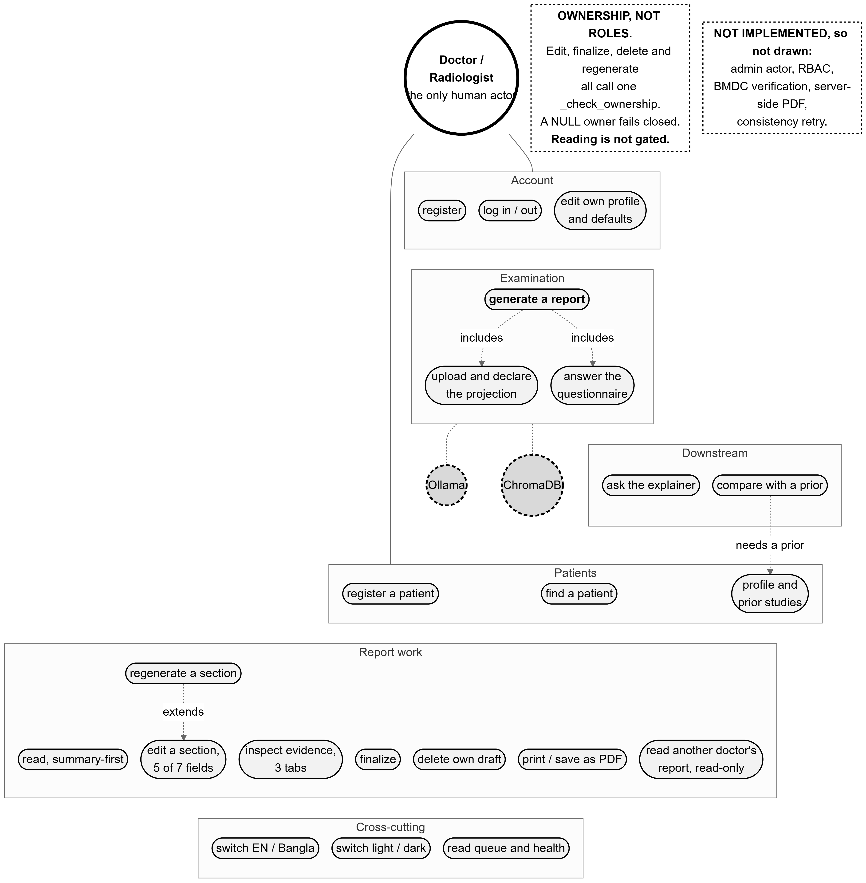
Figure 3.1: Use cases as actually implemented, grouped into six areas. One human actor, the doctor; Ollama and ChromaDB as secondary actors. The second note box lists what is deliberately not drawn, so that absence cannot be mistaken for oversight.
Source: thesis final report/03_diagrams/04_use_case.png, derived from backend/app/api/ (26 operations), frontend/src/app/**/page.tsx (15 routes) and backend/app/models/doctor.py:32-42.
Table 3.4: Primary use cases and their preconditions.
Source: 01_facts/feature_catalogue.md; 07_manual/user_manual_outline.md.
Use case | Actor | Precondition | Outcome
Register and sign in | Doctor | None | A session cookie; the queue screen.
Register a patient | Doctor | Signed in | A patient record with a system-assigned code.
Perform a new examination | Doctor, Ollama, ChromaDB | A patient exists; a frontal film; a declared projection | A draft report, or a coded rejection at admission, modality or projection.
Review and edit a draft | Doctor | Owns the report; it is not final | Status becomes DOCTOR_EDITED; a word-level diff against the AI draft.
Regenerate one section | Doctor, Ollama | Owns the report; the field is one of five editable | A candidate the doctor accepts or discards.
Inspect the evidence | Doctor | A report exists | Five neighbour cases, similarities, agreement, alternatives. No further request is made.
Ask about a report | Doctor, Ollama | A report exists | An answer grounded in the same evidence block, stored with the report.
Compare with a prior study | Doctor, Ollama | The patient has a prior report | Resolved / persistent / new, computed deterministically, then narrated.
Finalize | Doctor | Owns the report | FINAL, stamped and audited. A one-way door: later edits are refused 409.
Read another doctor’s report | Doctor | Signed in | Read-only view with an owner chip; every write is refused 403.
Print / save as PDF | Doctor | The report has narrative content | A complete seven-field document from the browser’s print engine.

3.3 Feasibility Study

3.3.1 Technical feasibility
The binding technical question was whether a retrieval-augmented pipeline with a local language model fits on one consumer GPU at a latency a clinician would tolerate. It does, and the margins are measured rather than projected.
Table 3.5: GPU residency of the production stack, measured on an NVIDIA RTX 4070 Ti SUPER (16,376 MiB).
Source: 01_facts/phase22_fix_architecture_v1.2_FROZEN.md §7, reproduced in 06_results/performance_and_tests.md §3.
Component | Marginal VRAM | Note
llama3:8b (Q4_0, 8B parameters) | 5,025 MiB | Measured from a genuinely cold 537 MiB baseline.
BiomedCLIP | 1,043 MiB | Loaded once per process, at startup.
CheXbert | 452 MiB | Reproduced to the byte across two independent runs.
Peak, all three resident plus inference | 7,095–7,125 MiB | 30 MiB spread across two runs.
Headroom | ≈ 9,251–9,281 MiB (≈ 9.0 GiB) | Threshold was to flag below 1,024 MiB — PASS by a wide margin.
The headroom is not incidental; it was what made Phase 23 possible. Swapping in a 14-billion-parameter model raised the peak to 11,401 MiB, still clearing the threshold by 3.86 GiB — so the larger model could be tested honestly on the same hardware rather than dismissed as infeasible. It lost on accuracy anyway (§6.6).
Latency is likewise measured: 4.50 s mean end-to-end per report over 477 cases, with the self-consistency check adding 6.9–7.8 ms, around 0.2% of the request. One caveat is recorded rather than glossed: the per-stage latency profile specified for Phase 21 was never produced. The architecture document specified a P50/P95 breakdown per pipeline stage written to a named file; that file and its directory do not exist. The figures above are whole-request latency from other phases, and the stage-by-stage breakdown that a resource-constrained deployment argument would ideally rest on is missing.
One further limit bounds the technical claim: the deployment is a single process with synchronous routes, no task queue and no background worker. No load test was ever run, so nothing is known about behaviour under concurrent users. Since the GPU hosts one language model that serves one generation at a time, concurrent generation would serialise rather than scale. For a single-reader workstation this is adequate; for a department it is not, and §8.3 lists it as future work.

3.3.2 Operational feasibility
The workflow the system implements — open a patient, upload a film, read a draft, edit it, sign it — mirrors the order in which a reporting session already proceeds, and the system inserts itself at the drafting step alone. Nothing in it asks the clinician to change how they read a film; it changes what they start writing from.
Three operational facts are unfavourable and are stated here rather than in a limitations appendix. Starting the system is a manual, three-process procedure — Ollama, the backend and the frontend, each started by hand, with no process manager, no container and no service definition. The frontend must be served from exactly one origin, because the CORS allowlist holds a single entry; served from anywhere else, every action fails with a message that does not name the real cause. And the consistency verdict a clinician sees is always partial for an English report, because one of the three checks cannot yet emit a result. That is the honest state rather than a defect in the display, and §6.8 explains why it is correct for the interface to say so.

3.3.3 Legal and ethical feasibility
The dataset is the IU/Indiana chest X-ray collection, publicly available and already de-identified at the report level, which is what makes research use feasible without a data-sharing agreement. One qualification is recorded: no licence text, DOI or formal citation for the dataset exists anywhere in this project’s repository — the dataset is named and its counts recorded, but its terms were never transcribed. [TO CONFIRM: the IU X-ray dataset licence and citation must be obtained from the source and stated before submission. Relatedly, whether storing query images inside the repository under backend/uploaded_images/ is compatible with those terms is not recorded.]
The CheXbert licence is recorded in full and is the most consequential legal constraint on this work. The governing terms are the Stanford Academic Software License Agreement, Docket S20-295, dated 2020-10-15: royalty-free but binding by use, restricted to internal academic non-commercial purposes (which this thesis satisfies), requiring citation of Smit et al. (2020) in any publication, and explicitly forbidding redistribution without written permission. The operational consequence is recorded in the project so it can never be violated silently: the 1.31 GB checkpoint must never be committed to the repository, pushed to any public remote, or included in a public submission bundle. It lives in a cache directory outside the repository entirely, so it never needs to be gitignored-and-trusted. A further detail is recorded because it affects reproducibility: the official Stanford distribution link returns a genuine 404, and the only working source found was a third-party mirror whose “MIT” tag is very likely a mislabel and is not authoritative.
The language model ships the META LLAMA 3 COMMUNITY LICENSE AGREEMENT inside the model itself. [TO CONFIRM: no licence text or citation for BiomedCLIP is recorded anywhere in this repository, and no LICENSE file exists for this project itself.]
The decisive legal fact for deployment is stated in §3.5: nothing here amounts to regulatory clearance, and this system in its current form may not be used for clinical care.

3.3.4 Schedule feasibility
The project ran to 90 commits between 2026-07-11 and 2026-09-23, 75 calendar days, with work occurring on 15 distinct days. The repository is silent about effort between those days, so no duration is claimed for any phase beyond its first and last commit date. One gap is large enough to state explicitly: there were no commits at all between 2026-08-10 and 2026-09-19, a 40-day interval whose content the repository does not record. Section 3.9 gives the phase-by-phase schedule and how the plan was revised around that gap.

3.4 Key Challenges Addressed
Table 3.6: The six challenges that shaped the delivered system, and how each was addressed.
Source: Cross-referenced to the chapters that carry the evidence.
Challenge | How it was addressed | Residual risk
Burned-in PHI in images. | OCR detection with solid black-box masking — never blur or inpainting, because inpainting hallucinates pixel content and would be a strange thing for an evidence-grounded system to feed its encoder. Masking runs before embedding, so the vector is derived from what the system is willing to store. | Detection accuracy is unvalidated: this dataset has no burned-in-PHI ground truth. Detection counts are pipeline signal, not a recall measurement (§3.8).
Hallucination. | The model is given real retrieved reports as evidence and instructed to ground its output in them. Structural validation enforces the seven-field shape with two content retries. | Only the structural check can stop a report. Semantic validation is advisory and gates nothing, by an explicit design decision (§5.3).
Evidence attribution — the failure that was actually found. | v1.2 labels the evidence block as other patients’ reports, forbids reproducing their sentences or transferring findings, requires the impression to follow this report’s findings, and states that no prior study exists. Measured: comparison language 35.0% → 2.7%; self-contradiction 4.6% → 0.8% (n=477). | A residual defect survives in the opposite direction: 27/477 reports state an abnormality in findings and call the study normal in the impression. No check covers it (§6.5).
Non-determinism at temperature 0. | Diagnosed by measurement, not assumption: temperature 0 alone does not pin the sampler, and a cold model produces different wording from a warm one. A seed and a 30-minute keep-alive were both added, each needed for a different reason. | Not solved. 67/100 re-runs still differ byte-for-byte. The measured endpoint, however, did not move at all — both halves matter (§6.9).
Bilingual output. | Reports are generated directly in the selected language rather than translated, so there is no translation pass to introduce drift. The interface carries 412 parity-checked keys. | Entirely unmeasured. All three consistency checks are English-only; a Bengali report correctly reads “checks not run” rather than showing a pass. Backend-composed validation warnings still appear in English on a Bengali screen.
Metric validity. | Every metric was required to clear a validity bar before its results were believed. BERTScore was tested against a random mismatched-pairs baseline and failed, so it was discarded rather than reported. | The remaining clinical instrument, CheXbert, carries a confirmed negation bug on this corpus and low support on most labels (§6.9).

3.5 Final Specifications and Requirements

3.5.1 The final agreed specification
The system as specified at completion is: a single-site, locally deployed, web-based decision-support tool that accepts a frontal chest radiograph from an authenticated doctor, masks burned-in text, encodes the image with a frozen BiomedCLIP encoder, retrieves the five most similar studies from a leakage-controlled knowledge base of 2,462 training-split cases, drafts a seven-field report in English or Bengali with a locally hosted 8-billion-parameter language model grounded on those cases, checks the draft structurally, semantically and for self-consistency, presents it alongside the evidence it was built from, and requires the doctor to review, edit and explicitly finalize it before it is anything other than a draft.

3.5.2 Stakeholder feedback and its source
One round of recorded, external stakeholder feedback exists. A team member outside the implementation work drove the complete owner flow through the real interface and filed 13 findings spanning registration, upload, the workspace, comparison and the reading queue. The findings were triaged into six real defects with a locatable root cause, five missing affordances, one theming request the design system had deliberately excluded, one already fixed by uncommitted work the tester did not have, and one that could not be called a defect until it had been measured.
Two of those findings changed the system materially, and both are worth recording because neither was what it appeared to be:
- “Set k = 3 and the interface still shows k = 5.” Tracing it revealed that every preference the settings screen saved was write-only — five columns persisted to the database and read by nothing. The screen saved successfully, showed a success state, and changed nothing about the system. Two of the five preferences were subsequently removed from the interface rather than wired up, because the behaviour they promised did not exist: a control whose choice cannot be honoured is the same defect as the one reported, not a smaller one.
- “The same image gives different results.” This was not triaged as a defect until it was measured, and measuring it produced the non-determinism characterisation in §6.9 — including the finding that a seed alone is insufficient because a cold model differs reproducibly from a warm one.
No clinician feedback of any kind has been collected. No radiologist has evaluated this system’s output or its interface, no feedback instrument or protocol exists, and the clinical label taxonomy still awaits the clinically-informed review it was always stated to need. Every usability and clinical-utility claim that might otherwise be made is therefore unevidenced, and this report makes none.

3.5.3 Standards, professional codes and regulatory requirements
The standards and codes reviewed, and their status in this project, are set out below. The honest summary is that the engineering standards were applied and the medical-device regulatory pathway was not entered at all.
Table 3.7: Standards and regulatory requirements reviewed, and their status here.
Source: Contrast and parity values from development_log.md (2026-09-23); licensing from 01_facts/thesis_facts.md §6.
Standard or requirement | Status in this project
WCAG 2.1 AA contrast for text | Applied and measured. Every pair was computed over its real composited backdrop in both themes; lowest value on a 4.5:1 target is 4.65:1. Measuring found a real defect — a status token at 3.83:1 — which was then fixed.
Data minimisation in logging | Applied. The uploaded filename is read exactly once, for its extension, and is never stored; rejection audit rows carry a hash, size and reason code only.
Stanford Academic Software License (CheXbert, Docket S20-295) | Complied with, and enforced structurally. Academic non-commercial use only; citation of Smit et al. (2020) required; no redistribution — the checkpoint lives outside the repository.
META Llama 3 Community License | Accepted by use; the text ships inside the model and is not stored in the repository.
Transport security (TLS) and secrets management | Not met. No HTTPS anywhere; the JWT signing secret resolves to a literal development placeholder in every measurement this project recorded. Local-development scope, stated as such (§5.3).
Medical device software regulation (e.g. IEC 62304, ISO 14971, and any national regulatory approval) | Not entered. No conformity assessment, risk-management file, clinical evaluation or regulatory submission of any kind was prepared. See §3.5.4.
Clinical validation by a qualified reader | Not performed. The blinded manual read designed for this purpose has not been carried out (§6.5).

3.5.4 The regulatory gap, stated plainly
Software that informs a clinical decision is, in most jurisdictions, a regulated medical device. Bringing this system into clinical use would require at minimum: a documented quality-management and software-lifecycle process; a risk-management file addressing hazards arising from incorrect or omitted findings; a clinical evaluation demonstrating safety and performance on a representative population; post-market surveillance; and approval from the relevant national authority. None of these exists. This project produced a research prototype and the evidence in Chapter 6; it did not produce a regulatory dossier, and nothing in this report should be read as suggesting that it did. The system must not be used for clinical care in its current form.

3.6 Societal Impact
The intended benefit is access. A district or Thana-level facility that owns an X-ray machine but has no resident radiologist can acquire films but cannot report them promptly. A tool that drafts the report locally, on hardware the facility could own, and hands it to whichever qualified reader is available, shortens the interval between acquisition and a signed report without requiring the reader to be in the room. Combined with direct Bengali drafting, this addresses both a geographic and a linguistic component of the access gap.
Automation bias is the principal societal risk, and the design addresses it structurally rather than by warning. A clinician who reads an authoritative-looking draft is liable to accept it. Four properties of the delivered system work against that, and each is enforced in code rather than in guidance:
- The evidence is visible and is not an inference. The doctor can open the five cases the draft was built from, with their real similarities and the agreement among them. This is a record of provenance, not a model-generated explanation of itself.
- Warnings are never hidden. The impression, the recommendation, the validation warnings and the consistency verdict all render outside the collapsible disclosure in every state, and four separate conditions force the disclosure open and disable its own control. A disclosure may hide context; it may never hide a conclusion or an alert.
- An unchecked state is never displayed as a pass. The four consistency states are rendered by four separate components rather than one parameterised by a colour lookup — specifically so that a later edit cannot quietly give the not-run state the appearance of a pass. A Bengali report reads “checks not run” with the reason given, because showing nothing at all is read by a clinician as “nothing wrong”, which would convert an acknowledged coverage gap into an affirmative false assurance.
- The doctor finalizes. The status model makes authorship explicit, and the signature block prints only on a finalized report: a draft is not a signed document, and a name under one would say otherwise on a page that outlives the screen.
Language accessibility carries its own risk and it must be stated alongside the benefit. Bengali output is generated directly and has never been evaluated. A Bengali-reading clinician receives a draft with no measured quality and no applicable automated checks. The interface is honest about this at the point of use — the consistency block says so in Bengali — but the underlying asymmetry is real and is recorded in §6.12 as a limitation, not a feature.
Health, safety, legal and cultural considerations. The safety-relevant failure mode is not a wrong draft, which a reader can correct, but a plausible wrong draft that a rushed reader accepts — which is precisely why the omission defect in §6.5 matters more than its 5.7% rate suggests: a report that states an abnormality in its findings and calls the study normal in its impression is internally contradictory in the direction a hurried reader is least likely to catch. Legally, responsibility for any signed report rests entirely with the signing clinician; the system produces drafts and claims nothing else. Culturally, the choice to generate Bengali rather than translate reflects that a translated clinical register frequently reads as neither natural Bengali nor precise clinical language.
Risks if misused. Deployed without a qualified reader, the system becomes an unvalidated automatic diagnosis engine with a 5.7% known self-inconsistency rate and no clinical validation — a materially harmful configuration. Deployed on a population unlike the source dataset, its retrieval quality is unknown, since every number in this report derives from a single US-sourced corpus (§3.8).

3.7 Environmental Impact
The system’s environmental argument rests on three properties, two measured and one not.
Local inference rather than cloud inference. Every generation runs on one workstation already present, and no request leaves the host. This avoids both the data-centre energy attributable to a hosted inference call and the network transfer of image data, though it substitutes the energy of a local GPU that would otherwise be idle.
A no-training design is the substantive sustainability claim. The dominant energy cost in most machine-learning projects is training, and this project performs none: BiomedCLIP is used frozen, the language model as distributed, and the clinical labeller as published. Improving the system means changing a prompt, a threshold or the contents of the knowledge base — none of which requires a training run. The knowledge base itself was built once: 2,462 records indexed in 1.03 seconds, and the full embedding pass over the corpus was a one-off.
Energy per report was never measured. [TO CONFIRM: no power measurement of any kind was taken in this project — no wall-power reading, no nvidia-smi power draw sample, and no energy-per-report figure exists in any artefact.] What is recorded is the VRAM residency (7,125 MiB peak of 16,376) and the wall-clock time per report (4.50 s mean), which bound the duration of a generation but do not give its energy. Deriving watt-hours from those two numbers would require a power figure this project never recorded, and no such derivation is offered here. A defensible statement of the environmental claim is therefore: the design eliminates training energy entirely and confines inference to a single consumer GPU for about four and a half seconds per report; the absolute energy per report is unmeasured.
Hardware lifetime. The system runs on one consumer graphics card rather than on server-class accelerators, and its headroom (≈ 9 GiB) means the hardware is not at its limit and need not be replaced to keep the system working. Against this, a consumer GPU is not a long-lived data-centre asset, and no lifecycle assessment was performed. [TO CONFIRM: no embodied-carbon or hardware-lifecycle figure is recorded.]

3.8 Ethical Issues

3.8.1 Patient privacy and PHI masking
Chest radiographs frequently carry burned-in identifying text. The system detects such text with OCR and masks it with solid black boxes before the image is embedded or stored, and only the masked copy is ever written to permanent storage — one artefact, not two copies that could diverge. On a rejected upload both copies are destroyed, the masked file being explicitly unlinked before the refusal returns. Privacy protection extends beyond the pixels: the uploaded filename is read exactly once, for its extension, and is never retained anywhere, because a filename routinely contains a patient name, and an audit row or an error message carrying one would leak it.
This is a privacy-by-design contribution, not a validated measurement, and the distinction must not be blurred. The dataset used here is already de-identified at the report level and contains no known burned-in-PHI ground truth, so there is nothing against which detection recall could be scored. The recorded outcome — 2,875 of 3,689 frontal images (77.9%) had at least one region masked, 4,278 regions in total — is pipeline evidence, not a PHI-detection performance figure, and must never be presented as one. What was validated is the safety of the masking: BiomedCLIP embeddings before and after masking have a mean cosine similarity of 0.992 across a 50-image sample, with none falling below the 0.90 threshold, confirming that masking did not perturb diagnostic content.

3.8.2 Dataset licensing and the non-redistribution term
The clinical labeller used for every evaluation number in this report is governed by an academic-use licence forbidding redistribution, which this project complies with structurally rather than by policy: the checkpoint lives outside the repository entirely, so it cannot be committed by accident. The required citation of Smit et al. (2020) is recorded as an obligation attaching to any publication of these results, including this report. The dataset’s own terms were never transcribed into this project ([TO CONFIRM], §3.3.3), which is itself an ethical gap rather than merely an administrative one: the project cannot currently demonstrate that its use of the images complies with the terms under which they were released.

3.8.3 Professional responsibility, and the disclaimer
Responsibility for a signed report is the signing clinician’s, entirely and without qualification. The system is built so that this is structurally true rather than merely asserted: a draft is marked as a draft, finalizing is a deliberate act, and the provenance line stating that the report was drafted from archive cases and is not an autonomous diagnosis is written by the server and replaces whatever the model wrote in that field. That replacement is deliberate. A disclaimer the model authors is a disclaimer the model can weaken, and an early sample showed exactly that risk — a model-written disclaimer cited only the agreement score while ignoring retrieval support, an independent signal that can disagree with it.

3.8.4 Dataset bias: a US corpus applied in Bangladesh
Every retrieval result, every label distribution and every evaluation number in this report derives from a single dataset collected at one US institution. Applying such a system to a Bangladeshi population raises a bias question this project cannot answer with its own evidence: disease prevalence differs, and a knowledge base whose prevalence reflects a different population will retrieve neighbours reflecting that population’s case mix. Tuberculosis is the obvious example, being far more prevalent in Bangladesh than in the source corpus, where the related terms were rare enough to be routed into a catch-all class. The curated taxonomy was, moreover, never given the clinically-informed review it was always stated to require. This is a real limitation of the evidence, not of the architecture: the knowledge base is replaceable without retraining anything, which is the strongest practical answer available — but replacing it and re-validating is future work (§8.3), not something this project did.

3.8.5 The decision not to ship image explainability
A saliency map over a radiograph is the feature a reader of the proposal would most expect, and it was deliberately not delivered. The reasoning is ethical rather than technical. A heat map is read by clinicians as the system looked here, which invites trust proportional to its apparent precision. This project has no localisation ground truth — the dataset provides report text and labels, not bounding boxes — so any map produced could be displayed but not validated. Shipping an unvalidated localisation alongside an explicit evidence panel would also create a hierarchy of trust pointing the wrong way: the heat map would look like the explanation, while the retrieved cases, which are the actual provenance of every statement in the draft, would look like supporting material. What ships instead is the evidence itself — the five neighbours, their similarities, the label agreement, and the alternatives that lost the vote — which is a record of what happened rather than an inference about it. Validated attention-based explainability is listed as future work with its prerequisite stated: localisation ground truth (§8.3).

3.9 Project Management Plan

3.9.1 The working method: freeze, build, measure
The project ran a freeze-then-build cycle rather than an iterative one, and the choice was deliberate. Before each phase, an architecture document was written and frozen; the implementation then followed it, and deviations from it were recorded as corrections rather than absorbed silently. Before each evaluation, the code was frozen and the decision criteria were committed before any output existed to score.
The reason for this discipline is specific to evaluating a generative system. Such a system produces many measurable quantities, and a criterion chosen after the numbers are visible is not evidence — it is selection. Freezing the criterion first is what makes a negative result meaningful, and this project produced several. The discipline is verifiable from commit order rather than claimed: a code freeze was committed on 2026-09-19, and every subsequent change is therefore a deliberate, documented post-freeze amendment rather than drift; the Gate A run plan was committed at 55e8bc08 before a single report of the version it evaluates existed; and the Phase 23 plan at d55bd8b8 before any variant had run.

3.9.2 Schedule, as executed
Table 3.8: Phase schedule as executed. Dates are the first and last commit of each phase.
Source: thesis final report/01_facts/timeline.md, derived from git log on branch final-prep at 99f3eab8.
Phase | Milestone | First | Last | Commits
0–2 | Data foundation, encoder validation gate, embedding pipeline | 2026-07-11 | 2026-07-11 | 1
3 | ChromaDB retrieval indexing | 2026-07-11 | 2026-07-11 | 1
4 | Backend assembly: retrieval, voting, database, migrations, FastAPI | 2026-07-12 | 2026-07-12 | 6
5–7 | Context builder, prompt builder, LLM orchestrator | 2026-07-12 | 2026-07-12 | 3
8–11 | Validator and formatter, questionnaire, explainability, comparison | 2026-07-13 | 2026-07-14 | 4
12 | Radiologist workflow UI — the whole frontend | 2026-07-14 | 2026-07-14 | 1
13–16 | Authentication, ownership, visual system, settings | 2026-07-17 | 2026-07-17 | 5
17–19 | Finalize/edit workflow, word-level diff, section regeneration | 2026-07-18 | 2026-07-18 | 4
20 | Generation-quality evaluation; JSON → delimiter-marker format change | 2026-07-22 | 2026-07-23 | 5
— | Reading Room redesign, E2E harness, release audit | 2026-08-08 | 2026-08-10 | 7
— | No commits recorded (40 days). Content NOT RECORDED. | 2026-08-10 | 2026-09-19 | 0
— | Input admission + projection gate v1.1, Gate B recalibration, QA fixes | 2026-09-19 | 2026-09-19 | 4
21 | Evidence-mode ablation, arms A/B/C | 2026-09-19 | 2026-09-19 | 12
— | CODE FREEZE — backend, ml and thresholds frozen | 2026-09-19 | 2026-09-19 | 1
22 | Consistency service, CheXbert labeller, prompt grounding, Gate A, post-hoc | 2026-09-21 | 2026-09-22 | 14
23 | Pre-registered accuracy experiment, 4 variants × 150 dev cases | 2026-09-22 | 2026-09-22 | 5
— | Final UI: summary-first report, light mode, print/PDF, page-based flow | 2026-09-23 | 2026-09-23 | 15
Total | 90 commits over 75 calendar days, on 15 active days | 2026-07-11 | 2026-09-23 | 90

3.9.3 The revised plan, and the rescheduling actually applied
Two revisions to the plan were made in response to what the work produced, and both are recorded because they changed the project’s direction rather than its timetable.
The 40-day gap and what followed it. The repository records no activity between 2026-08-10 and 2026-09-19. What the plan looked like on either side of it is, however, visible in the work: before the gap the project had completed generation-quality evaluation and a UI redesign; the period after it opens with an input-admission gate, a threshold recalibration and then the ablation — that is, with hardening and measurement rather than with new features. The remaining schedule was spent on evaluation and remediation, and no new clinical feature was added after 2026-09-19. [TO CONFIRM: the repository does not record what occurred during the 40-day interval, so no account of it is offered here.]
Phase 22 was unplanned and was inserted after the code freeze. It exists because a live report contradicted itself in a way that turned out not to be a one-off. Rather than patch the instance, the project diagnosed the mechanism, measured its prevalence across 477 reports, designed a fix, pre-registered the evaluation of that fix, and ran it — four phases of work arising from one observed defect. The rescheduling this forced is visible in the timeline: Phase 23, the accuracy experiment, ran on a development set drawn from the validation split precisely so that it could not touch the test pool Phase 22 had just used.

3.9.4 Roles, tooling and resources
The project was carried out by three students of the Department of Computer Science and Engineering, BRAC University — Borhan Uddin (22101540), Sumaiyah Mosabber (23301698) and Halimaya Sadia (22101931) — under the supervision of Md. Shahriar Rahman, Lecturer, CSE, BRAC University. These identifications come from the P1/P2 report front matter.
The repository itself records only three role facts, and they are given here as recorded. All commits on the branch carry the git author suborhan7. Borhan is designated reader 1 for the blinded manual read and is the named owner of the Bengali limitation. Sumaiyah is designated reader 2 and is the author of the 13-finding QA report described in §3.5.2. Neither designated reader is a radiologist, which is recorded in the project and is the reason the blinded read is a check on internal grounding rather than on clinical correctness. [TO CONFIRM: the repository records no role, task allocation or contribution for Halimaya Sadia, and no formal division of responsibilities for any member. The per-member allocation must be supplied from outside the repository.]
Table 3.9: Tooling and resources used.
Source: 01_facts/environment.md, read from the running machine on 2026-09-23.
Category | Resource
Version control | git 2.54.0. Branching by phase; annotated tag v1.1-evaluated marks the evaluated baseline. Automatic background maintenance was disabled deliberately after three diagnosed repack failures under disk pressure.
Compute | One Windows 11 workstation; NVIDIA RTX 4070 Ti SUPER, 16,376 MiB; driver 591.86; CUDA 12.1 as torch was built against.
Backend | Python 3.12.3, FastAPI 0.139.0, uvicorn 0.51.0, SQLAlchemy 2.0.51, Alembic 1.18.5, ChromaDB 1.5.9, torch 2.5.1+cu121.
Frontend | Node 24.18.0, Next.js 16.2.10, React 19.2.4, Tailwind 4, Vitest.
Models | llama3:8b (digest 365c0bd3c000) via Ollama; BiomedCLIP; CheXbert (outside the repository by licence).
Evaluation | A separate frozen virtual environment (torch 2.6.0 CPU, transformers 4.46.0) holding the scoring instrument, kept apart from the production environment so that every Phase 20–23 number comes from one unchanging instrument.
Budget | No monetary budget was recorded. See §3.11.

3.10 Risk Management
The register below is built from risks that actually materialised during this project, not from a generic catalogue. Likelihood is stated as observed frequency where one was measured. Residual risk is what remains after the mitigation that was applied.
Table 3.10: Risk register: risks that materialised, their mitigation, and residual risk.
Source: 08_admin/known_defects.md; 08_admin/open_items.md; 06_results/.
Risk | Impact | Likelihood (observed) | Mitigation applied | Residual risk
Grounding-attribution failure — the report states a finding belonging to a retrieved neighbour, not the patient. | Severe. A plausible, well-formed report about the wrong patient is the most dangerous output this system can produce. | Materialised. 23.5% of scorable impressions at overlap ratio 1.0; 35.0% used comparison language with no prior study (n=477). | v1.2 attribution boundary, anti-copying prohibition, impression-follows-findings constraint, explicit no-prior-study statement; plus an observational consistency service. | Moderate. Rates fell sharply, but the omission defect (27/477) survives in the opposite direction and no check covers it. The blinded read that would confirm the fix has not been done.
Threshold miscalibration — a genuine frontal film rejected as a projection mismatch. | High. A refused upload is a clinician unable to use the system on a valid image. | Materialised once, on a real out-of-distribution frontal scoring 0.8582. | The selection rule was revised on 2026-08-19 from the midpoint of the separation gap to just above the observed lateral maximum, and re-verified on the same 600-study set: 300/300 lateral rejected, 0/300 frontal rejected. | Moderate, and honestly labelled. The revision is post-hoc — the rule changed after seeing a failure — and is recorded as such in the source itself. It remains an observed separation point on one dataset, not a validated boundary.
Metric invalidity — an evaluation instrument that does not measure what it claims. | High. Conclusions drawn from it would be worthless and would not be visibly wrong. | Materialised. BERTScore: 0.8420 for real pairs against 0.8403 for randomly paired reports. | Every metric was required to clear a validity bar before its results were believed. BERTScore failed and was discarded, not reported. | Low for this instrument, real for the survivor. CheXbert carries a confirmed negation bug and 7 of 14 labels have support below 10.
Non-determinism — identical inputs producing different reports. | Moderate. It undermines reproducibility and was reported as a defect by an external tester. | Materialised, and measured: 67/100 re-runs differ byte-for-byte. | Cause diagnosed by measurement: a seed was pinned and a 30-minute keep-alive set, each addressing a different half of the cause. | Present and documented. Text still varies; the measured endpoint, however, moved 0.0 percentage points on re-run, so results are not attributable to this noise.
A dependency security advisory blocking an evaluation tool. | Moderate. It blocked one evaluation tier entirely. | Materialised. A CVE mitigation in the tokeniser library required a newer torch than the production environment could take. | An isolated, fully decoupled evaluation environment was created rather than upgrading production torch and disturbing the frozen encoder. | Low. Two environments now exist and are explicitly not interchangeable; which one produced each number is recorded.
Storage exhaustion corrupting the repository. | High. Three silent failures had accumulated ~55 GiB of orphaned scratch files. | Materialised three times before being diagnosed. | Diagnosed as one recurring mechanism, not unrelated flakiness; integrity verified before and after cleanup with identical results; automatic maintenance disabled deliberately. | Low. History was never at risk; the trade-off is that repository hygiene is now manual and deliberate.
A test that cannot fail. | Moderate. A suite that appears to protect an invariant but does not is worse than a missing test. | Materialised. One assertion compared a function’s output to the very constant the function iterates. | Every retargeted test was checked under negative control — the behaviour was deliberately broken to confirm the assertion still failed. Five of six did; the sixth revealed the tautology. | Low for audited tests. The remaining suite has not been audited this way in full.
A deferred safety mechanism never being completed. | Moderate. A check that records violations and acts on none gives an appearance of protection. | Materialised. 17/477 recorded violations were acted on by nothing. | The gap is stated everywhere it appears: in the configuration, in the code comment, in the interface (partial, never clean) and in this report. | Open. Gates B and C are unstarted; this is the most significant piece of unfinished safety work (§8.3).

3.11 Economic Analysis
This section states what the project can support with its own records and marks what it cannot. No financial record of any kind was kept during this project — no purchase price, no electricity tariff, no hours log — so the figures below are structural rather than monetary wherever a monetary value was not recorded.

3.11.1 Development cost
Table 3.11: Development cost components, and what the project recorded about each.
Source: Hardware from 01_facts/environment.md; licence status from thesis_facts.md §6; monetary values are not recorded.
Component | What is recorded | Cost
Compute hardware | One workstation with an NVIDIA RTX 4070 Ti SUPER (16,376 MiB), Windows 11. | [TO CONFIRM: purchase price not recorded.] The hardware was already available; no acquisition was made for this project.
Electricity | Nothing. No power draw was ever measured. | [TO CONFIRM: not recorded.] See §3.7.
Model licences | llama3:8b under the Meta Llama 3 Community License; BiomedCLIP; ChromaDB; the full Python and Node stacks — all open and used without fee. | Zero. This is a genuine and verifiable property of the design: no paid API, no per-token charge, no subscription.
Clinical labeller licence | Stanford Docket S20-295: royalty-free, academic non-commercial only. | Zero for this work, but not transferable. A commercial deployment could not use this labeller under these terms — an economic constraint, not merely a legal one.
Dataset | IU/Indiana chest X-ray, publicly available. | Zero acquisition cost. Its licence terms were never transcribed ([TO CONFIRM], §3.3.3).
Labour | 90 commits across 15 active days by a three-member team. | [TO CONFIRM: no hours were logged and no labour rate is recorded.] Commit counts are not a measure of effort.

3.11.2 Marginal cost per report
The marginal cost of generating one additional report is, in monetary terms, the electricity consumed by roughly 4.5 seconds of GPU inference on hardware that is already running, and nothing else. There is no per-call fee, no external service and no per-seat licence in the request path. That absolute figure cannot be quoted, because energy was never measured ([TO CONFIRM], §3.7), but the structural point does not depend on the number: the marginal cost does not scale with the number of reports in any way that involves a third party. This is the most economically significant property of a locally hosted design, and it is the one a hosted-API design cannot offer at any price.
Storage grows by one masked image and one database row per examination — negligible against the 14 MB the development database reached over the entire project.

3.11.3 A cloud-hosted alternative
A cloud alternative would replace the local model with a hosted inference API and the local vector store with a managed one. Its cost structure differs in kind, not just in amount:
- Per-report charges become unavoidable and grow linearly with use. The local design’s marginal cost is electricity; a hosted design’s is a per-token fee on every generation, every section regeneration and every explainability question.
- A recurring managed-store cost replaces a one-off indexing cost. This project indexed its 2,462 records once, in 1.03 seconds.
- Patient images would leave the building. This is the decisive objection rather than a cost line. The current design’s privacy property — nothing leaves the host — is not purchasable at any tier.
- Connectivity becomes a dependency. A facility with intermittent connectivity could not report at all, in precisely the settings this project targets.
[TO CONFIRM: no cloud pricing was gathered and no hosted-deployment estimate was computed at any point in this project. Any monetary comparison must be built from current published provider pricing and stated as an estimate with its date and source.]

3.11.4 Cost–benefit estimation
An honest cost–benefit estimate requires two quantities this project does not have: the cost of producing a chest X-ray report under current practice in the target setting, and the measured time saving a clinician realises from starting with a draft rather than a blank field. Neither was recorded. [TO CONFIRM: no baseline reporting cost, no clinician time-and-motion measurement, and no productivity figure exists in this project. No radiologist has used this system.]
What can be said without inventing a number is the shape of the argument and the conditions under which it would hold. The system’s costs are almost entirely fixed — one workstation, already owned — and its marginal costs are near zero, so its benefit is governed entirely by whether a qualified reader is faster starting from a draft than from nothing, and by how often that draft needs correcting. This project measured the second quantity in part and not the first at all: clinical label agreement against reference reports is modest in absolute terms (§6.3), and 5.7% of drafts carry a known internal inconsistency (§6.5). A cost–benefit claim therefore cannot be made from this project’s evidence, and none is made. The clinician validation study that would supply the missing quantity is the first item of future work in §8.3.
This chapter has set out the requirements the system was built against and met, the single actor it serves, the feasibility of building it on the resources available, the standards it does and does not satisfy, the ethical positions it takes, the schedule it actually ran to, the risks that actually materialised, and the economics it can and cannot evidence. Chapter 4 describes how the system was designed to meet these requirements, and which alternative designs were rejected and on what evidence.

Chapter 4 Design and Methodology
This chapter establishes how the system is put together and why it is put together that way. It describes the development process actually followed, the architecture component by component, the two pipelines at the system’s core — machine learning and retrieval-augmented generation — the workflow and its decision points, the data model, and the interface principles. It then sets out the alternative designs that were considered and rejected, in each case naming the evidence that decided it, and closes with the dataset and the preprocessing that produced the knowledge base. Throughout, the design is described as built; where the delivered design differs from the one proposed in P1/P2, the difference is stated and its evidence given.

4.1 Design Process and Methodology Overview
The project followed a phase-structured variant of the Software Development Life Cycle in which each phase is bounded by two documents rather than one: an architecture specification written and frozen before implementation, and a validation record written after it. Twenty-three numbered phases were executed in this form, from the retrieval validation gate through to the final interface work.

4.1.1 Freeze-then-build
The freeze step is the load-bearing part of the method, and it operates at three levels.
- Architecture is frozen before code. Each phase’s design document is completed, reviewed and marked frozen before implementation begins. Where implementation then revealed the document to be wrong, the correction was recorded as a correction — for example, a missing field on an entity found during Phase 4, or an ordering error in the Phase 12 workflow in which questionnaire and explainability were drawn as parallel siblings when one must precede generation and the other must follow it. Recording these as corrections rather than absorbing them keeps the document trustworthy.
- Code is frozen before measurement. A code freeze was committed on 2026-09-19, and the baseline it produced was tagged. Every change after it is therefore a deliberate, documented post-freeze amendment rather than drift, which is what allows Phase 22’s paired comparison to attribute a difference to the change under test rather than to accumulated edits.
- Criteria are frozen before results exist. Each evaluation phase pre-registered its primary endpoint, its statistical procedure and its decision rule in a committed document before any output existed to score. This is verifiable from commit order.
The discipline was applied symmetrically, which is the only thing that makes it worth anything. In Phase 21 the pre-registered primary endpoint did not clear, and the pre-registration forbade promoting any other metric in its place; that ban was honoured and the negative result is reported as the phase’s headline (§6.4). In Phase 23 the selection rule was applied mechanically by a script rather than by judgement, and it selected the incumbent (§6.6). In Phase 20 an entire evaluation tier was discarded for failing its own validity check (§6.3).

4.1.2 How pre-registration shaped the design itself
Pre-registration is usually discussed as an evaluation practice, but here it shaped the architecture directly, in three concrete ways.
- The evidence mode became a configuration value rather than a code path. Because Phase 21 needed to compare three evidence conditions, ContextBuilder takes its evidence mode injected from configuration. An ablation arm is therefore a restart with an environment override, not a branch in the source — which means the arms cannot drift apart, and the production arm is the same code that was measured.
- Thresholds became named, documented constants with a recorded provenance. Every behavioural threshold lives in one configuration module and carries, in the source, how it was chosen: pre-registered, calibrated, post-hoc revised, or a plain engineering default. The one threshold whose selection rule changed after a failure was observed is labelled post-hoc in capital letters in the source itself (§5.3).
- The prompt and the checker were made to share one word list. The temporal terms the prompt forbids and the terms the consistency checker matches on are the same configuration value. A prompt banning different words from the ones the checker looks for would make the measured rate a statement about two unrelated vocabularies rather than about the system.

4.2 Design Specification

4.2.1 System architecture
The system is three processes on one host: a Next.js frontend, a FastAPI backend, and Ollama serving the language model, with ChromaDB and SQLite as persistent stores and BiomedCLIP, EasyOCR and CheXbert loaded inside the backend process. Figure 4.1 shows every component and every connection between them.
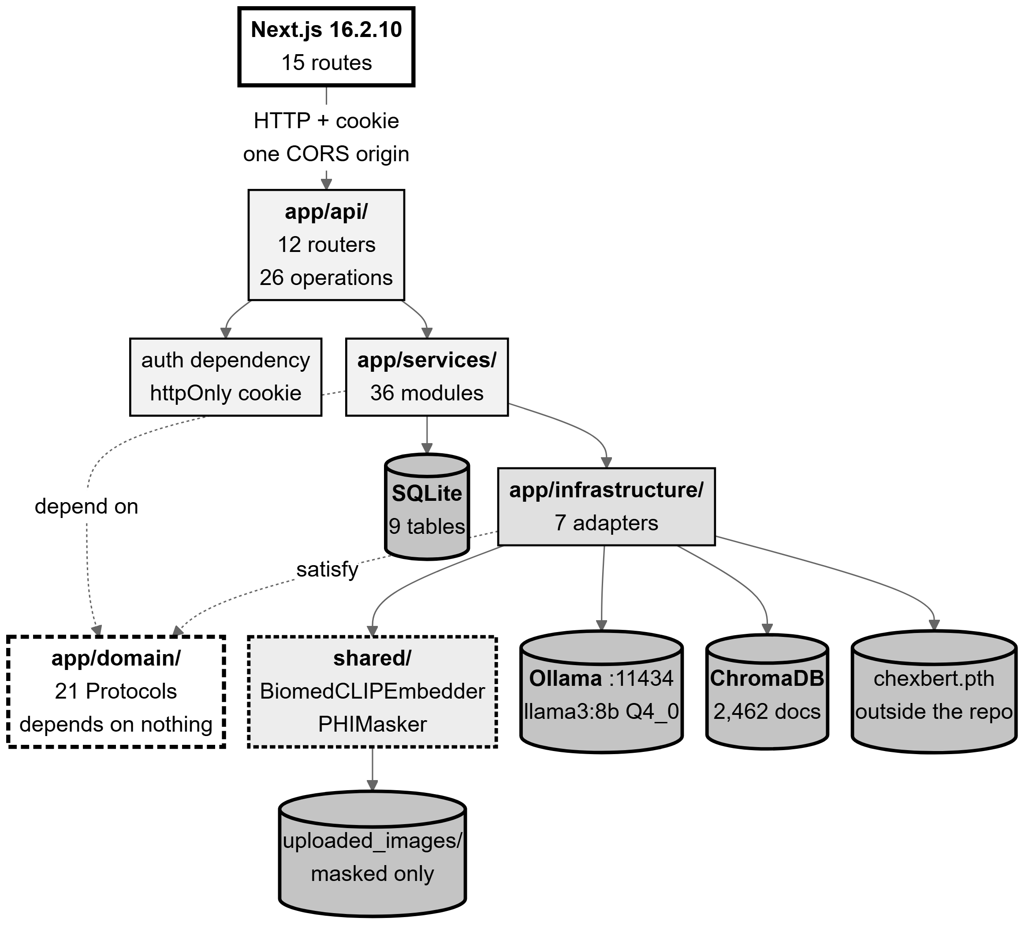
Figure 4.1: System architecture as implemented. Read it as four rings: the browser, the FastAPI process (API → services → domain ← infrastructure), the shared/ package, and the external processes and stores. The dashed arrows are the structural claim: services and infrastructure both point inward at the domain layer, which depends on nothing.
Source: thesis final report/03_diagrams/01_system_architecture.png, derived from backend/app/main.py:106-269, domain/interfaces.py, and live readings taken 2026-09-23.
The backend is organised in four layers with dependencies pointing inward only. The API layer holds FastAPI routers that validate a request, call one service, serialise the result and map an exception to an HTTP status — and contain no clinical logic. The services layer holds every rule, sequence and clinical decision. The domain layer holds entities and 21 runtime-checkable Protocol interfaces, and depends on nothing else in the codebase. The infrastructure layer holds adapters to the outside world, each satisfying exactly one Protocol. Persistence models are kept deliberately separate from domain entities: the two are not the same objects, so the database shape can change without the clinical logic changing with it.
Protocols rather than abstract base classes, and that choice is load-bearing twice. Because Python Protocols are satisfied structurally, the shared embedder in shared/ satisfies the backend’s embedder interface without importing anything from the backend — which is what keeps the research pipeline and the production application from importing each other while both use one embedder implementation. That matters more than it may appear: two independent BiomedCLIP implementations with a subtle preprocessing difference would not raise an error, they would silently degrade retrieval by placing knowledge-base vectors and query vectors in slightly different spaces. The second use is smaller but real: the prompt builder implements six of its interface’s seven methods and deliberately omits the seventh, because there is no translation pass to build a prompt for — Bengali is generated directly. A Protocol permits that; an abstract base class would not.
There is no dependency-injection framework. A single application lifespan constructs every shared collaborator once per process and attaches it to application state; routes read them from there and construct nothing expensive themselves. The model loads, the OCR engine, the labeller and — significantly — the modality gate’s text prompt vectors are all built exactly once. That last item is not an optimisation bolted on afterwards: the constructor line that encodes the prompt vectors is the cache the design requires.

4.2.2 The machine-learning pipeline
Figure 4.2 shows the machine-learning path end to end. Every number in it is the real configured value rather than an illustration.
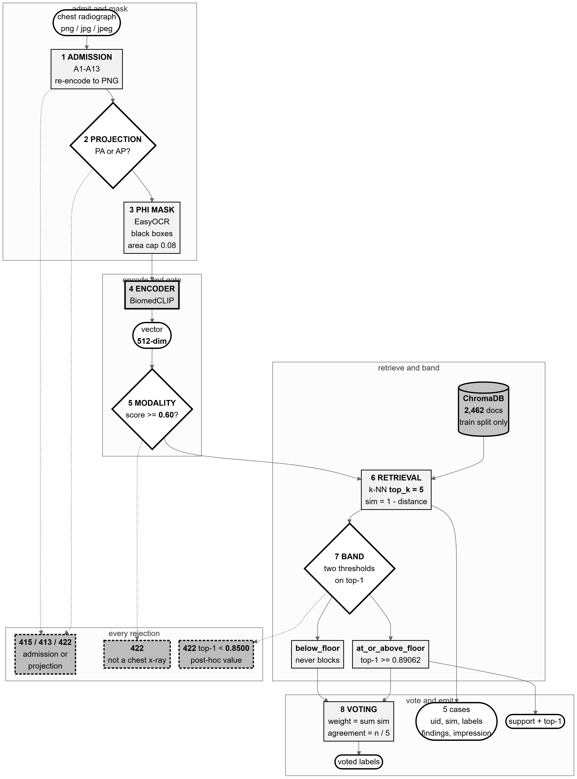
Figure 4.2: The machine-learning pipeline: upload → admission → PHI masking → BiomedCLIP encoding → modality gate → vector store → k-NN retrieval → label voting. White diamonds are decisions that really exist in the code; dashed edges are rejection paths. The projection threshold is marked in the figure itself as a post-hoc value.
Source: thesis final report/03_diagrams/02_ml_pipeline.png, derived from backend/app/api/retrieval.py:292-505, services/image_admission_service.py, modality_gate_service.py and core/config.py.
Preprocessing and admission. An uploaded file passes thirteen checks before anything expensive runs: an extension allow-list, a magic-byte signature sniff, agreement between signature and extension, size bounds, a verification pass followed by a second open for loading, a pixel ceiling, dimension bounds, and finally a re-encode from the pixel array alone. That last check is the strongest control in the sequence: whatever was uploaded, what proceeds is a PNG this process encoded, carrying no metadata, no trailing bytes and no embedded payload. The raw bytes never reach disk.
PHI masking, and the order it runs in. Detected text regions are masked with solid black boxes, and the masked file is written straight to its permanent location — one artefact, not two copies that could diverge. The ordering is a frozen decision: admit → mask → embed → gate → retrieve. Admission runs on the raw upload because an unsafe file must never reach the OCR library, and masking runs before embedding so that the vector the system judges and stores is derived from the pixels the system is willing to keep. Masking used to run last, from raw pixels; the reorder is safe because the embedding impact of masking was measured at a mean cosine similarity of 0.992 with none of 50 sampled images falling below threshold.
Encoding. The masked image is encoded by BiomedCLIP into a 512-dimensional vector, L2-normalised so that cosine similarity is a dot product for every downstream consumer. The encoder is frozen: no training of any kind occurs in this system.
The gate, and why there are two thresholds rather than one. The same vector is reused — never recomputed — for two distinct questions. First, is this a chest radiograph at all? A softmax over BiomedCLIP text prompts, using the model’s own learned logit scale as its temperature, must exceed 0.60; below that the upload is refused and the masked file is deleted. Second, after retrieval, how well supported is this image by the knowledge base? Here two thresholds apply to the top-1 similarity: below 0.8500 the upload is refused as a projection mismatch, while the retrieval floor at 0.8906208872795105 only classifies support as at_or_above_floor or below_floor and never blocks. Collapsing the two into one value would delete the middle band that the disclaimer, the stored support category and the evidence display all depend on. One property of this design is recorded honestly: the floor’s low-support branch was never exercised in calibration — 0 of 300 frontal cases fell below it.
Retrieval and label voting. The vector queries a ChromaDB collection of 2,462 documents built from the training split only, returning the five nearest neighbours with their real findings and impression text. A similarity-weighted vote over those neighbours’ curated labels produces, for each label, a weight and an agreement fraction. The agreement fraction is what the interface later displays, and it is explicitly not a probability that the report is correct — the interface says so at the point of display.
The system does not classify, and this is the central design commitment. No classifier is trained, and no predicted probability over a label set exists anywhere in the pipeline. The voted labels are a summary of what five real archived cases were labelled with, not a prediction about this patient. The consequence is traceability: every finding the draft asserts can be traced to specific retrieved studies that a reader can open and judge for themselves. A classifier would produce a number; retrieval produces evidence. Section 4.3 gives the empirical basis on which this was chosen over the classification design P2 proposed.

4.2.3 The retrieval-augmented generation pipeline
Figure 4.3 shows the generation path, and is organised around the three questions a reader should ask of any RAG system: what is retrieved, what reaches the model, and what is checked afterwards.
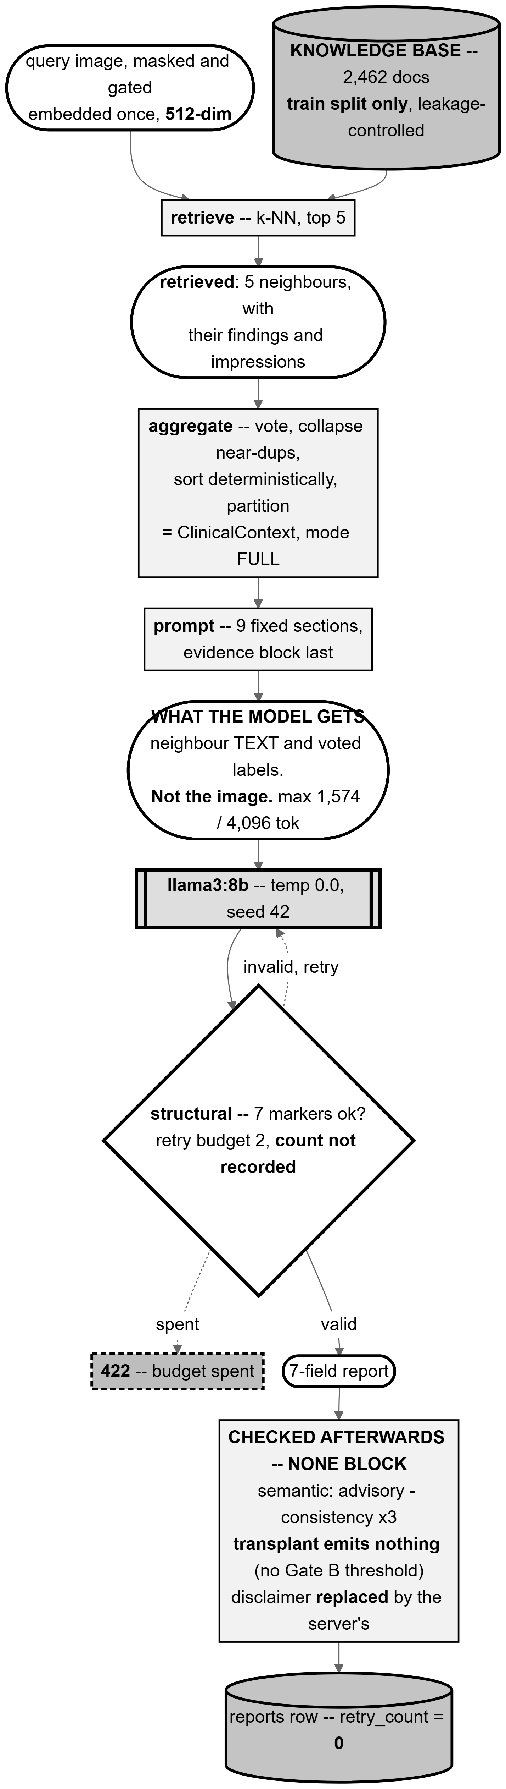
Figure 4.3: The retrieval-augmented generation pipeline. The node marked what the model gets is the one that matters most: the prompt carries the five neighbours’ findings and impression text plus the voted labels, and the image itself never reaches the language model.
Source: thesis final report/03_diagrams/03_rag_pipeline.png, derived from services/report_generation_service.py:160-355, context_builder.py, prompt_builder.py:168-206 and report_consistency_service.py.
What is retrieved. Five neighbour studies from a collection that is the training split only, leakage-controlled twice over: at study level, so a study’s own second view cannot be its own neighbour, and by near-duplicate clustering, so a study’s near-identical twin cannot sit on the other side of the split. A query case can therefore retrieve neither itself nor its own near-duplicate.
How evidence is aggregated. The context builder sorts the retrieved cases by descending similarity with a deterministic tie-break, collapses near-duplicates, and partitions the evidence per label. It performs no diagnosis and no synthesis — it organises, and nothing more. This is a deliberate boundary: any judgement it made would be a clinical judgement made by a component with no way to explain itself.
What reaches the prompt. Nine sections in a fixed order, carrying the retrieved reports’ text, the voted labels with their agreement, the questionnaire answers, the clinical notes and the language instruction. Two properties are worth stating explicitly. The image contributes only the 512-dimensional vector that selected the neighbours; generation is text-only. And the prompt fits comfortably: measured across all 477 cases, it peaks at 1,574 tokens of a 4,096-token window, so the evidence block is never truncated — a failure mode that would silently drop evidence and would not be visible in the output.
What is checked afterwards — and the honest answer is: nothing that blocks. This is stated plainly because it is the single most misreadable property of the design.
Table 4.1: The post-generation checks, and which of them can stop a report.
Source: 03_diagrams/03_rag_pipeline_caption.md; services/response_validator.py:6-10; main.py:233-241.
Check | What it does | Can it stop a report?
Structural validation (7 markers) | Parses the seven delimiter-marked fields. | Yes — the only one. Two content retries, then HTTP 422.
Semantic validation | Warns on empty sections, unsupported terms, an unreflected top label. | No — advisory by design. It produces warnings and gates nothing.
Temporal check | Detects comparison language where no prior study exists. | No — observational.
Transplant check | Scores overlap between the impression and each neighbour’s impression. | No — and it currently emits nothing at all: no threshold has been calibrated.
Contradiction check | Labels findings and impression separately and compares them. | No — observational.
Disclaimer | Not a check: the server replaces the model’s disclaimer text. | n/a
That the semantic validator is advisory is a deliberate decision rather than an omission. A validator that blocks must be right; one that advises may be conservative. This validator flags terms absent from the retrieved evidence, and a correct report can legitimately use a term its neighbours did not — so blocking on it would refuse good reports. The consequence, stated plainly, is that the only automated gate on clinical content is structural, and everything clinical rests on the doctor’s review. Section 6.7 discusses whether the evidence supports that choice.

4.2.4 Workflow and decision points
Figure 4.4 traces the whole flow from upload to a persisted draft, with every decision node in it being a branch that really exists in the code. The figure’s task is as much to show what does not branch as what does.
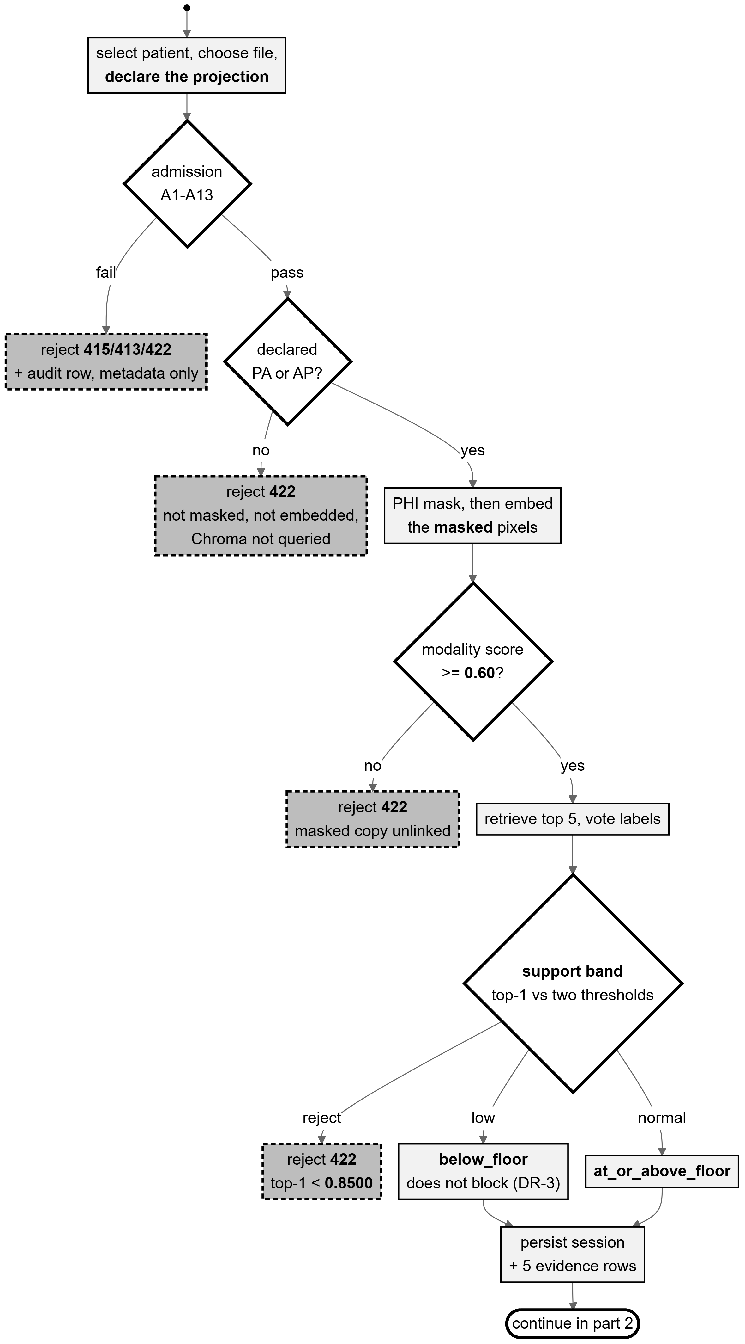
Figure 4.4: Activity flow, part 1: upload → admission → masking → embedding → modality gate → retrieval → support band → persistence. Dashed mid-grey nodes are rejection paths; each corresponds to a specific HTTP status.
Source: thesis final report/03_diagrams/05_activity_report_generation.png, derived from backend/app/api/retrieval.py:292-505.
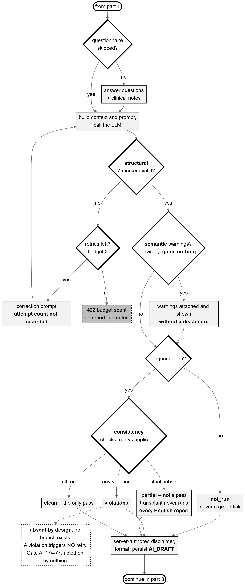
Figure 4.5: Activity flow, part 2: questionnaire → prompt → LLM → structural retry → semantic validation → consistency → persist as AI draft. The dashed box hanging off the violations state records a decision that does not exist: a recorded violation triggers no retry. Drawing it as an absence rather than a live branch is the point.
Source: thesis final report/03_diagrams/05b_activity_generation_review.png, derived from services/report_generation_service.py:139-355 and llm_orchestrator.py:56-110.
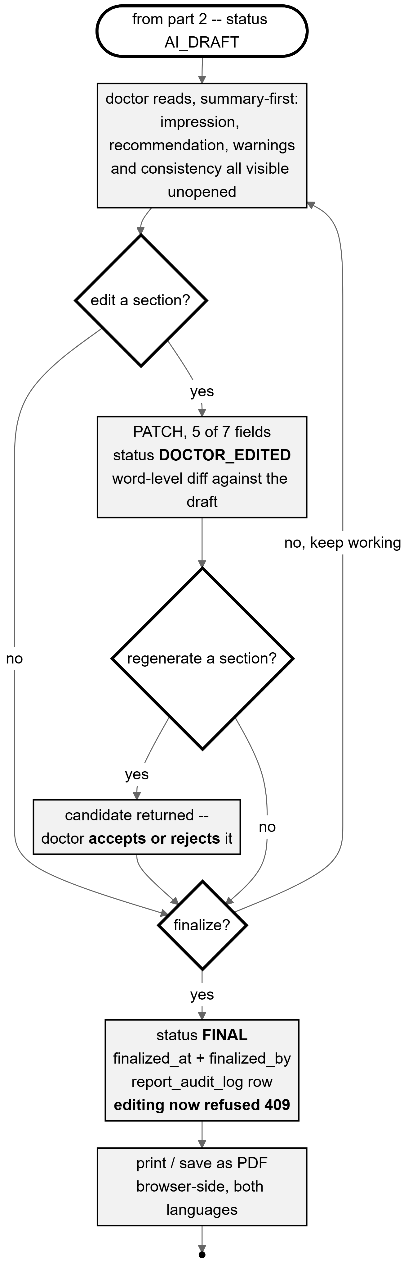
Figure 4.6: Activity flow, part 3: the doctor’s loop — read, edit, regenerate, finalize, print. FINAL is a one-way door: after finalizing, an edit is refused with HTTP 409, ownership or not.
Source: thesis final report/03_diagrams/05c_activity_doctor_review.png, derived from services/report_edit_service.py and api/reports.py.
Table 4.2: Every decision point in the flow, and whether it blocks.
Source: 03_diagrams/05_activity_report_generation_caption.md, with the file and line of each branch.
Decision | Blocks? | Outcome
Admission checks A1–A13 | Yes | HTTP 415, 413 or 422; an audit row is written.
Declared projection A14–A17 | Yes | HTTP 422. A lateral declaration is refused before masking, embedding or any query.
Modality gate, score ≥ 0.60 | Yes | HTTP 422; the masked image is unlinked.
Projection band, top-1 ≥ 0.8500 | Yes | HTTP 422 with reason FRONTAL_MISMATCH; masked image unlinked; the audit row carries the modality score.
Retrieval support vs the floor | No | Sets a category only, which reaches the disclaimer and the evidence display.
Structural validation, 7 markers | Yes | Up to 2 content retries with a correction prompt, then HTTP 422 carrying the last response and errors.
Semantic warnings | No | Advisory; stored and displayed.
Consistency state (4 states) | No | Observational; stored and displayed.
Doctor edit / regenerate / finalize | — | The human decisions. These are the only ones that change the report’s authorship.
Two consistency states must be read carefully, and the design makes that unavoidable. partial is not a pass: because the transplant check has no calibrated threshold it can never be listed as having run, so the set of checks that ran is always a strict subset of those applicable, and every English report lands in partial. And a non-English report shows not_run rather than nothing at all, because showing nothing is read by a clinician as “nothing wrong”, which would convert an acknowledged coverage gap into an affirmative false assurance.

4.2.5 Sequence of one generation
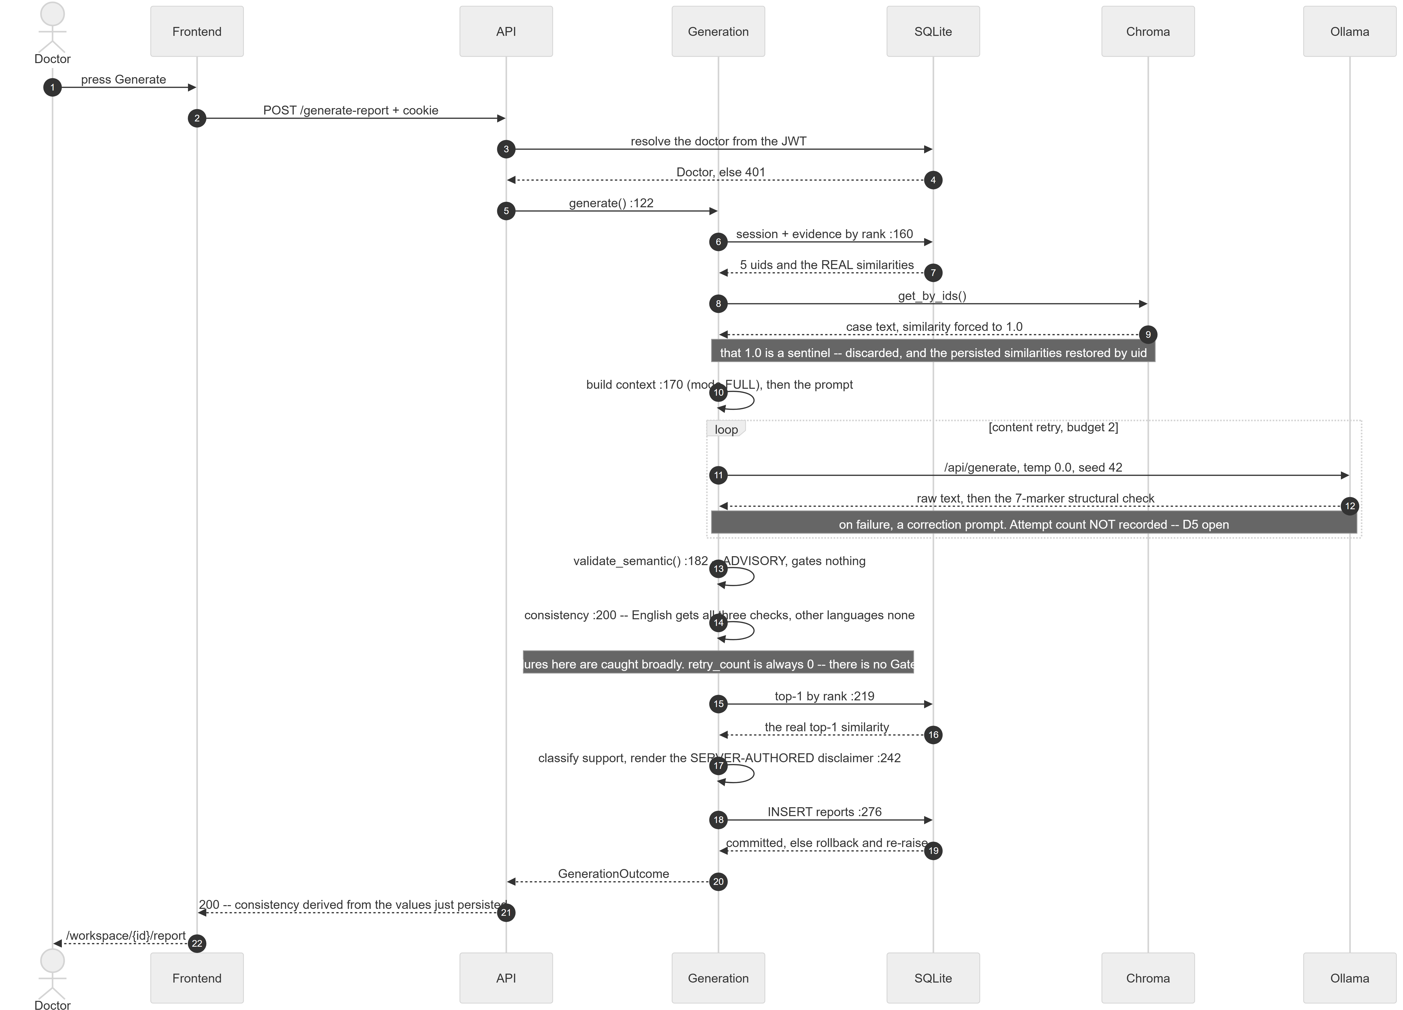
Figure 4.7: Sequence of a single report generation across seven participants. The numbers after a call are the line at which control passes on.
Source: thesis final report/03_diagrams/06_sequence_generate_report.png, derived from api/generation.py:94-151 and services/report_generation_service.py:139-355 at commit 99f3eab8.
Four properties of this sequence are worth drawing out, because each encodes a design decision that is not obvious from the component list.
- The similarity is restored, not recomputed. Fetching the retrieved cases back from the vector store by identifier is an unranked lookup, so it reports a sentinel similarity of 1.0 for every case. Three consumers once treated that sentinel as a measurement: vote weights collapsed to a plain case count, the evidence sort degenerated to alphabetical order, and the interface showed 100% on every case. The real values were never lost — they are persisted at retrieval time — and are restored keyed by identifier rather than zipped positionally, because the lookup can return fewer rows than were asked for.
- The retry loop exists, and what it does not record is stated. Up to two content retries, each with a correction prompt carrying the rejected text and the exact errors. The attempt count is never persisted. Every “zero structural failures” in Chapter 6 therefore means zero failed after retries, never zero needed a retry.
- The consistency check cannot fail the generation. Its exception handler is deliberately broad and its worst case is three NULL columns and a log line. The reasoning is explicit: a safety warning that can take down report generation is a net loss, because the doctor then loses the report entirely instead of receiving one with an unchecked caveat.
- The response cannot disagree with the database. The consistency block returned by the generation call is derived from the values just persisted, not from the in-memory result they were built from — so that call and a later read of the same report cannot describe it differently.

4.2.6 Data model
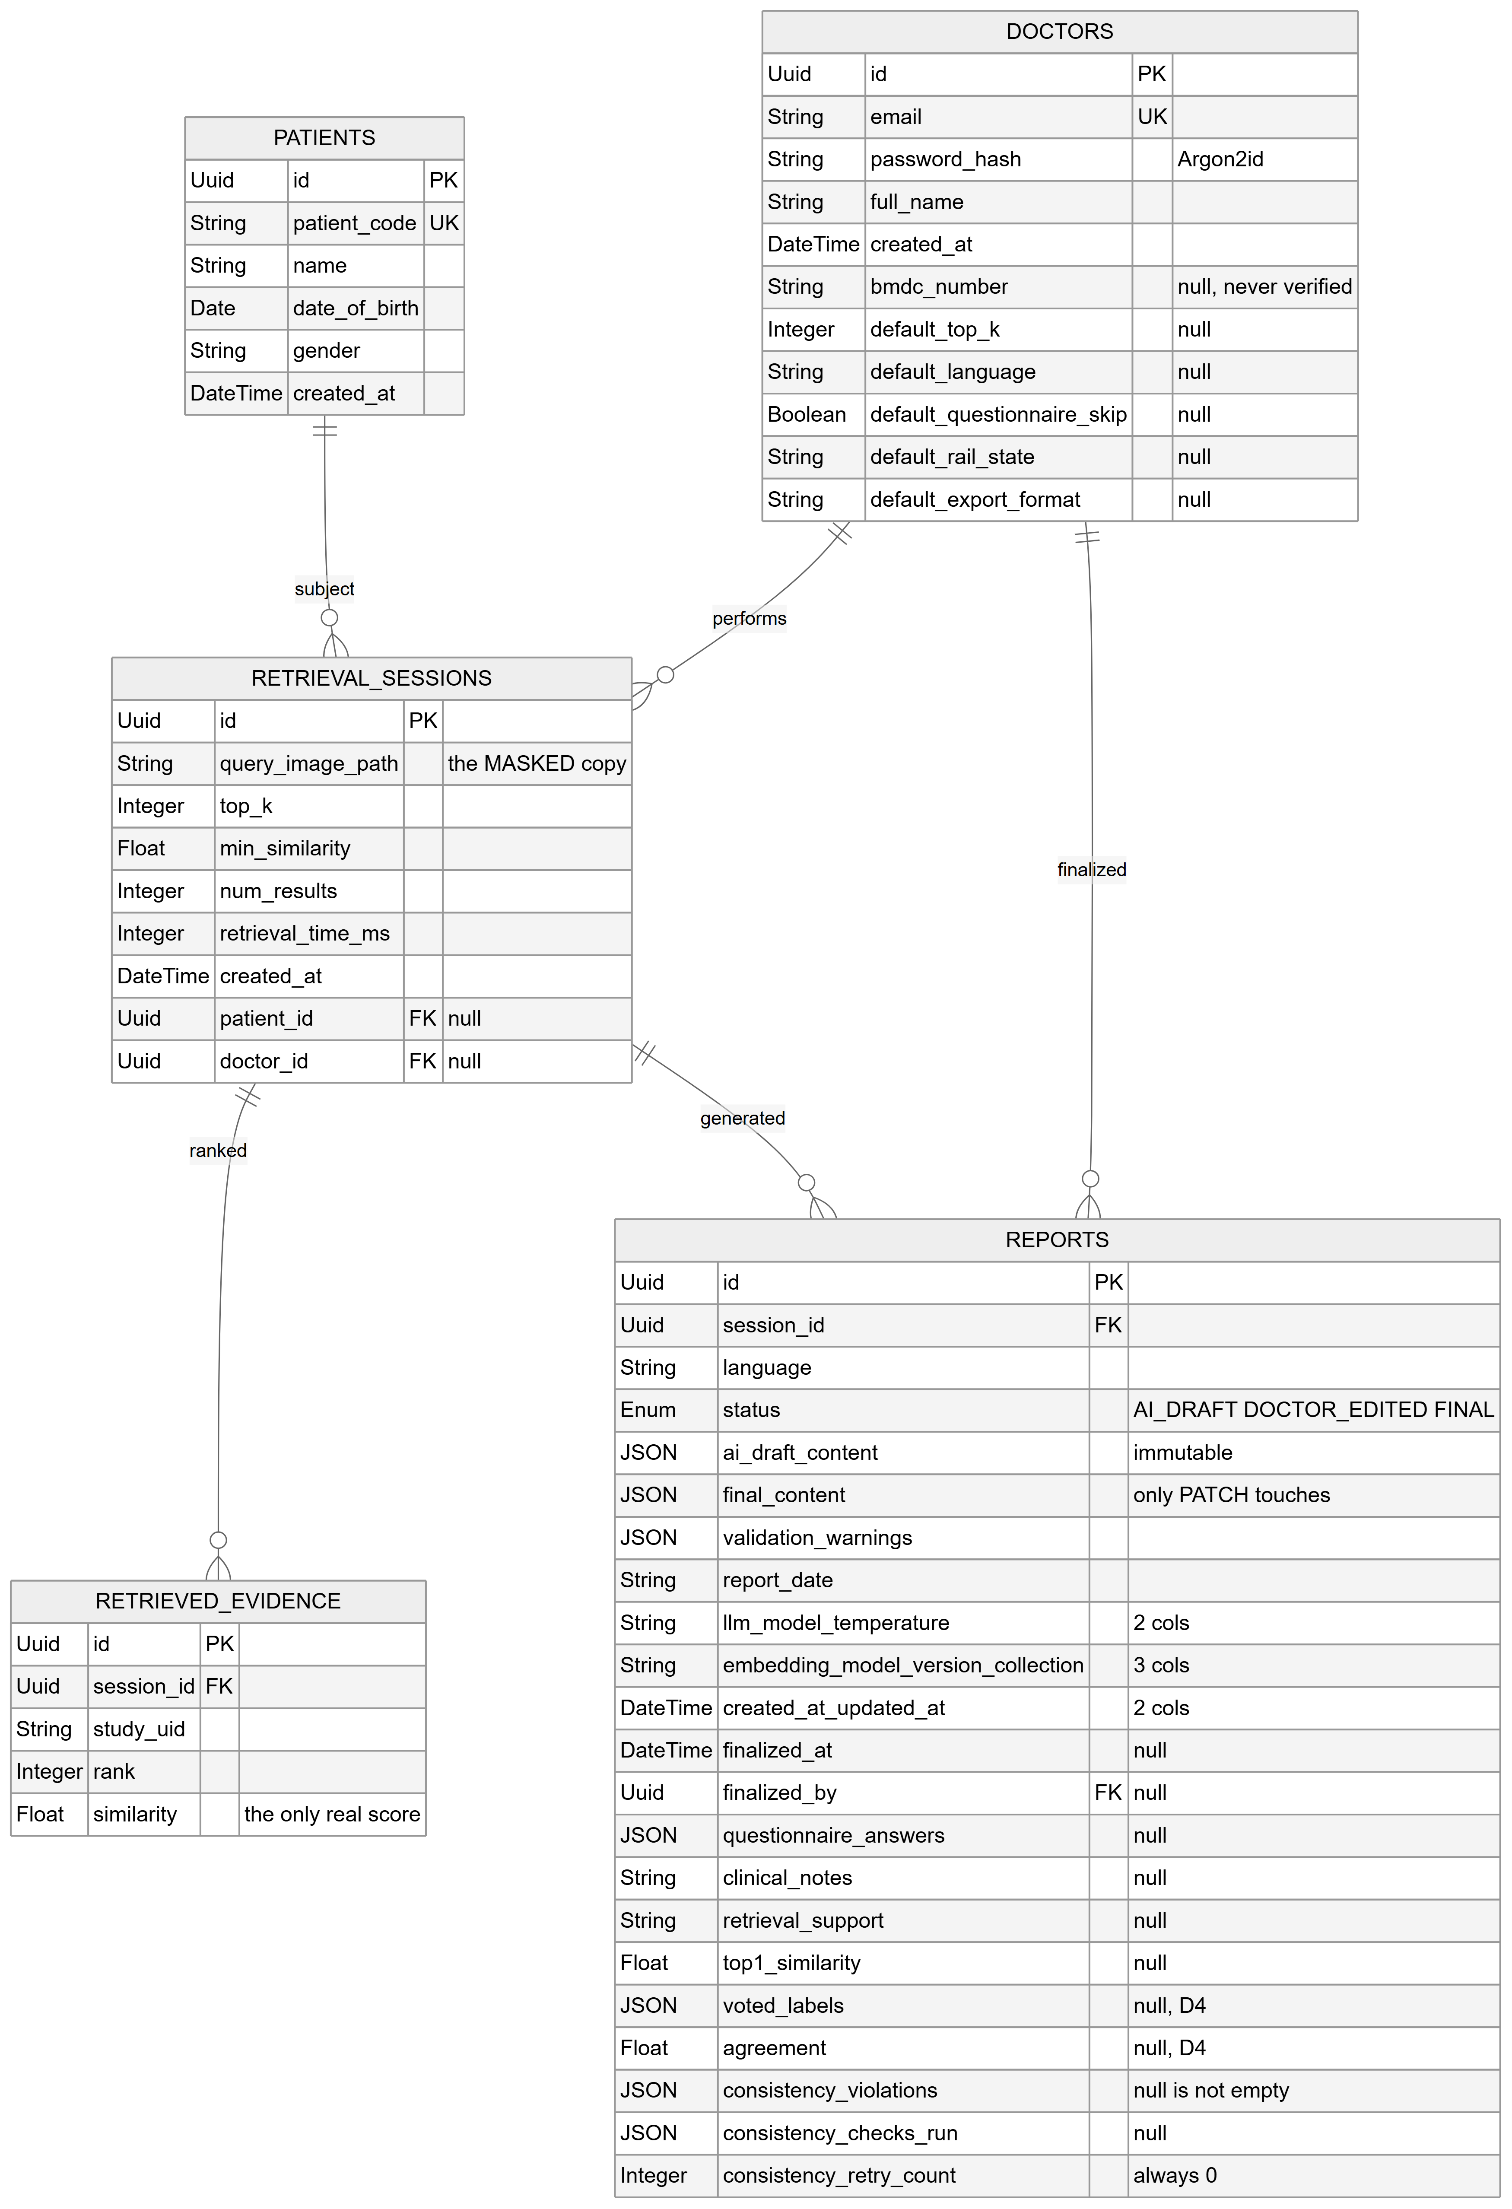
Figure 4.8: Entity relationships, part 1: the report lifecycle core — doctors, patients, retrieval sessions, retrieved evidence and reports.
Source: thesis final report/03_diagrams/07_er_diagram.png, derived from backend/app/models/*.py after alembic head 7f2a91c4d6e8.
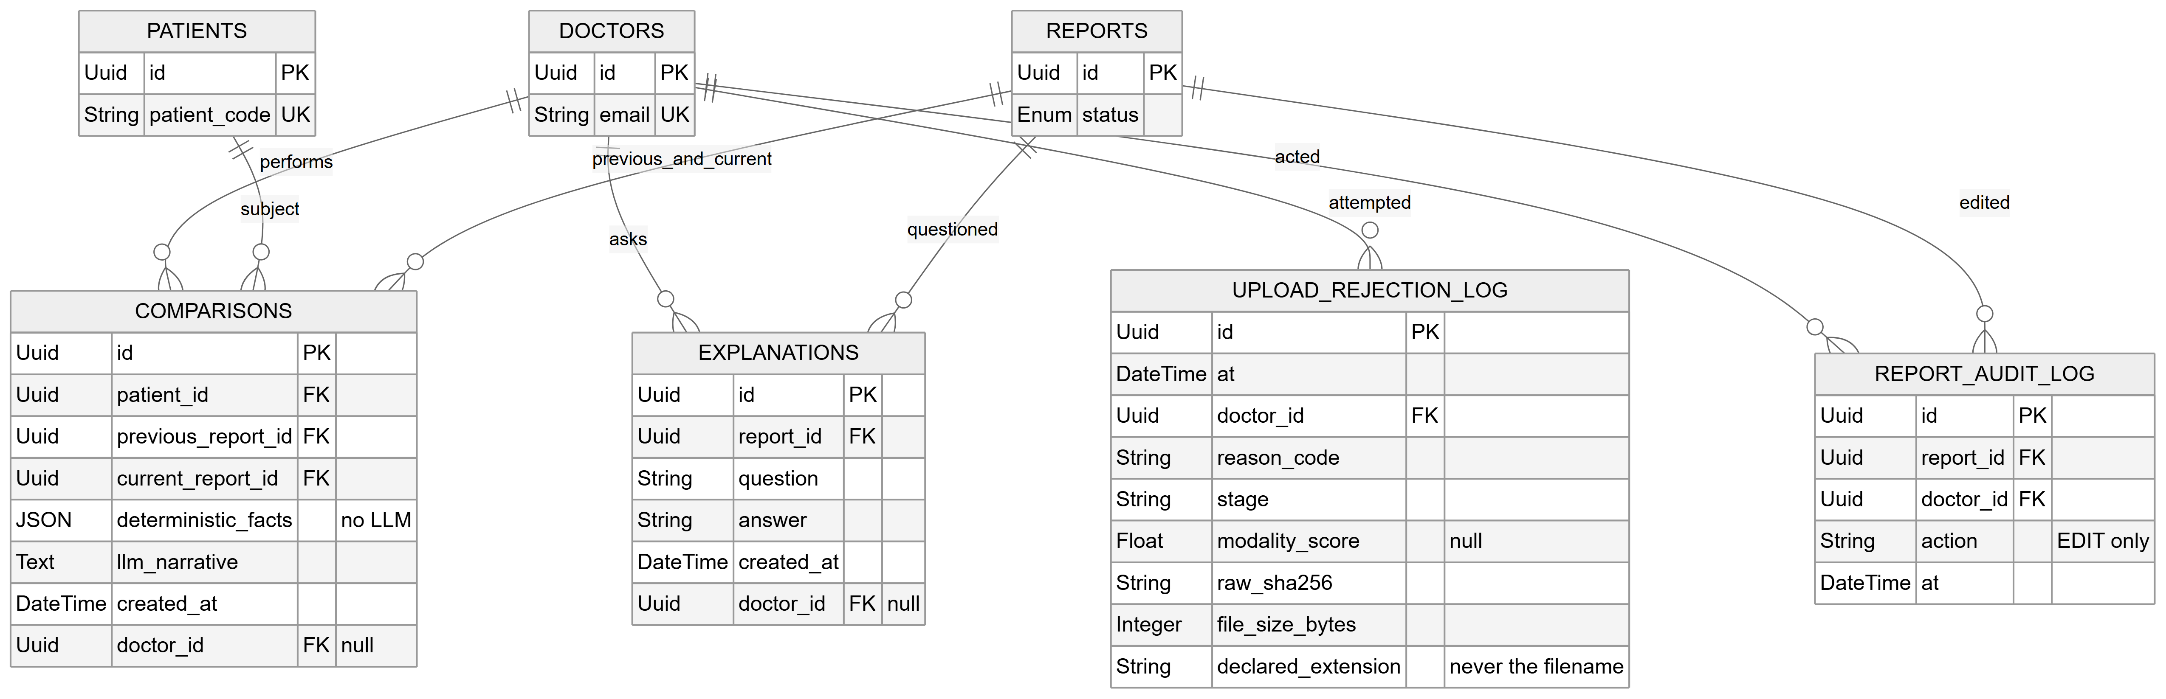
Figure 4.9: Entity relationships, part 2: the four satellite tables — comparisons, explanations, the report audit log and the upload rejection log. The three core tables are repeated with key columns only, as join anchors.
Source: thesis final report/03_diagrams/07b_er_diagram_satellites.png, same derivation as Figure 4.8.
Nine tables, reached through fifteen linear migrations. Three properties of the schema encode design decisions rather than mere structure.
- retrieved_evidence.similarity is the only place the real ranked similarity survives. It is not a cache of something re-derivable — it is the measurement, for the reason given in §4.2.5.
- NULL and the empty list mean different things, and the migration made the consistency columns nullable specifically to preserve that distinction. An empty violations list means checked and clean; NULL with an empty checks-run list means we know zero checks were applicable, which is the state a Bengali report is in; NULL on both means the checker raised and nothing is known. Writing an empty list for a Bengali report would assert it had been examined and found clean — exactly the false assurance the design forbids.
- doctor_id is nullable on every work table, because each of those columns was added by a later migration to a table that already held rows and no backfill was performed. This is why the ownership check treats a NULL owner as owned by nobody, editable by nobody rather than as an error.
Why two stores rather than one. SQLite holds the relational records; ChromaDB holds the vectors. The two answer different questions and have different lifecycles. The vector store is a rebuildable derived artefact — it was built once from the embedding cache in 1.03 seconds and can be rebuilt from the same inputs at any time — whereas the clinical records are the system’s durable state and must survive any re-indexing. Keeping them apart means the knowledge base can be replaced, re-embedded or extended without touching a patient record. It also keeps the specialised index in the tool built for it: approximate nearest-neighbour search over 512-dimensional vectors is what ChromaDB does, and the relational store is not asked to do it.
Why SQLite rather than the MongoDB proposed in P2. The data is unambiguously relational — a doctor owns sessions, a session yields evidence rows and a report, reports carry explanations, comparisons and audit rows, and ownership and foreign keys are enforced across those relations. A document store would have to reconstruct those joins in application code. SQLite additionally requires no server process, which matters directly for a design whose deployment claim is that a facility can run it on one machine. The cost is recorded rather than glossed: SQLite is single-writer and this deployment is single-process, so a multi-user installation would need a server-backed database, which is noted as a deployment decision deferred to later.

4.2.7 Interface design
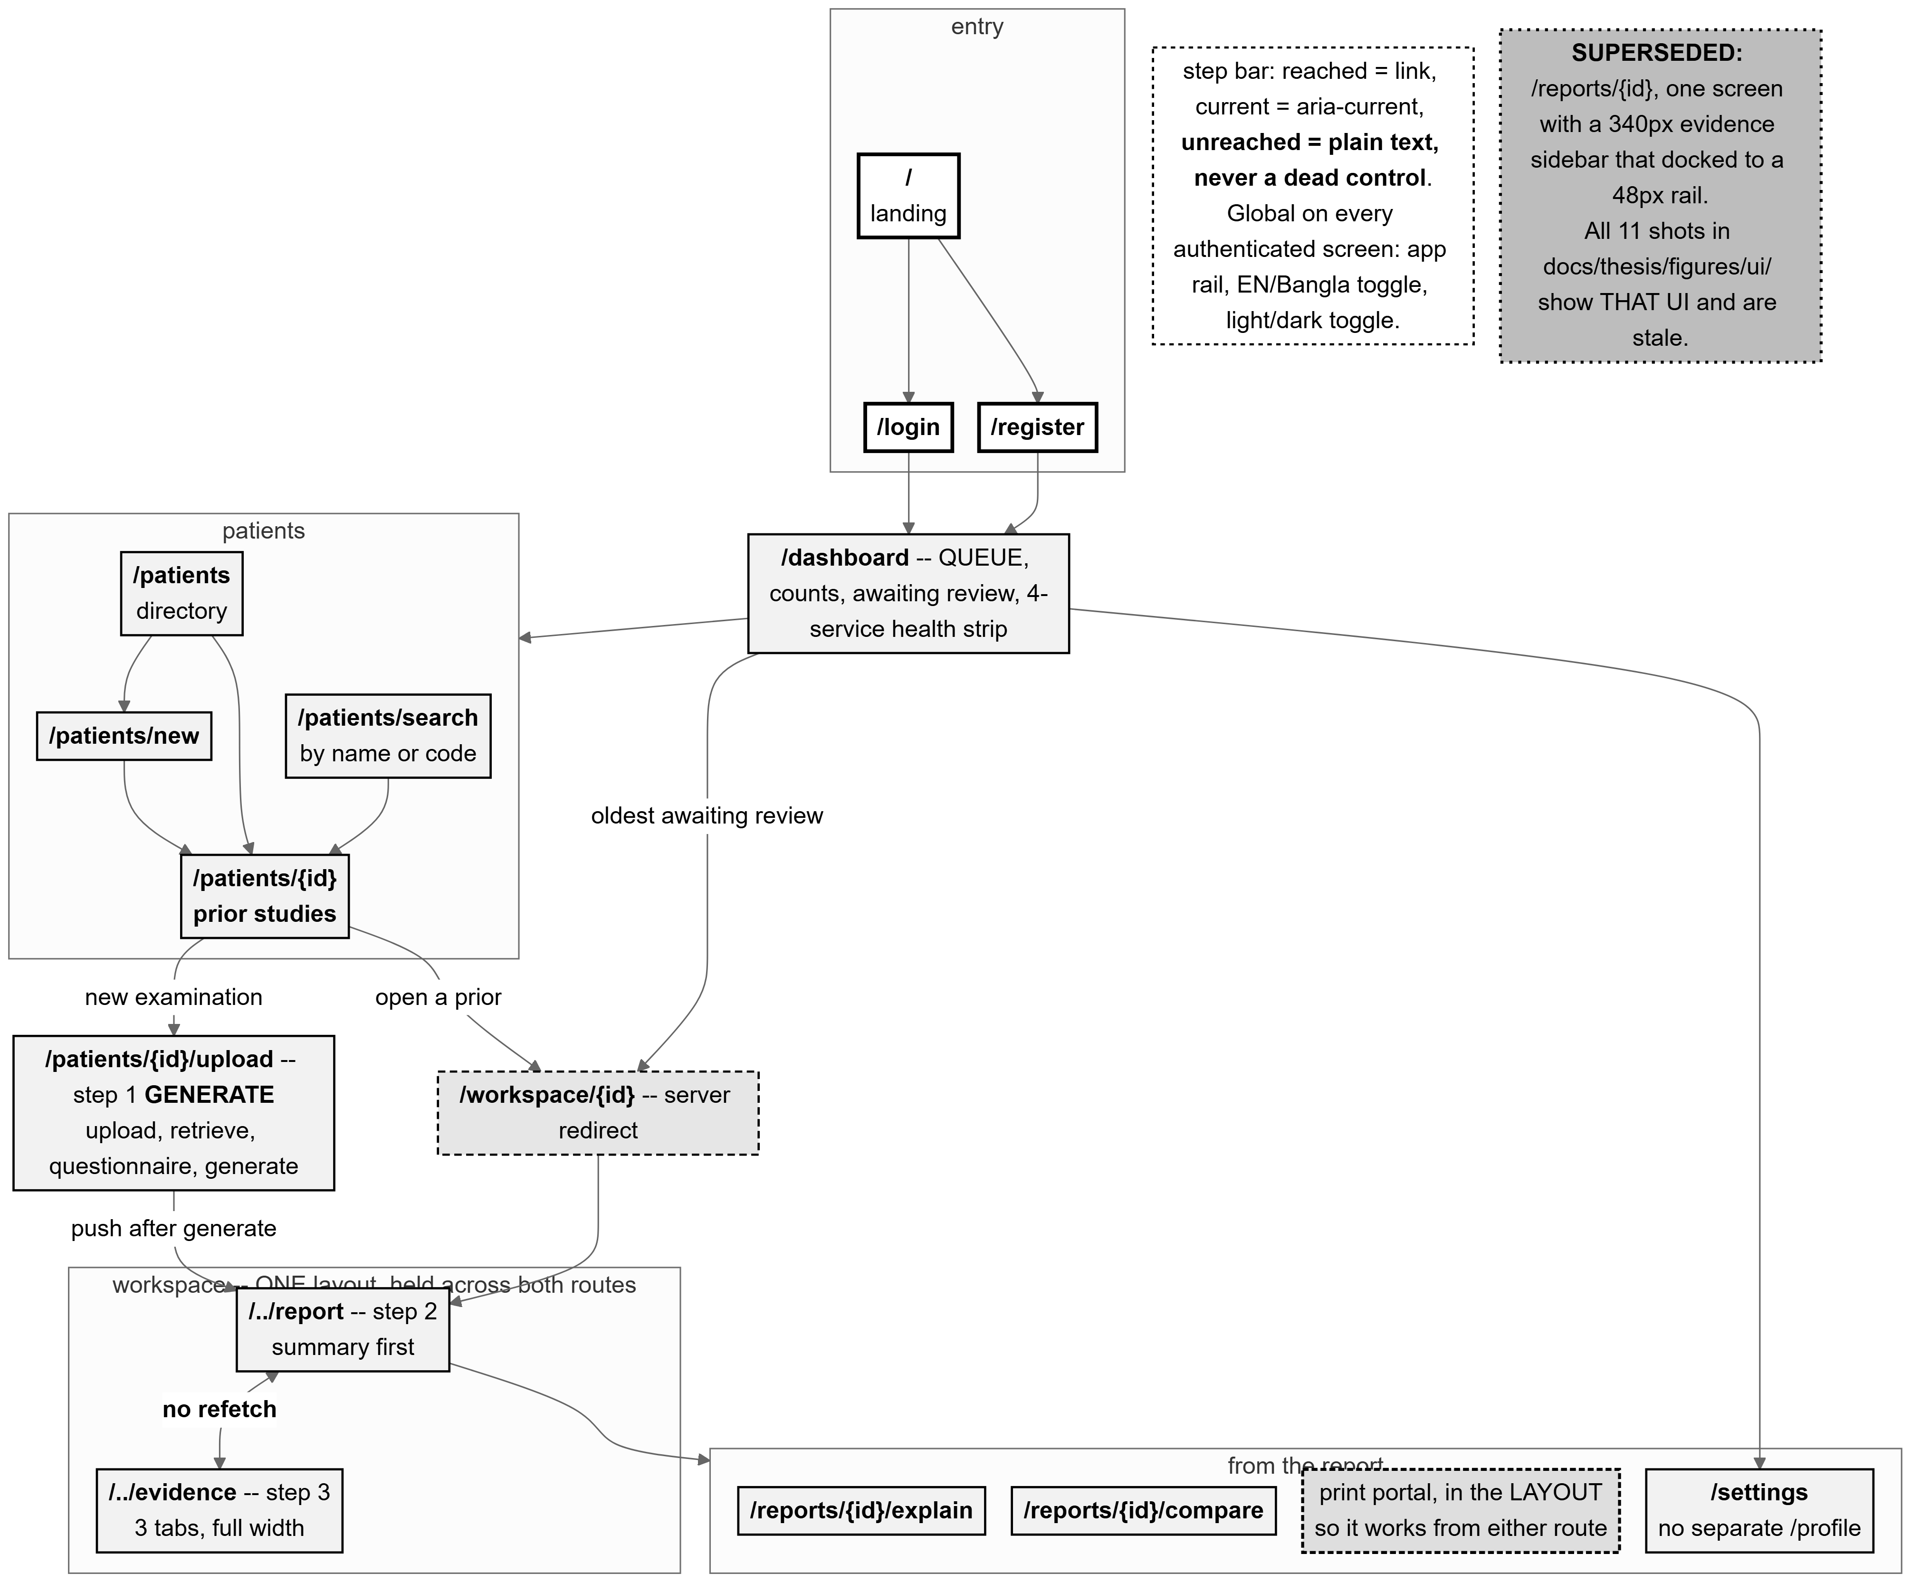
Figure 4.10: The page-based flow across all 15 frontend routes, with Generate → Report → Evidence at the centre. The dashed box records that the earlier single-screen workspace is superseded.
Source: thesis final report/03_diagrams/09_page_flow.png, derived from frontend/src/app/**/page.tsx and commit a8252e09.
The workspace was originally one screen doing three jobs: a film column, a report column and an evidence sidebar, competing for the same width. The evidence lost that competition twice, and was twice given more aggressive collapsing behaviour in response — treating a symptom. The screen was carrying more than one screen’s work, and it is now three routes: Generate, at the patient’s upload flow; Report; and Evidence, full width with three tabs.
Four design principles govern the interface, and each is enforced structurally rather than by convention.
- Evidence is visible, and reaching it costs nothing. The Evidence page fetches nothing at all: every value on it comes from the report object the segment layout already holds. Moving between Report and Evidence fires no request — not because a cache answers it, but because nothing asks again. A cache would satisfy this conditionally, correct until invalidated wrongly; hoisting the fetch into the layout satisfies it unconditionally, because the child routes have no loader to call.
- Warnings are never hidden. The impression, the recommendation, the validation block and the consistency verdict render outside the collapsible disclosure in every state, and four conditions force the disclosure open and disable its own control: a section being edited, a regeneration in flight or awaiting a decision, the finalize preview, and printing. A disclosure may cover context; it may never cover a conclusion or an alert. The invariant is asserted by test, because layout invariants rot quietly.
- An unchecked state never looks like a pass. The four consistency states are rendered by four separate components, deliberately not by one component parameterised by a colour lookup — because the parameterised version is the one in which a later edit silently gives the not-run state the pass treatment. partial is styled with not_run, not with clean, because it is closer to the former in what it licenses a reader to conclude.
- The human decides, and the printed document proves it. The printout is a second render built from the canonical seven-field list, not the screen re-styled by a print stylesheet — so a collapsed disclosure cannot produce a report that silently prints five sections short. The component takes no collapsed parameter and a test asserts its arity so that none can be added. The signature block prints only on a finalized report, because a draft is not a signed document.
Two further properties were verified rather than assumed. Bengali printing was proven by rasterising the page and looking at it, not by counting characters: a missing font subset produces empty boxes while leaving the text layer perfectly intact, so a character count would pass while the page was unreadable. The measured result was 9 sections and 781 Bengali codepoints with conjuncts correct and no missing glyphs. And the no-refetch guarantee was proven twice — once by component test and once in a real browser, counting report requests during a Report → Evidence → Report round trip, which recorded zero.

4.3 Alternative Designs Considered and Rejected
Five significant alternatives were considered, and four of them were tested rather than merely reasoned about. This section states what each alternative was, how it was verified, and what decided it.

4.3.1 Classification (DenseNet121) versus retrieval
The P1/P2 proposal specified a DenseNet121 classifier as the core of the pipeline, with its predicted disease labels driving report assembly and one of its feature layers serving as the retrieval embedding. The delivered system contains no classifier.
How it was verified. Phase 0 compared four encoders under an identical image-to-image retrieval protocol: BiomedCLIP, a generic CLIP, a zero-shot DenseNet121 feature extractor, and an empirical random baseline. The knowledge base was the training split and the queries the validation split, with relevance defined by graded label overlap and decided by class-stratified paired bootstrap confidence intervals.
What decided it. DenseNet121 reached macro Recall@5 of 0.5127 and nDCG@10 of 0.1324, against BiomedCLIP’s 0.5875 and 0.1745. Notably, DenseNet121’s Recall@5 was below the random baseline’s 0.5155, which is the clearest possible statement that ImageNet features are not informative for this retrieval task. The full table and the three pre-registered gates are in §6.2.
The proposal’s own evidence pointed the same way, and this report corrects its record. The P2 report trained DenseNet121 over four epochs on a 1,000-image labelled subset and reported training accuracy climbing from 43.03% to 94.45% while validation accuracy stayed near 55% — textbook overfitting on an imbalanced subset. Two corrections to that record are made here. First, P2’s narrative text states a maximum validation accuracy of “51.91%”, which contradicts its own results table, where the highest validation accuracy is 55.91% at epoch 1; the table value is correct and the narrative figure appears to be a transposition. Second, P2 gives the dataset size inconsistently as both 7,265 and 7,625 images; the actual figures, counted from the source files, are 3,851 studies and 7,466 image rows. Section 4.4 gives the corrected dataset counts in full.
The design consequence goes beyond the score. A classifier trained on 1,000 hand-labelled images of an imbalanced 12-class subset would have been the system’s accuracy ceiling and its least inspectable component. Retrieval removed both problems at once: nothing is trained, so there is no overfitting to a small labelled subset, and the output is a set of real cases rather than a probability vector.

4.3.2 Evidence modes: how much retrieval actually helps
Having chosen retrieval, the design question became how much of the retrieved material should reach the model. Three arms were defined, differing only in what the context builder assembles: arm A with no retrieval-derived evidence, arm B with the voted labels only, and arm C with the full evidence text — the production configuration.
Arm B is the critical comparison and must be described precisely: it is retrieval-as-classifier, never “no retrieval”. Retrieval still executes in arm B; only its output is reduced to labels. Arm B is therefore the modern equivalent of the classify-then-template approach this project abandoned after Phase 0, and C−B is the direct empirical test of the retrieval-augmented design against a classification-based one.
What decided it, and it did not decide cleanly. The pre-registered primary endpoint — clinical label macro-F1 on the impression, C−B — did not clear, at either sample size: +0.0256 with a 95% interval of [−0.0198, +0.0710] at n=477. Every secondary contrast did clear, some by large margins. The design was retained on that secondary evidence while the primary endpoint remains unproven, and §6.4 reports this at exactly that strength.

4.3.3 Model and prompt variants
Two levers were tested against the incumbent design in a pre-registered experiment on a development set held separate from the test pool: a larger model (14 billion parameters against the incumbent’s 8 billion), and an explicit label checklist instructing the model to disposition every retrieved label. Four variants were run over 150 development cases each, 600 generations in total.
What decided it. The incumbent won 23 of 24 accuracy cells, and the single exception was a findings macro-precision lead of 0.0008 — far inside noise, on the section the checklist does not target. The larger model was worse on every accuracy metric while costing 61% more latency and 4,276 MiB more VRAM, and both of its arms reintroduced self-contradiction that neither incumbent arm produced. The checklist was therefore not adopted, and its configuration flag ships set to false; with the flag off, the prompt is byte-identical to the evaluated one. Section 6.6 gives the results and the limitation that bounds them.

4.3.4 Server-side PDF versus browser print
The workspace originally carried a disabled control labelled “Download PDF” — a control naming a capability the system did not have, greyed out so the promise was not actionable. A real server-side PDF pipeline requires a renderer, a template language, a document store and a server-side Bengali font stack, the last being the genuinely hard part. The alternative chosen was the browser’s own print engine, which reaches paper without any of that.
The design decision inside that choice is the more interesting one: the printed page is a second render rather than a print stylesheet over the screen. A stylesheet would make the printout’s completeness a function of interface state — one stale selector after a future layout change and a report silently prints five sections short, with nothing to indicate it. Building the document from the canonical field list makes completeness a property of the markup. The honest limitation is carried in the control’s own label, which reads “Print / Save as PDF (browser)”: the file is produced by the browser, not by this system.

4.3.5 Image explainability, deferred
A saliency map over the radiograph was specified in P2 and deliberately not built. The reasoning is given in full in §3.8.5; in summary, this project has no localisation ground truth against which such a map could be validated, and an unvalidated localisation displayed beside a validated evidence panel would invite exactly the wrong distribution of trust. What ships instead is the retrieval evidence itself, which is a record of provenance rather than an inference.
Table 4.3: Alternative designs, how each was verified, and what decided it.
Source: This report, §4.3 and Chapter 6.
Alternative | How verified | Decision and evidence
DenseNet121 classification | Phase 0 four-encoder bake-off with pre-registered gates and bootstrap CIs. | Rejected. R@5 0.5127, below the random baseline’s 0.5155 (§6.2).
Generic CLIP encoder | Same bake-off. | Rejected. Beaten on nDCG@10 with the CI excluding zero; the Recall@5 comparison was inconclusive and is reported as such.
Labels-only evidence (retrieval-as-classifier) | Phase 21 three-arm ablation, paired, pre-registered primary endpoint. | Rejected on secondary evidence; the primary endpoint did not clear (+0.0256 [−0.0198, +0.0710]) (§6.4).
A larger (14B) language model | Phase 23, 150 dev cases, mechanical selection rule fixed in advance. | Rejected. Worse on every accuracy metric; +61% latency, +4,276 MiB VRAM (§6.6).
Explicit label checklist in the prompt | Same experiment. | Rejected. No accuracy gain; more asserted labels without more correct ones. Flag ships false.
Server-side PDF export | Design analysis; not built. | Rejected on scope, with the limitation carried in the control’s own label.
Image saliency explainability | Design analysis; not built. | Deferred on ethical grounds — no localisation ground truth exists to validate it (§3.8.5).
MongoDB | Design analysis. | Rejected. The data is relational and enforced as such; SQLite needs no server process (§4.2.6).

4.4 Dataset and Preprocessing

4.4.1 Provenance and licence
The dataset is the IU/Indiana chest X-ray collection, a publicly available corpus of chest radiographs paired with their real radiology reports, already de-identified at the report level — redacted spans appear as placeholder tokens in the text. It was chosen because it provides both images and reports, which is what a retrieval knowledge base of real reports requires. [TO CONFIRM: no licence text, DOI or formal citation for this dataset is recorded anywhere in this project’s repository; see §3.3.3.]

4.4.2 Counts after every filtering step
The counts below are the real ones, counted from the source files. They correct the P2 report, which gave the dataset size inconsistently as 7,265 and 7,625 images and did not distinguish studies from images at all — a distinction that matters, because a study may contribute several views and treating images as independent units is precisely the leakage hazard §4.4.4 addresses.
Table 4.4: Dataset counts after each filtering step.
Source: 01_facts/thesis_facts.md §2, counted from the source CSVs and master_metadata.csv.
Stage | Count | Note
Unique studies in the source reports file | 3,851 | The true study-level unit. One row per study.
Image rows in the source projections file | 7,466 | 1–4 images per study, mostly frontal + lateral pairs.
Studies with at least one frontal view | 3,689 | 162 studies have no frontal view and cannot be used: the system is frontal-only.
Studies excluded by quality flag | 84
Frontal images with ≥ 1 PHI region masked | 2,875 of 3,689 (77.9%) | 4,278 regions in total; mean 0.43 s per image.
Studies with a cached embedding | 3,609 | The usable corpus: non-flagged, frontal, embedded.
— of which train / val / test | 2,462 / 576 / 571 | The embedded subset per split.
Documents indexed in the vector store | 2,462 | Training split only. Verified by an independent count after insertion.
Evaluation-eligible test cases | 477 | Frontal, with real findings and real impression — the only two fields with genuine ground truth.
Two exclusions deserve explanation. Findings text is missing on 514 studies and both fields on 25; such studies are kept in the retrieval knowledge base, where their impression still carries evidence, but excluded from generation-quality evaluation, where a missing reference field would make a score meaningless. And of the 595 raw test-split studies, the evaluation-eligible pool is 477: 85 lack findings only, 9 lack both, and — a detail worth noting — none lacks the impression only.

4.4.3 The curated label taxonomy
The dataset carries disease terms already, but as raw automatic medical-subject indexing: real finding terms mixed with bare anatomy (Lung, Spine, Aorta), administrative tags (No Indexing, Technical Quality Unsatisfactory) and device descriptors. This is not usable as a label matrix without curation, so 18 clinically meaningful classes were curated from it: finding terms were mapped to classes (for example, opacity, infiltrate and consolidation all to Lung Opacity), bare anatomy and administrative tags were dropped, and genuinely pathological but rare terms — sarcoidosis, tuberculosis and others, each with no more than seven instances — were routed to Other Abnormality and logged for review.
Two properties of this taxonomy matter. It is fully data-driven: the mapping lives in a versioned configuration file and the code is agnostic to its contents, so changing the taxonomy requires no code change. And it carries a standing caveat: it is a clinical input that has never received the clinically-informed review it was always stated to need (§3.5.2, §3.8.4).

4.4.4 Near-duplicate audit and leakage-safe splitting
This is the load-bearing preprocessing decision, and it defeats two distinct leakage hazards.
View-pair leakage is handled by indexing at study level — one row per study — so a study’s frontal and lateral views can never land on opposite sides of a split.
Template leakage is the harder one and is specific to this corpus. Chest reports for normal studies are frequently near-identical in wording, and such reports carry different study identifiers, so a study-level split would cheerfully place a report and its near-twin on opposite sides of the train/test boundary — after which the system would appear to retrieve a strikingly good match for a test case it had effectively already seen. The audit measured the scale of the problem rather than assuming it: normalised report text was compared by TF-IDF cosine similarity at a threshold of 0.90 and clustered by connected components, finding that 28.2% of studies (1,064 of 3,767) live in a near-duplicate cluster, the largest containing 51 near-identical normal-chest templates.
The consequence for the design is that clusters, not studies, are the atomic unit of the split. Every study in a cluster is assigned to the same split. On top of that, an iterative multi-label stratification assigns clusters so that every one of the 18 classes appears in all three splits, including the rarest — pneumothorax, at 17 / 4 / 4 across train, validation and test. The split is seeded and written once, and every later stage and ablation reuses that same file, so the test set is touched exactly once.
The result is train 2,563 / validation 609 / test 595 studies at study level. Purity was verified directly rather than assumed before any evaluation was allowed to run: the vector store’s actual indexed identifiers and the source embedding cache were each read and cross-referenced against the recorded test identifiers, confirming zero test-split overlap in either. The collection’s own split metadata field was explicitly distrusted for this check, having been confirmed to be a hardcoded literal rather than a per-study value — a check that verified the label rather than the contents would have proven nothing.

4.4.5 What the knowledge base contains
Each of the 2,462 indexed records carries its 512-dimensional image embedding and a metadata block: the study identifier, a synthetic patient identifier, the masked image path, the projection, the primary label and full label set, the cleaned findings and impression text, the dataset name, the embedding model and version, the split, the near-duplicate cluster identifier, and the time it was indexed. Two of these deserve comment. The image path points at the masked file, not the raw one, because that is what was embedded — pointing it at the raw image would mean any future display showed a different image from the one the vector came from, a silent correctness bug. And the findings and impression text is stored in the record itself, so retrieval returns evidence text directly without a second join against the metadata file.
Indexing is guarded by six validation checks that run before any database mutation: that every row is genuinely from the training split, that the metadata identifiers and the embedding cache identifiers are set-equal, that no identifier is duplicated, that no required field is null, that every embedding is 512-dimensional, finite, unit-norm and non-degenerate, and that the collection name is valid. A failure leaves any pre-existing collection completely untouched. After insertion, an independent count must equal the validated input count exactly. The real run indexed all 2,462 records in 1.03 seconds.
This chapter has described the process the project followed, the architecture and the two pipelines at its core, the decision points in its workflow, the data model, the interface principles, the alternatives that were tested and rejected, and the dataset and preprocessing that produced the knowledge base. Chapter 5 describes how this design was implemented.

Chapter 5 Implementation
This chapter establishes how the design of Chapter 4 was actually built: the environment it runs in, the frontend, the backend — which is the largest body of engineering in this project and is treated at correspondingly greater length — and the testing strategy that holds it together. Every version, threshold and count below was read from the running system or from the source, at commit 99f3eab8 on branch final-prep, and anything the project did not record is marked rather than estimated.

5.1 Development Environment

5.1.1 Host and hardware
Table 5.1: Host environment, read from the running machine on 2026-09-23.
Source: 01_facts/environment.md §1, each value read by the command named there.
Item | Value
Operating system | Microsoft Windows 11 Pro, build 10.0.26200.8655
GPU | NVIDIA GeForce RTX 4070 Ti SUPER, 16,376 MiB
NVIDIA driver | 591.86
CUDA (as torch was built against) | 12.1; available at runtime: True
CUDA toolkit installed system-wide | NOT RECORDED — no compiler version is pinned anywhere; torch ships its own runtime.
git | 2.54.0.windows.1
One deployment caveat is recorded rather than glossed over: the repository’s line-ending configuration names a Linux deploy target, but every measurement in this project was taken on the Windows host above, and no Linux run of this system is recorded anywhere.

5.1.2 Runtimes and models
Table 5.2: Runtimes, with the command each version was read by.
Source: 01_facts/environment.md §2.
Runtime | Version | Read by
Python (main environment) | 3.12.3 | .venv/Scripts/python.exe -V
Python (frozen evaluation environment) | 3.12.3 | that environment’s own python -V
Node.js | v24.18.0 | node -v
npm | 11.16.0 | npm -v
Ollama | 0.34.3 | ollama --version
A version discrepancy is reported rather than corrected away. Ollama is 0.34.3 on the machine today, but every Phase 22 number was produced under 0.34.2, which was the version at the Gate A run. Both are stated; neither is silently harmonised, because a reproduction attempt needs to know which one produced the results.
Table 5.3: Models: identity, quantisation and licence.
Source: 01_facts/environment.md §3; thesis_facts.md §6.
Role | Model | Identity and settings
Generation | llama3:8b | Ollama digest 365c0bd3c000, 4.7 GB on disk, 8.0B parameters, quantisation Q4_0, model context length 8192. Licence: Meta Llama 3 Community License, shipped inside the model.
Generation (tested, rejected) | qwen2.5:14b | Digest 7cdf5a0187d5, 9.0 GB. Lost to llama3:8b on all twelve accuracy cells in Phase 23 (§6.6).
Image embedding | BiomedCLIP | hf-hub:microsoft/BiomedCLIP-PubMedBERT_256-vit_base_patch16_224; 512 dimensions; runtime open_clip_torch 3.3.0. Its learned logit scale, 85.2322769165039, is reused as the modality gate’s softmax temperature. Licence: NOT RECORDED in this repository.
Clinical labelling | CheXbert | chexbert.pth, 1,314,414,442 bytes, 14 condition heads, max length 512, batch size 16. Lives in a cache outside the repository and must never enter it — Stanford Docket S20-295 forbids redistribution.
PHI detection | EasyOCR 1.7.2 | PyTorch-native, chosen to avoid adding a second deep-learning framework to the stack.
The generation call settings all come from one configuration module: temperature 0.0, seed 42, keep-alive 30m, request timeout 120 s. One correction to the project’s own fact sheet is recorded here: num_ctx 4096 is not set by this codebase. The client sends only temperature and seed, and a repository-wide search finds no occurrence of the parameter in the backend. 4096 is Ollama’s own default, and the run plan states as much. This matters because a reproduction that set the value explicitly would not be reproducing what was measured.

5.1.3 The frozen evaluation environment, and why it exists
Two CheXbert runtimes exist and they are deliberately not interchangeable. The evaluation path runs inside a separate, frozen virtual environment (torch 2.6.0 CPU, transformers 4.46.0) and produced every Phase 20, 21, 22 and 23 number in this report. The runtime adapter runs in the main environment (torch 2.5.1+cu121) and serves only the live consistency check; it has never produced an evaluation number.
The separation exists for a specific reason rather than for tidiness. A security mitigation in the tokeniser library requires a newer torch than the main environment can take, because the main environment is pinned to the torch version the frozen encoder needs. Upgrading production torch to satisfy the evaluation tool would have disturbed the encoder that every embedding in the knowledge base was computed with. Isolating the evaluation instrument instead means one unchanging instrument measured every phase, which is what makes cross-phase statements about the instrument meaningful even though results are never pooled across phases. A second real defect surfaced during that isolation — an overflow arising from a newer tokeniser meeting an unbounded length sentinel — and was fixed by pinning the library version inside the isolated environment only.
The two runtimes must nonetheless agree on labels, and that was proven rather than assumed: 954 of 954 token sequences identical, and 0 of 13,356 label cells mismatched on CPU and 0 of 13,356 on CUDA. The adapter disables TF32 inside its inference context, because the output is an argmax over four logits and reduced precision flips near-ties.

5.1.4 Package versions
Table 5.4: Key package versions, read from the running interpreter via importlib.metadata.
Source: 01_facts/environment.md §4 and §5.
Backend | Version | Frontend | Version
fastapi | 0.139.0 | next | 16.2.10 (exact pin)
uvicorn | 0.51.0 | react / react-dom | 19.2.4 (exact pins)
pydantic / pydantic-settings | 2.13.4 / 2.14.2 | tailwindcss | ^4
SQLAlchemy | 2.0.51 | typescript | ^5
alembic | 1.18.5 | vitest | ^4.1.10
chromadb | 1.5.9 | @testing-library/react | ^16.3.3
torch / torchvision | 2.5.1+cu121 / 0.20.1+cu121 | jsdom | ^30.1.1
open_clip_torch | 3.3.0 | openapi-typescript | ^7.13.0
transformers | 5.13.0 | clsx / tailwind-merge / diff | ^2.1.1 / ^3.6.0 / ^9.0.0
easyocr | 1.7.2 | eslint / eslint-config-next | ^9 / 16.2.10
argon2-cffi / PyJWT | 25.1.0 / 2.13.0
numpy / pandas / scipy | 2.5.1 / 3.0.3 / 1.18.0
pytest | 9.1.1
Reproducibility is qualified on both sides, and the qualification is stated rather than implied. On the Python side there is no lockfile: a requirements file exists but does not pin the backend stack, so the table above is the installed truth read from the running interpreter, and a fresh install from that file is not guaranteed to reproduce these versions. On the frontend, only next, react and react-dom are exact pins; everything else is a caret range, so the lockfile is the authority for an exact reinstall. One further note is recorded because it corrects a plausible assumption: python-jose is not installed — the JWT implementation is PyJWT.

5.1.5 Deployment and repository layout
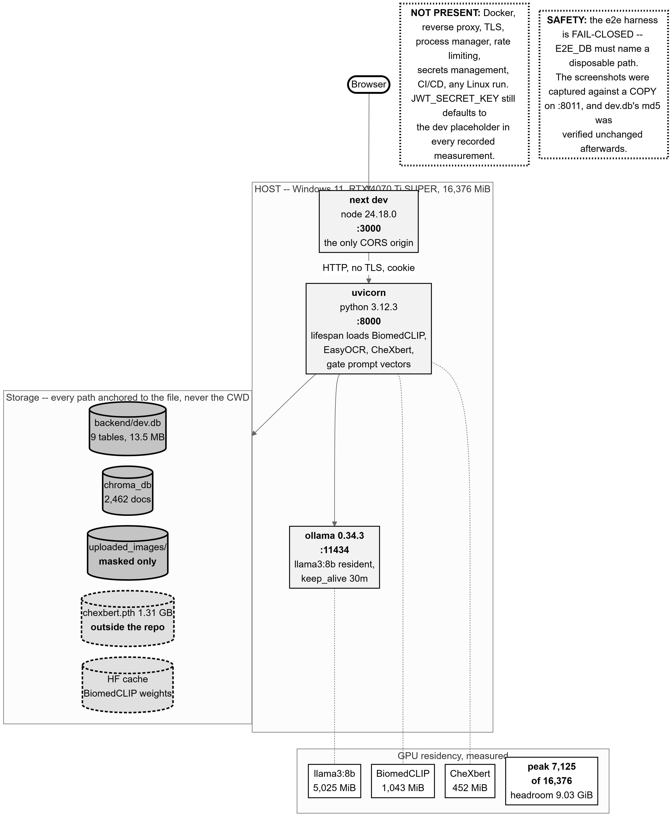
Figure 5.1: Local deployment: three processes started by hand on one Windows host, with their ports, GPU residency and storage locations. The warning boxes list what this deployment does not have.
Source: thesis final report/03_diagrams/08_deployment.png, derived from backend/app/main.py:106-269, core/config.py:22-145 and live readings taken 2026-09-23.
Table 5.5: The three processes and their ports.
Source: 01_facts/environment.md §7; 03_diagrams/08_deployment_caption.md.
Process | Runtime | Port
Next.js dev server | node v24.18.0, next 16.2.10 | 3000
FastAPI / uvicorn | python 3.12.3, uvicorn 0.51.0 | 8000 (8011 and 8021 were used for evaluation and screenshot capture)
Ollama | 0.34.3 | 11434
The frontend must be served from port 3000, because the CORS allowlist holds exactly one origin and the configuration wraps a single string in a one-element list. Served from anywhere else, every preflight returns 400 and the interface reports a failure that does not name the real cause. This was hit for real during screenshot capture and is recorded as a known defect.
Every path is anchored to its own file’s location rather than to the process working directory, after a real incident: a stray directory change produced an empty vector store in the wrong place instead of failing loudly. One related defect survives and is recorded rather than fixed, because the phase in which it was found forbade code changes: the vector store adapter carries its own default path and is constructed with no argument, so the configured persist path is declared, documented and never read. The two values happen to be identical today, so nothing is broken — but the setting is not the thing in control, and no environment override can redirect the store.
The repository layout is ml/ for the research pipeline, backend/ for the FastAPI application, frontend/ for the Next.js application, shared/ for the two genuinely cross-cutting modules, docs/ for the architecture and methodology record, and e2e/ for browser harnesses. ml/ and backend/ never import each other; shared/ is the single deliberate exception, holding the embedder and the masker so that the offline pipeline and the live query path use one implementation. [TO CONFIRM: the repository’s own README.md and CLAUDE.md both describe layouts that no longer match it — the latter states that backend/ and frontend/ do not exist in this copy, when all three do, along with e2e/. The drift is recorded as a defect in the record; the layout above was verified directly on 2026-09-23.]
What the deployment does not have is part of its description: no container images or compose file, no reverse proxy, no TLS, no process manager, no rate limiting, no secrets management and no CI/CD. Starting the system is a manual three-process procedure.

5.2 Frontend Development

5.2.1 Stack and rationale
The frontend is Next.js 16.2.10 with React 19.2.4, TypeScript and Tailwind CSS 4. Two properties of this choice did real work rather than being defaults. The App Router’s segment layouts are what make the no-refetch guarantee structural rather than cached (§5.2.3). And server-side rendering of the theme and language cookies is what prevents a full-screen flash of the wrong palette or language on every navigation — the server layout reads those cookies before first paint.
The type boundary between frontend and backend is handled without violating the rule that the two never share code: TypeScript types are generated at build time from the backend’s own OpenAPI schema, output into a generated directory and never hand-maintained. The generated file is the contract, and regenerating it is how a backend change reaches the frontend’s type checker. During the final UI phase the generated types were suspected of being stale and were regenerated from the running backend; they came back byte-identical, which located the real gap precisely — the types already carried the consistency block, and the defect was that nothing rendered it.

5.2.2 The page-based flow
The workspace is three routes — Generate → Report → Evidence — joined by a step bar that doubles as the way back. Two findings settled the route design before any code was written, and both are worth recording because they were constraints discovered rather than preferences chosen.
First, the workspace identifier had to be the report identifier, not the session identifier. The brief specified otherwise, but there is no session-to-report lookup anywhere in the API: the report list item carries no session identifier, and the only session-keyed endpoints serve the image and the questionnaire. With the backend off-limits under the code freeze, the question “does a report already exist for this session?” is unanswerable from a session identifier. Generate therefore stays on the patient’s upload route — which already owns the image, the questionnaire and the pipeline states — and is step one of the breadcrumb. The URL space is consequently not uniform across the three steps, which is recorded as a limitation.
Second, a library was importing from a route file: production code pulled a field-list constant out of a page module, which is backwards and had a visible cost — two test files could not import what they wanted to assert on, because loading that module pulls in the router, so they read the route file as text and matched substrings instead.
The old workspace URL redirects permanently rather than 404-ing, and the reason is specific: that URL appears in screenshots, in working notes and possibly in this report. A 404 on a URL printed in a thesis is not a broken link, it is a broken citation.

5.2.3 State management and the single-fetch layout
The requirement was that moving between the report and its evidence must not refetch the report. That was not merely unimplemented — it was contrary to how the application worked, since the explain and compare routes each independently refetch.
A workspace provider mounted in the segment layout owns the fetched report, every mutation handler, the dirty and editing sets behind both unsaved-work guards, and the active evidence tab. Next keeps a segment layout mounted while its children change, so the report is fetched once and both pages read the same object. Nothing is cached; nothing asks twice. The distinction matters: a cache satisfies the requirement conditionally — correct until it is invalidated wrongly, and every mutation is an opportunity to get that wrong — whereas hoisting the fetch into the layout satisfies it unconditionally, because the child routes have no loader to call. The active tab lives there too, because “the tab is preserved on return” is only true if the tab is not owned by the component that keeps unmounting.
The guarantee was proven at two levels, because each proof has a gap the other closes. A component test swaps the provider’s child — which is what the framework does on navigation under a shared layout — and asserts that both the fetch count and a mount counter are unchanged; that proves the provider does not refetch, but cannot prove the framework really keeps the layout mounted across a genuine client-side navigation, which is the assumption the whole design rests on. A browser harness settles that in a real browser, counting report requests from the debugging protocol rather than inferring them, and recorded zero across a Report → Evidence → Report round trip, with the active tab surviving and both back and forward behaving correctly.

5.2.4 The report editor and section regeneration
The report page is summary-first: impression and recommendation, the validation block and the consistency verdict all render before, and outside, a disclosure holding the other five fields. The two field lists are derived by partitioning the canonical seven-field list rather than by being restated, so a field added to the canonical list lands in the full report automatically instead of silently appearing in neither half.
Four states hold the disclosure open and disable its own control: a section being edited, a regeneration in flight or awaiting accept-or-discard, the finalize preview, and printing. That rule lives in its own module with a test per case rather than as a compound condition inside the markup — a safety rule that exists only inside a render is one nobody can point at.
Nothing unmounts on collapse. Children stay rendered and the wrapper is hidden, which removes the content from the accessibility tree and the tab order — which a height-based collapse would not do, leaving a screen-reader user to hear five sections a sighted reader was told are closed. Both halves are asserted, by a fetch spy and a mount counter across repeated toggles, because a fetch spy alone would pass even while the subtree was being destroyed and rebuilt.
Five of the seven fields are editable; examination and disclaimer are set once by the system. Any editable section can be regenerated individually, producing a candidate the doctor accepts or discards, and a word-level diff shows what changed against the AI draft. Editing moves the report to DOCTOR_EDITED; finalizing moves it to FINAL and is a one-way door.

5.2.5 The evidence panel
The evidence page is full width with three tabs — Evidence, Agreement, Alternatives — and fetches nothing at all: every value on it, including the agreement re-derivation and the stored retrieval-support category, comes from the report object the layout already holds. The support category is read as the backend computed it and is never re-derived client-side, so the interface cannot disagree with the stored record.
The panel states its own limits at the point of use, which is a deliberate choice about where a caveat belongs: the agreement display carries the sentence that it measures agreement among retrieved cases and is not a probability that the report is correct, and the below-threshold notice explains that it does not mean no similar case exists, only that none retrieved met the threshold.

5.2.6 Bilingual interface
A global toggle switches the whole interface between English and বাংলা, and new reports are drafted in the selected language. The two dictionaries are held at exact key parity — 412 keys in both — by a script in the build gate, which exists because a missing key does not error: it silently falls back, which is the same class of failure the design-token gate was written to prevent one layer down.
Two honest asymmetries are recorded. Validation warning text is composed by the backend with string interpolation and is never translated, so it appears in English on an otherwise fully Bengali screen — visible in this project’s own screenshot set. And Bengali printing was proven by rasterising the page, not by counting characters: a missing font subset produces empty boxes while leaving the text layer perfectly intact, so a character count would have passed while the page was unreadable. The measured result was 9 sections and 781 Bengali codepoints with conjuncts correct and no missing glyphs, which works because the Bengali font is self-hosted through the framework’s font pipeline with the Bengali subset — a hypothesis until the page was actually rendered.

5.2.7 Accessibility, contrast and design tokens
Colour, spacing and type live in a token file, and a design gate script fails the build on a raw hex literal anywhere outside it — including inside comments, which caught a real instance when a reference stylesheet’s rules were quoted verbatim into a component docstring. The gate also enforces palette parity between the two themes, because a themed token missing from one palette does not error: it silently inherits the other’s value.
Contrast was measured over real composited backdrops rather than quoted from token colours, because a translucent token’s own colour describes a surface nobody sees. Measuring found a genuine defect: the not-run consistency verdict was first styled with a token documented for a 3:1 target and measured 3.83:1 in dark and 4.29:1 in light — below AA for text a clinician acts on. It was changed.
Table 5.6: Measured contrast ratios on the report screen, composited over real backdrops.
Source: development_log.md, 2026-09-23 workspace UI entry. Target 4.5:1 for body text.
Surface | Dark | Light
Body text, report column | 16.49:1 | 17.58:1
Body text, evidence panel | 15.80:1 | 18.55:1
Evidence prose (secondary) | 6.49:1 | 7.41:1
Validation warning text | 9.17:1 | 5.98:1
Consistency — violations | 9.17:1 | 5.98:1
Consistency — clean | 12.26:1 | 6.13:1
Consistency — partial | 15.12:1 | 16.34:1
Consistency — not_run | 7.57:1 | 8.08:1
The light theme is re-derived rather than inverted. It was asked to follow a medical website template, and measuring that template’s own palette against this project’s bar found that six of its eight colour pairs fail — white on its primary button measures 2.90:1 where 4.5:1 is required. The template’s identity was therefore adopted — its hue, its surface model and its button interaction pattern — and its luminance values were re-derived to clear the bar. The detail worth recording is that the obvious fix was insufficient: the template’s own darker green passes as a button fill and still fails at 4.20:1 as text on its own wash, which is only discoverable by measuring the combination the interface actually renders. One colour could not be borrowed at all, because the template has none: amber, for warnings. A clinic brochure has nothing to warn about; a report screen does, and the warning colour cannot share a hue with the primary action or the two things on the screen that mean stop would look like the thing that means go.
One further measurement discipline is worth stating because it prevented a false claim. A 3:1 bar was briefly applied to borders and failed at 1.82:1 — until the palette being replaced was measured on the same pair and came in at 1.59:1. Reporting that as a regression would have been false. Measuring the incumbent, not only the proposal, is what keeps a contrast claim honest.

5.3 Backend Development
The backend is the largest body of engineering in this project: 11,477 lines of Python across 36 service modules, 12 API routers, 9 ORM models, 7 infrastructure adapters and 15 database migrations, covered by 534 passing tests. This section treats it at proportionate length, and every claim in it cites the file, and where useful the line, that proves it. Figure 4.1 gives the layering and Figure 4.7 the generation sequence; this section supplies the detail behind both.

5.3.1 Clean architecture as actually realised
app/api/ transport. FastAPI routers. Validate, call one service,
serialize, map exception -> HTTP status. No medical logic.
app/services/ the application layer. Every rule, every sequence, every
clinical decision. Depends on Protocols, never on adapters.
app/domain/ entities.py (dataclasses + enums) and interfaces.py
(Protocols). Depends on NOTHING in this codebase.
app/infrastructure/ adapters to the outside world: ChromaDB, Ollama, CheXbert,
BiomedCLIP, PyJWT, Argon2. Each satisfies one Protocol.
app/models/ SQLAlchemy ORM. Persistence shape, deliberately separate
from domain entities.
Dependencies point inward only. The interfaces module is 396 lines containing 21 runtime-checkable Protocol classes and nothing else, and its own docstring states the rule: services depend on these, never on concrete implementations.
Table 5.7: The 21 Protocol interfaces and what implements each.
Source: 02_backend/backend_architecture.md §1.1, from backend/app/domain/interfaces.py.
Protocol | Implemented by
IEmbedder | infrastructure/biomedclip_adapter.py → shared/embeddings/biomedclip_embedder.py
IVectorStore | infrastructure/chroma_store.py
IImageValidator | services/image_validator.py
ISimilaritySearchPolicy | services/similarity_search.py
ILabelVoter | services/label_voting_service.py
IContextBuilder | services/context_builder.py
IPromptBuilder | services/prompt_builder.py — six of seven methods; the seventh is deliberately omitted
ILLMClient | infrastructure/ollama_client.py
IStructuralValidator | services/structural_validator.py
ILLMOrchestrator | services/llm_orchestrator.py
IResponseValidator | services/response_validator.py
IReportFormatter | services/report_formatter.py
IQuestionnaireProvider | services/questionnaire_templates.py
IPatientRepository | services/patient_service.py
IDeterministicComparator | services/deterministic_comparator.py
IStudyRepository, IReportRepository | declared; no concrete implementation in this repository
IDoctorRepository | services/doctor_service.py
IPasswordHasher | infrastructure/password_hasher.py
ITokenService | infrastructure/jwt_handler.py
ISectionLabeler | infrastructure/chexbert_labeler.py
IReportConsistencyChecker | services/report_consistency_service.py

Dependency injection: one lifespan, no container
There is no dependency-injection framework. The application lifespan constructs every shared collaborator once per process and attaches it to application state; routes read them from there. What is built once, and why, is itself part of the design: the embedder because it loads a model, the vector store because it opens a persistent client, the masker because it loads the OCR engine, the admission service because every one of its parameters is read from configuration at that single point, and — significantly — the modality gate, because the text prompt vectors are encoded inside its constructor. That constructor line is the prompt-vector cache the design requires; there is no separate caching layer.
Two deviations from that pattern are documented rather than left as inconsistencies. The patient service is not a singleton, because it depends on nothing but a per-request database session, so the routes construct it per request. And the comparison service is deliberately mixed: it takes a per-request patient service and three singletons. Only the database session and two cheap per-request shells are request-scoped.

5.3.2 Every service and its single responsibility
Table 5.8: Services, their single responsibility, and their input and output types.
Source: 02_backend/backend_architecture.md §1.3.
Service | Single responsibility | In → out
ImageAdmissionService | Is this file admissible at all? Checks A1–A17. | bytes, ext → AdmittedImage or raises
ImageValidator | The older path-based file check. | path → None or raises
ModalityGateService | Is this a frontal chest radiograph, and how well supported is it? | vector → float; top1 → RetrievalSupport or raises
RetrievalService | Orchestrate embed → query → select. No logic of its own. | vector, top_k, min_sim → list[RetrievedCase]
SimilaritySearchPolicy | Threshold, then top-K descending. | raw, top_k, min_sim → list[RetrievedCase]
LabelVotingService | Similarity-weighted vote plus per-label agreement. | list[RetrievedCase] → list[VotedLabel]
ContextBuilder | Deterministically organise and partition evidence. No diagnosis, no synthesis. | cases + votes + answers + notes → ClinicalContext
PromptBuilder | Pure text construction. No LLM calls, no parsing. | ClinicalContext, language → str
LLMOrchestrator | Pure sequencing and two independent retry budgets. Zero semantic judgment. | ClinicalContext, language → ReportContent or raises
StructuralValidator | Shape only — the seven marker fields. | raw str → (bool, ReportContent|None, errors)
ResponseValidator | Semantic warnings. Advisory; gates nothing. | content + evidence + votes → SemanticValidationResult
ReportConsistencyService | Does this report contradict itself or its evidence boundary? | content + context + cases + language → ConsistencyResult
render_disclaimer | Server-authored disclaimer from both signals. | agreement + support + sims → str
ReportFormatter | Attach section headers for the language. Pure function; never renders PDF or HTML. | content + language + date → FormattedReport
ReportGenerationService | Sequence the whole generation chain and persist. | session_id, language, … → GenerationOutcome
ReportEditService | Edit, finalize, delete, regenerate — with ownership. | ids + updates → ReportRecord or raises
ReportDetailService | Assemble one report’s read model. | report_id → detail
QuestionnaireService | Pick questions for the top voted label. | session_id → questions
ExplainabilityService | Answer a question about a finished report, on the same evidence. | report_id, question → answer
ComparisonService | Deterministic facts first, then a narrative. | two reports → ComparisonRecord
DeterministicComparator | Label-level deltas. No LLM. | two contents → ComparisonFacts
PatientService / DoctorService / AuthService | Repository implementations and registration/login. | —
UploadAuditService | Write one upload-rejection row. | metadata → row
Dashboard / SystemStats / ServiceHealth | Read models for the three status surfaces. | —
session_reconstruction / report_reconstruction | One shared reconstruction, not two copies that could drift. | session_id → (session, cases, votes)
taxonomy_matching | Word-boundary-safe term matching, shared by validator and comparator. | —

5.3.3 Request lifecycle: POST /retrieve
Table 5.9: The upload lifecycle, step by step, with the point at which control passes on.
Source: 02_backend/backend_architecture.md §2.
# | Step | Where, and what it does
0 | Authentication | get_current_doctor reads the httpOnly cookie, verifies it, and resolves the real doctor record.
1 | Read multipart, drop the filename | _declared_extension() is the only place in the admission path that touches the uploaded file name, and it keeps nothing but the extension — because a filename frequently contains a patient name.
2 | Admission A1–A13 | Extension allow-list, magic-byte sniff, signature-vs-extension agreement, size bounds, verify-then-reopen-to-load, pixel ceiling, dimension bounds, PNG re-encode from the pixel array alone. On failure: an audit row, then 415 / 413 / 422.
3 | Declared projection A14–A17 | Absent ⇒ PROJECTION_NOT_DECLARED; LATERAL ⇒ LateralProjectionError. A17: not masked, not embedded, the vector store is not queried on this path.
4 | PHI masking | Writes straight to its permanent home — one masked artifact, not two copies that could diverge.
5 | Embedding | Embeds the masked file, so the vector the gate judges derives from what the system is willing to store.
6 | Modality gate — BLOCKS | Below 0.60: the masked image is unlinked, an audit row is written, 422 returned.
7 | Retrieval | Route → RetrievalService → ChromaVectorStore → SimilaritySearchPolicy.
8 | Label voting | Similarity-weighted vote over the retrieved cases.
9 | Projection band — BLOCKS | Below 0.8500: masked image unlinked, audit row carrying the modality score, 422 with reason FRONTAL_MISMATCH.
10 | Persistence | One session row plus one evidence row per case, then commit with rollback-and-reraise.
One measurement detail matters for how latency figures in this report should be read: retrieval_time_ms is measured from the masking call to the end of voting — the machine-learning pipeline only. It excludes the upload I/O before it and the database write after it.

5.3.4 Request lifecycle: POST /generate-report
Table 5.10: The generation lifecycle, step by step.
Source: 02_backend/backend_architecture.md §3.
# | Step | Where, and what it does
0–2 | Auth; assemble the service; normalise inputs | The service is a cheap shell assembled per request from singletons plus the session. Inputs are defaulted in the service, not only at the API boundary.
3 | Reconstruct the session | Fetches cases by identifier, then restores the real similarities from the persisted evidence rows — see §5.3.8.
4 | Build context | Sort by descending similarity with a deterministic tie-break, collapse near-duplicates, partition evidence per label.
5 | Build prompt | Nine sections in a fixed order. Called exactly once, structurally guaranteed by having exactly one call site at the top of the orchestrator.
6 | LLM call | Non-streaming POST to Ollama.
7 | Structural validation + content retry | Up to two retries, each with a correction prompt carrying the rejected response and the specific errors.
8 | Semantic validation | Advisory. Produces warnings; gates nothing.
9 | Consistency check | Three checks; observational. Cannot fail the generation.
10 | Support signal | Top-1 read from the persisted evidence by rank, never from the reconstructed cases.
11 | Server-authored disclaimer | Replaces the model’s disclaimer text.
12–14 | Format, persist, respond | One report row; commit with rollback-and-reraise; the response is built from what was persisted.

Three ordering decisions that are load-bearing
- The consistency check sits after semantic validation and before the disclaimer. After the validator, so the validator’s subject remains the model’s clinical claims against retrieved evidence and it is never handed post-processed text; before the disclaimer, so the disclaimer is rendered from the same content the check just judged.
- The disclaimer is rendered after semantic validation on purpose. Handing the validator a server-authored string would be validating this system’s own template output as though it were generated content.
- The report date is generated in the service, not the formatter, so the formatter stays a pure deterministic function.
A fourth detail is small and deliberate: the AI draft and the final content are built by calling the conversion twice, not once with the result assigned to both fields, so that each is a genuinely independent dictionary and no shared-reference risk exists. The edit endpoint is the only thing that ever touches the final content.
The disclaimer must read both signals, and there is a recorded failure behind that requirement. A model-authored disclaimer once read only the agreement score — the real sample was “Clinical uncertainty due to low agreement score (0.60)” — while retrieval support is an independent signal that can disagree with it. The mechanism is spelled out in the gate service: five cases all below the floor can carry the same label, making agreement high while support is low. A disclaimer citing only one of the two would therefore reassure in exactly the case that warrants caution.

5.3.5 Every threshold and configuration value, and how it was chosen
Every behavioural value lives in one configuration module, and each carries its provenance in the source: pre-registered, calibrated, post-hoc revised, or a plain engineering default.
Table 5.11: Gate thresholds, with the rule that selected each.
Source: 02_backend/backend_architecture.md §4.1-4.2; ml/outputs/calibration/v1_1_gate_b_selected_values.csv.
Name | Value | How chosen
MODALITY_THRESHOLD | 0.60 | Calibrated. False-negative budget of 0.02 stated before results were read; frontal false-negative rate 0.0000 at n=300. A value of 0.82 was considered and declined.
PROJECTION_REJECT_THRESHOLD | 0.8500 | POST-HOC REVISED — and must be presented as such. See below.
RETRIEVAL_FLOOR | 0.8906208872795105 | Calibrated, with the rule fixed before the value was computed: the 0th percentile of the frontal calibration set (n=300). Reported as a result: 0 of 300 fall below it — the low-support mechanism is unexercised.
MODALITY_SOFTMAX_TEMPERATURE | 1 / 85.2322769165039 | Not chosen at all — it is BiomedCLIP’s own learned logit scale.
DISCLAIMER_AGREEMENT_THRESHOLD | 0.5 | Stated, not calibrated: a majority of retrieved neighbour cases agree on this label. Deliberately the same number as the validator’s own threshold but declared separately, because they answer different questions and nothing requires them to move together.

The projection threshold revision — post-hoc, and recorded as such
This is the single most important provenance statement in the implementation, and the source itself says so in capitals: the rule was changed after seeing a failing image, and that is recorded rather than presented as a pre-registered choice.
- The old rule was the midpoint of the observed separation gap, giving 0.8695459067821503 (lateral maximum 0.84847092628479, frontal minimum 0.8906208872795105).
- The new rule, revised on 2026-08-19, is just above the observed lateral maximum, giving 0.8500.
- What forced it: a genuine frontal chest radiograph from outside the dataset scored a top-1 similarity of 0.8582 and was rejected as a projection mismatch. It sits above every lateral in the calibration set and below the old midpoint — inside the empty gap the midpoint rule had placed the boundary in the middle of.
- Why the change is defensible rather than merely convenient: the calibration population was single-dataset, this gate’s stated purpose is detecting distribution shift at deployment time, and no observation of any kind lies between 0.84847 and 0.89062 — so moving the boundary to the edge of what was observed removes an unmeasured margin rather than adding one.
- Re-verified on the same 600-study set: 300/300 lateral still rejected, 0/300 frontal rejected.
- The caveat that survives: this is an observed separation point, not a validated frontal/lateral boundary — 300 images of each projection from one dataset, not a universal cosine boundary.
The calibration file still records 0.8695; the configured value 0.8500 supersedes it, and both numbers appear in this report so the revision is legible rather than hidden behind a single current value.
Table 5.12: LLM, upload and check configuration values.
Source: 02_backend/backend_architecture.md §4.3-4.5.
Name | Value | How chosen
OLLAMA_MODEL | llama3:8b | Engineering choice; re-tested in Phase 23 and retained.
LLM_TEMPERATURE | 0.0 | Determinism attempt.
LLM_SEED | 42 | Measured necessity. A report of the same image yields different results was reproduced at this layer: temperature 0.0 with the default random seed produced two different reports from five identical requests.
OLLAMA_KEEP_ALIVE | 30m | Also measured necessity. A cold model produces different (though itself reproducible) wording than a warm one. Both settings are needed, for different halves of the cause.
LLM_CONTENT_RETRY_COUNT | 2 | Frozen in the Phase 7 architecture.
LLM_TRANSPORT_RETRY_COUNT | 1 | Frozen in the Phase 7 architecture.
UPLOAD_ALLOWED_EXTENSIONS | png,jpg,jpeg | Engineering default.
UPLOAD_MAX_BYTES / MIN_BYTES | 20 MB / 20 kB | Engineering defaults.
IMAGE_MIN/MAX_DIMENSION_PX | 256 / 8192 | Engineering defaults.
IMAGE_MAX_PIXELS | 80,000,000 | Decompression-bomb guard, checked at three separate points.
PHI_MASK_MAX_REGION_AREA_FRACTION | 0.08 | Cap on how much of an image masking may cover.
ACCEPTED_PROJECTIONS / DECLARED_* | PA,AP / PA,AP,LATERAL | LATERAL is declarable but not accepted on purpose, so declaring it is a distinct, separately coded rejection rather than an unrecognised value.
CHEXBERT_MAX_LENGTH | 512 | The model’s positional limit. The longest of all 954 real evaluation sections is 298 tokens, so this bound is never exercised.
CONSISTENCY_TEMPORAL_TERMS | 5 frozen terms | The same list the prompt forbids. A prompt banning different words from those the checker seeks would make the measured rate a statement about two unrelated vocabularies.
CONSISTENCY_RETRY_COUNT | 1 | Read by no service. Its only two occurrences in the backend are its declaration and its settings field.
transplant thresholds | not passed at all | Gate B’s to calibrate; passing a number now would be inventing one.
PROMPT_LABEL_CHECKLIST_ENABLED | False | Phase 23’s lever, tested and not adopted. With the flag off the prompt is byte-identical to the evaluated one.
EVIDENCE_MODE | FULL | Arm C, the production arm. Injected from configuration so an ablation arm is a restart, not a code path.
JWT_* | HS256, 1440 min | See §5.3.9.

5.3.6 The validation layers
Three layers inspect a generated report, and only the first can stop one.
Structural validation parses the seven delimiter-marked fields. The marker format itself is a finding: the output format was originally JSON, and 17 of 477 generations failed structurally, all 17 tracing to a single cause — the model inconsistently quoting label names inside the disclaimer field’s JSON string value, which broke parsing at that boundary. Switching to ###FIELDNAME### markers removes the nested-string boundary a stray quote can break, for that field and every other. 1,777 generations since that change have produced zero structural failures.
Semantic validation is advisory by design, and the reason is worth stating precisely. It warns on empty sections, on terms unsupported by the retrieved evidence, and on a top voted label not reflected in the report text. It gates nothing. A validator that blocks must be right; one that advises may be conservative. This one flags terms absent from the evidence, and a correct report may legitimately use a term its neighbours did not — so blocking on it would refuse good reports. Two limitations follow and are recorded: it concatenates findings and impression before inspecting them, so a cross-section contradiction is not representable in it at all, and a transplanted finding is structurally exempt from its unsupported-terms check, because a copied finding is by definition present in the evidence.
The consistency service runs three checks — temporal, transplant and contradiction — and is observational: it records what it found and alters nothing the model wrote. A property asserted by test makes that guarantee concrete: the same fake model output generated with and without the service injected produces byte-identical persisted content and formatted report.
Table 5.13: The four consistency states and what each licenses a reader to conclude.
Source: amendment_01_consistency_status.md §2; frontend/src/components/report/consistency-state.tsx.
State | Meaning | Reachable today?
violations | A check found a problem. The actionable state. | Yes — 17 of 477 in the evaluation run.
partial | Some applicable checks ran and some did not. Not a pass. The label names both halves: Ran: temporal, contradiction. Not run: transplant. | Yes — every English report, 459 of 477.
clean | Every applicable check ran and found nothing. The only pass. | No. Unreachable until Gate B calibrates the transplant threshold, because that check can never be listed as having run.
not_run | Nothing was assessed — a non-English report, or a pre-v1.2 row. | Yes.
The status is derived in one place and is never recomputed independently by the response layer or the frontend, so the generation response and a later read of the same report cannot describe it differently. The set of applicable checks is a function of language alone, never of service configuration — otherwise a report checked by a degraded deployment would compute applicable equal to checks-run and report itself clean.

5.3.7 Error handling, retries, and behaviour when a component is down
Two independent retry budgets exist and they do not interact. The transport retry retries the same prompt once on a connection-level failure, and every real model call passes through it — the initial call, every content retry’s call, the explainability call and section regeneration — so each invocation gets its own fresh budget. The content retry loop runs up to twice on a structural failure, each time building a correction prompt carrying the rejected response and the specific errors; on exhaustion it raises an error carrying the last raw response and the last error list, so the 422 body shows what went wrong rather than a bare status.
What is not recorded (decision D5). The number of structural attempts is never persisted. There is no attempt-count column and no counter written anywhere; the orchestrator keeps the attempt as a loop variable and discards it. The consequence is precise and is carried through every results table in Chapter 6: the evaluation runs can state 477/477 completed, 0 failed and 600/600 completed, 0 failed, but neither can say how many needed a retry. Every “zero structural failures” in this report therefore means zero failed after retries, never zero needed a retry. This decision is open and blocks another (D3), which would have reported the marker-format failure rate per attempt. A known confound is already recorded: attempts after the first use a different prompt, so attempt counts would not be exchangeable observations even once recorded. This decision’s full text exists only in the project chat log of 2026-08-17 and not in any repository document, and is cited as such.
By contrast the consistency retry count is persisted, and is always 0 — because Gate C does not exist. The source states the distinction exactly: Gate A performs no retry, so 0 is a fact about this run, not a placeholder.
Table 5.14: Behaviour when a component is unavailable.
Source: 02_backend/backend_architecture.md §6.3.
Component | Behaviour
CheXbert missing | Startup does not fail. The error is caught and logged as a warning, because running without it is a supported configuration. The contradiction check is dropped, the other two still run, and it is omitted from the checks-run list rather than reported as passing — the gap is recorded rather than hidden. The reasoning is explicit: refusing to boot would take out report generation entirely to protect a warning.
The consistency checker raises | Generation never fails because of it. The handler has no raising path; the worst case is three NULL columns and a logged exception. The catch is deliberately broad and says so: a safety improvement that can take down report generation is a net loss — the doctor loses the report entirely instead of receiving one with an unchecked caveat.
Ollama down, timing out or erroring | Every transport error becomes one project exception → transport retry → HTTP 502. 502 rather than 503 because this server itself is healthy.
ChromaDB collection missing | The adapter fetches the collection in its constructor, which raises at startup. There is no catch: the application will not boot without the collection, and no graceful-degradation path exists.
A study identifier missing from the collection | Silently dropped, deliberately, with the consequence documented: the returned list can be SHORTER than the identifiers requested — which is exactly why similarity restoration is keyed by identifier rather than zipped positionally.
Database commit failure | Rollback, then re-raise, at both write sites.
Table 5.15: Exception to HTTP status mapping.
Source: 02_backend/backend_architecture.md §6.5.
Exception | Status | Exception | Status
UnsupportedImageFormatError | 415 | SessionNotFoundError | 404
ImageTooLargeError | 413 | LLMTransportError | 502
InvalidImageError | 422 | LLMGenerationValidationError | 422 + last response + errors
LateralProjectionError / ProjectionMismatchError | 422, i18n key + reason code, never English text | ForbiddenError | 403
NotAChestRadiographError | 422 | ReportAlreadyFinalizedError | 409
malformed patient identifier | 400 | InvalidTokenError / no cookie | 401
The mapping is written as a table rather than a chain of exception handlers, deliberately: the API layer’s single responsibility is this mapping, and a table makes a missing or duplicated entry visible at a glance.

5.3.8 Caching, session reuse, and what is recomputed
Table 5.16: What is recomputed and what is not.
Source: 02_backend/backend_architecture.md §7.
Item | Recomputed? | Where
BiomedCLIP model | Never — loaded once per process | Lifespan, with a log line asserting it appears exactly once per application lifetime.
EasyOCR, CheXbert | Never | Lifespan. Loading the labeller per request would dominate the ~9 ms the check itself costs.
Modality gate prompt vectors | Never — encoded in the constructor | That constructor line is the cache the design requires.
Ollama model residency | Held by a 30-minute keep-alive on the Ollama side | Because a cold model differs reproducibly from a warm one.
Query embedding | Computed once per upload and reused | The gate must not re-encode, so the route embeds explicitly and passes the vector on.
Retrieved case text | Re-fetched at generation time by identifier | The evidence rows store only identifier, rank and similarity.
Retrieved case similarity | Not recomputed — restored from the persisted rows | Because an identifier fetch reports a sentinel 1.0.
Label votes | Re-voted at generation time, then stored, not re-voted again | The stored votes are the same list the context, the validation and the disclaimer all used.
Retrieval support and top-1 similarity | Stored with the report, not re-derived later | So the evidence state cannot change after the report exists.
Report read in the workspace | Fetched once per visit | The segment layout holds it; Report ⇄ Evidence fires no request.
Language switching | A new generation, not a translation | There is no translation pass — Bengali is generated directly.
The sentinel-similarity defect, and why it is architectural rather than trivial. Fetching cases back by identifier is an unranked lookup, so the store forces a distance of 0.0 and reports a similarity of 1.0 for every case. Three downstream consumers treated that sentinel as a measurement: vote weights collapsed to the plain case count — three cases became “3.00”, printed into the prompt — the context sort degenerated from similarity order to alphabetical identifier order, and the interface showed 100.0% on every case. The real numbers were never lost; they were in the evidence rows all along, read for their identifier and then discarded. The restore is keyed by identifier, never zipped positionally, precisely because the fetch can return fewer rows than were asked for.
A named reproducibility limitation. The session row does not persist the collection name, embedding model or embedding version, so the generation service reads them from the current configuration — the current config, not necessarily what was true at retrieval time. If configuration changes between a session’s retrieval and its later generation, the persisted reproducibility metadata reflects the later configuration.

5.3.9 Security: what is enforced, and what is not

Authentication
- Argon2id password hashing. The salt lives inside the encoded hash string, so the doctors table needs no salt column.
- JWT, HS256, subject is the doctor identifier, expiry 1440 minutes. Every library failure mode — expired, tampered, malformed — is caught under one base exception and re-raised as this project’s own error type, so callers depend on this project’s exception and the token library stays swappable.
- An httpOnly cookie rather than an Authorization header, so the token is inaccessible to frontend JS, mitigating XSS token theft.
- Every protected route resolves the real doctor record, not merely a claim: a validly signed token for a deleted doctor is a 401.

Authorization
Ownership only. There are no roles. The rule is four lines, and edit, finalize, delete and regenerate all call it, so a non-owner is refused deletion exactly as they are refused an edit. A NULL owner fails closed — a pre-authentication report is owned by nobody and editable by nobody. A finalized report is refused with 409 regardless of ownership. Reading is deliberately not ownership-gated: any authenticated doctor may read any report, and the interface shows an owner chip and hides the edit controls.

Upload validation
The thirteen admission checks are described in §5.3.3. The strongest is A12, the re-encode from the pixel array alone: whatever was uploaded, what goes forward is a PNG this process encoded — no metadata, no trailing bytes, no embedded payload. The raw bytes never reach disk; only the normalised PNG is written to a temporary path, and only its masked form survives the request. On a rejected upload both copies are destroyed.
PHI protection here is structural rather than by convention. The filename is read exactly once, for its extension, so nothing downstream — not the audit row, not an error message, not the gate — can leak a patient name that arrived in a filename. Rejection messages carry an i18n key and a reason code, never English prose, so the two languages cannot drift apart through a hardcoded default.

What is not enforced
Table 5.17: Security gaps, stated plainly.
Source: 02_backend/backend_architecture.md §8.4.
Gap | Detail
No roles or RBAC | No role column exists on the doctors table.
No rate limiting anywhere | No middleware beyond CORS.
Default JWT secret in every recorded run | The signing key defaults to the literal string dev-only-insecure-secret-do-not-use-in-production. It is overridable by environment, but no deployment configuration in this repository sets it, and every measurement in this project was taken under that default.
CORS allows credentials from one hardcoded-by-default origin | Local development only, by explicit scope decision.
No HTTPS anywhere | The auth cookie is set insecure in the test harness.
No general audit trail | Only report-edit actions and upload rejections are recorded. No login, read or export events exist anywhere.
Query images stored in the repository | Whether this is compatible with the dataset’s terms is NOT RECORDED.
No LICENSE file for this project | NOT RECORDED.

5.3.10 The API
26 operations, generated from the live OpenAPI schema of a running instance rather than read off the source. Every route except the health check requires the authentication cookie.
Table 5.18: Every API endpoint: method, path, purpose and shape.
Source: 02_backend/backend_architecture.md §9, generated from the live /openapi.json on 2026-09-23. * = required.
Method | Path | Purpose | Request → response
GET | /health | Four-service reachability. Public. | — → {status, fastapi, ollama, chromadb, gpu}
POST | /retrieve | Admit → mask → embed → gate → retrieve → vote. Creates the session. | multipart {file*, top_k=5, min_similarity=0.0, patient_id?, declared_projection?} → {session_id, retrieval_time_ms, embedding_model, embedding_version, collection_name, retrieved_cases[], voted_labels[], modality_score, retrieval_support, top1_similarity}
GET | /retrieval-sessions/{id}/image | Serve the masked query image of a past session. | — → image
POST | /generate-report | The whole generation chain; persists the report. | {session_id*, language="en", questionnaire_answers?, clinical_notes=""} → {report_id, session_id, formatted_report, validation, generation_metadata, consistency}
GET | /questionnaire/{session_id} | Questions conditioned on the top voted label. | — → {session_id, based_on_label, questions[]}
GET | /reports | The signed-in doctor’s report list. | — → list
GET | /reports/{id} | One report in full. | — → detail
PATCH | /reports/{id} | Edit final content. Owner only; refused once final. | {clinical_history?, technique?, findings?, impression?, recommendation?} → detail
DELETE | /reports/{id} | Delete. Owner only; 409 once final. | — → 204, no body
PATCH | /reports/{id}/finalize | Doctor-edited → final; stamps who and when. | — → detail
POST | /reports/{id}/regenerate-section | Regenerate one of the five editable fields as a candidate. | {field*} → candidate
POST | /reports/{id}/explain | Answer a question grounded on the same evidence block. | {question*} → answer
POST | /comparisons | Deterministic facts plus narrative against a prior report. | {patient_id*, current_report_id*, compare_against_report_id?} → comparison
POST | /patients | Register a patient; the system assigns the code. | {name*, date_of_birth*, gender*} → patient
GET | /patients | All patients, registration order. | — → list
GET | /patients/search | Search by name or patient code. | query → list
GET | /patients/{id} | One patient. | — → patient
GET | /patients/{id}/history | That patient’s reports, chronological. | — → list
POST | /auth/register | Create a doctor. | {email*, password*, full_name*} → registration
POST | /auth/login | Issue the JWT cookie. | {email*, password*} → login + Set-Cookie
POST | /auth/logout | Clear the cookie. | — → ok
GET | /auth/me | The signed-in doctor, self-scoped fields included. | — → doctor
PATCH | /auth/me | Partial self-update; omitted ≠ null. | {full_name?, bmdc_number?, default_top_k?, default_language?, default_questionnaire_skip?, default_rail_state?, default_export_format?} → doctor
GET | /doctors/{id} | Another doctor, public fields only. | — → public doctor
GET | /dashboard/stats | Queue counts. | — → {my_reports, total_reports, my_patients, total_patients, examinations_today, awaiting_review, …}
GET | /system/stats | Index size read from the vector store itself. | — → {masked_images_stored, original_images_stored, index_size, embedding_model, embedding_version, collection_name, evidence_mode}
Two response shapes are separate on purpose. The self-scoped doctor response carries the licence number and the five workspace preferences; the public one does not, and they must never be added to the public shape — the same reasoning that already kept the email address and creation time out of it.

5.4 Testing Strategy

5.4.1 What is covered, and by how much
Table 5.19: Test suites, executed on 2026-09-23 rather than counted from source.
Source: 06_results/performance_and_tests.md §5; 01_facts/environment.md §6.
Suite | Command | Result | Wall time
Backend | pytest -q from backend/ | 534 collected, 534 passed, 0 failed | 207.51 s and 213.99 s across two runs the same day
Frontend | npx vitest run from frontend/ | 138 passed, 0 failed, 12 files | 1.08–1.57 s
Total |  | 672 automated tests pass
The backend run reports 14 warnings, all deprecation notices; none is a failure. Two integration tests skip without a real clinical-labeller checkpoint, by design — the loader fails loudly on a partial match rather than leaving randomly initialised heads emitting plausible garbage.
The split between unit and integration tests follows the layering: services are unit-tested against fake collaborators satisfying the same Protocols the real adapters satisfy, which is what makes the Protocol boundary useful in practice rather than only in principle; integration tests exercise real chains end to end. The largest test modules are those added with the consistency work — 32 tests for the consistency service, 34 for its wiring, 31 for the prompt grounding changes, 25 for the labeller adapter and 16 for held-out term containment.

5.4.2 The label-equivalence gate
The most consequential single test in the project is the one proving that the two clinical-labeller runtimes agree. The evaluation path could not simply be imported into the backend — the research and application trees never import each other, and a library version difference had removed the tokenisation call the older code used — so the tokenisation was ported, which created exactly the risk that the live check and the evaluation instrument would disagree.
Equivalence was proven rather than assumed, in three layers: 954 of 954 token sequences identical, 0 of 13,356 label cells mismatched on CPU, and 0 of 13,356 mismatched on CUDA. The third layer required disabling TF32 inside the inference context, because the output is an argmax over four logits and reduced-precision arithmetic flips near-ties. Without this gate, every consistency verdict the live system produces would be uninterpretable against the evaluation numbers in Chapter 6.

5.4.3 Negative controls
A test suite can pass while asserting nothing, and this project found a real instance by looking. When the page-based refactor moved files that six tests read, each retargeted assertion was checked by deliberately breaking the behaviour it protects and confirming the test failed. Five of the six did. The sixth did not: its ordering assertion compared a function’s output to the very constant the function iterates, so reordering the constant moved both sides of the comparison at once and the assertion could never fail on ordering. That tautology pre-dated the refactor and would have gone on passing forever; it was found only because the retargeting was audited rather than assumed. The assertion now pins the literal order, giving it an independent reference, and the control passes 6 of 6.
A second negative control guards the prompt. Ten temporal synonyms were generated from the frozen architecture document and never shown to the model; a test asserts that none of them appears in any of the nine prompts the backend can send, with the checklist flag both off and on. This is what allows the Chapter 6 reading that the measured reduction reflects a real change in behaviour rather than the model substituting an unlisted synonym — the held-out rate fell alongside the primary rate.

5.4.4 The design and internationalisation gates
Two scripts run as build gates, and both exist because the failures they catch are silent. The design gate fails on a raw colour literal anywhere outside the token file and enforces palette parity between themes; it reports 0 violations across 89 files, and it was itself verified to fail by deleting a token and observing the failure. The internationalisation gate asserts exact key parity between the two dictionaries — 412 keys in both — because a missing key does not error, it silently falls back to the other language.

5.4.5 End-to-end harnesses, and the safety rule they run under
Several browser harnesses drive the real interface over the debugging protocol: a full owner happy path, a read-only ownership check asserting that a second doctor receives 403 on edit, finalize, regenerate and delete while still receiving 200 on read — and that the report still exists afterwards, since a 403 that deleted anyway would otherwise read as a refusal — plus the workspace navigation check described in §5.2.3.
The harness is fail-closed about which database it touches: the target must name a disposable path, and it refuses to run if that is unset or equal to the development database. Screenshot capture ran against a disposable copy, and the development database was verified byte-identical afterwards by hash, size and modification time.

5.4.6 What is not covered by tests
- There is no machine-learning test suite. The research pipeline has no tests; its stages are verified by running them and reading their printed reports.
- Bengali output quality is untested, as is every generated report’s clinical content — tests assert structure, wiring and invariants, never whether a finding is correct. That question belongs to Chapter 6, and ultimately to a clinician study that has not happened.
- No load or concurrency testing was performed at any point.
- Content-retry behaviour cannot be fully tested, because the attempt count is not observable (decision D5).
- Two consistency states are covered only by component test, not by a real database row: clean and violations had no such row in the capture database, and staging them would have meant writing rows that no generation run produced.
This chapter has described the environment the system runs in, the frontend, the backend in the detail its size warrants, and the tests that hold it together. Chapter 6 reports what happened when the system was measured.

Chapter 6 Result and Discussion
This chapter reports what happened when the system was measured. It begins with the evaluation methodology that governs every number in it, then reports each phase in turn: retrieval, generation, the evidence ablation, the grounding failure and its remediation, and the accuracy experiment. It then analyses which design choices the evidence supports and which it does not, states the statistical properties that bound every result, compares against published work under an explicit caveat, and closes with what the system achieves and what it does not.
Three rules govern this chapter and are stated before any result. First, results are never pooled across phases: each phase ran on its own case set, under its own code state, with its own instrument, so every table states its own n and no number from one table is differenced against a number from another. Second, every difference carries a 95% confidence interval, and a difference whose interval includes zero is reported as not having cleared — including where the point estimate favours the design this project adopted. Third, negative and inconclusive results appear in the main text at the same weight as positive ones. Four results in particular must not be misread, and they are flagged where they appear: Phase 0’s Gate 2 on Recall@5 did not clear; Phase 21’s primary endpoint did not clear at either sample size; Phase 20’s BERTScore tier failed its own validity bar; and Phase 22 passed every automated criterion but adoption is not final.

6.1 Evaluation Methodology and Performance Evaluation

6.1.1 Pre-registration
Each evaluation phase wrote its decision rule into a committed document before any output existed to score. That document named the primary endpoint, the field it is computed on, the averaging convention, the statistical procedure, the direction that counts as success, and — in the later phases — the stop conditions and withhold triggers that would override a pass. The ordering is verifiable from the repository rather than asserted: the Gate A run plan was committed at 55e8bc08 on 2026-09-22 at 01:09:38 +0600, before a single report of the version it evaluates existed, and the Phase 23 plan at d55bd8b8 before any variant ran.
The discipline was honoured where it cost something, which is the only test of it that matters. In Phase 21 the primary endpoint failed to clear and no alternative metric was promoted to replace it, because the pre-registration forbade that in advance. In Phase 23 the selection rule was applied mechanically by a script rather than by judgement, and it selected the incumbent. In Phase 20 an entire tier was discarded for failing its validity check. One genuine pre-registration defect also occurred, and §6.5.6 records it rather than resolving it quietly.

6.1.2 Paired bootstrap, and why intervals rather than point estimates
Every comparison in this chapter is paired: the two arms are evaluated on the identical case set, so each case contributes a difference and the resampling is over those differences. Pairing cancels the shared case-level variance — the fact that some studies are simply harder than others — which would otherwise dominate any between-arm comparison at these sample sizes. The configuration is 2,000 resamples, seed 42, percentile method, and it is the same configuration throughout, carried forward from Phase 0 rather than re-chosen per phase.
Point estimates alone would be misleading here, and demonstrably so. Several differences in this chapter have point estimates that favour the adopted design while their intervals comfortably include zero; reporting the point estimate alone would convert “we cannot distinguish this from no effect” into an apparent finding. Phase 0 additionally used class-stratified resampling, because the Normal class is roughly 47% of this dataset and pooled resampling over such a distribution is deceptively favourable.

6.1.3 The frozen labeller as a single instrument
Every clinical-label number in Phases 20 through 23 comes from one unchanging instrument: the evaluation path running inside a frozen virtual environment, never the runtime adapter that serves the live consistency check. This is what makes statements about the instrument comparable across phases even though results are never pooled. The two runtimes were proven label-equivalent (§5.4.2), and uncertain labels are collapsed to positive following Miura et al. (2021) — a stated deviation from the labeller’s own weighted-F1 metric, recorded in the scoring code.

6.1.4 The leakage-safe test pool
The knowledge base is the training split only; generation is evaluated on test-split studies. The split is leakage-controlled at study level and by near-duplicate clustering with clusters as the atomic unit (§4.4.4), so a query case can retrieve neither itself nor its own near-duplicate. Purity was verified directly before any evaluation ran: the vector store’s actual indexed identifiers and the source embedding cache were each read and cross-referenced against the recorded test identifiers, confirming zero test-split overlap in either, with the collection’s own split metadata field explicitly distrusted because it is a hardcoded literal rather than a per-study value. The evaluation pool is the 477 test cases that have a frontal image, real findings and a real impression — the only two fields with genuine ground truth.

6.1.5 What each phase asked
Table 6.1: The evaluation phases, their questions, case sets and verdicts.
Source: 06_results/, one file per phase.
Phase | Question | n | Verdict
0 | Does BiomedCLIP retrieve clinically similar cases well enough to justify the architecture? | val split vs 2,462-study KB | BiomedCLIP adopted. Gate 1 passed; Gate 2 split — Recall@5 inconclusive; Gate 3 satisfied.
Gate B | What threshold values does the admission and projection gate need? | 600 studies (300 frontal, 300 lateral) | Three values selected; one rule later revised post-hoc.
20 | How good are the generated reports, measured three ways? | 460 completed of 477 | Tier 1 usable; Tier 2 invalid; Tier 3 the valid clinical instrument.
21 | Does full retrieved evidence beat voted labels alone? | 100 (three arms) and 477 (two arms) | The pre-registered primary endpoint DID NOT CLEAR at either n. Secondaries all cleared.
22 (diagnosis) | Why do impressions contradict their findings, copy neighbours and assert absent priors? | 477 | Four root causes confirmed; three independently sufficient.
22 (Gate A) | Does the v1.2 fix reduce ungrounded language without damaging accuracy? | 477 paired | PASS on all three gating criteria. ADOPTION NOT FINAL — a withhold trigger is open.
22 (post-hoc) | Is the improvement just shorter text? | 477 | No, refuted on four independent tests — but two findings argue against the fix.
23 | Does a larger model or a label checklist improve accuracy? | 150 dev cases × 4 variants | The winner was the incumbent. No variant beat it; Step 3 was not run.

6.2 Retrieval Results (Phase 0)
Phase 0 was the gate that justified the whole architecture: four encoders compared under an identical image-to-image retrieval protocol, with the knowledge base built from the training split and queried with the validation split, relevance defined by graded label overlap over the 18-class curated taxonomy.
Table 6.2: Phase 0 encoder bake-off: macro-averaged retrieval metrics.
Source: ml/outputs/evaluation/encoder_comparison_macro.csv, via 06_results/phase00_retrieval.md §1.1.
Encoder | MRR | R@1 | R@5 | R@10 | nDCG@10
biomedclip | 0.4238 | 0.2826 | 0.5875 | 0.7422 | 0.1745
clip_generic | 0.3091 | 0.1304 | 0.5227 | 0.6831 | 0.1140
densenet121 | 0.3511 | 0.1806 | 0.5127 | 0.6808 | 0.1324
random | 0.3237 | 0.1627 | 0.5155 | 0.6995 | 0.1021
One row deserves particular attention, because it decided the project’s central design question. DenseNet121 — the classifier P1/P2 specified as the core of the pipeline — reached a macro Recall@5 of 0.5127, below the random baseline’s 0.5155. ImageNet features, used zero-shot, carry no useful signal for retrieving clinically similar chest radiographs. That is the empirical basis on which classification was abandoned in favour of retrieval (§4.3.1).

6.2.1 The three pre-registered gates
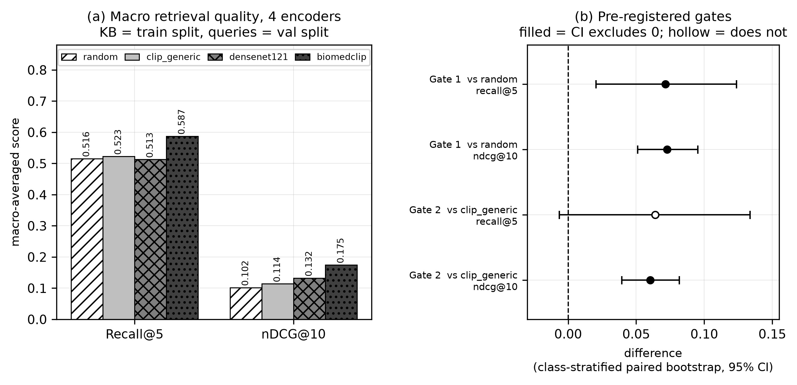
Figure 6.1: Phase 0 encoder bake-off with both pre-registered gates and their class-stratified paired bootstrap confidence intervals. Marker convention: a filled marker means the interval excludes zero; a hollow marker means it does not. The Gate 2 Recall@5 marker is hollow.
Source: thesis final report/04_figures/fig01_phase0_encoder_bakeoff.png, built from encoder_comparison_macro.csv and gate_decision_table.csv. Nothing was recomputed.
Table 6.3: The three pre-registered gates and their verdicts. n = val split queries against the 2,462-study training KB.
Source: ml/outputs/evaluation/gate_decision_table.csv, class-stratified paired bootstrap, 2,000 resamples.
Gate | Comparison | Metric | Δ | 95% CI | Excludes 0 | Verdict
1 | biomedclip − random | recall@5 | +0.0716 | [0.0204, 0.1236] | yes | PASS
1 | biomedclip − random | nDCG@10 | +0.0726 | [0.0510, 0.0952] | yes | PASS
2 | biomedclip − clip_generic | recall@5 | +0.0639 | [−0.0065, 0.1336] | no | INCONCLUSIVE
2 | biomedclip − clip_generic | nDCG@10 | +0.0604 | [0.0394, 0.0817] | yes | PASS
3 | wins concentrate on real findings | — | 11 of 15 real-finding classes | — | — | SATISFIED
Gate 2 did not pass cleanly, and this report does not present it as though it did. BiomedCLIP beats generic CLIP on nDCG@10 with the interval excluding zero, but the Recall@5 comparison is inconclusive at this sample size — the interval spans zero, containing values favouring either encoder. The likely reason is that Recall@5 is a coarse binary top-5 hit-or-miss signal while nDCG@10 uses the full graded ranking and therefore extracts more information from the same queries; but that is an explanation, not a rescue. The Recall@5 comparison against generic CLIP remains open.
Gate 3 was satisfied qualitatively: BiomedCLIP beat the random baseline on 11 of 15 clinically meaningful finding classes, with a pronounced advantage on Pleural Effusion (0.889 against 0.444–0.511 for the competing encoders). A weak spot on the heterogeneous Degenerative/Bone class is documented as a limitation rather than omitted.
The decision, stated at the strength the evidence supports: BiomedCLIP was adopted as the frozen encoder on Gate 1’s clean pass, Gate 2’s partial pass on nDCG@10, and clinically coherent per-class wins — reported honestly including the inconclusive comparison rather than rounded up to a clean sweep.

6.2.2 How good the relevance proxy itself is
Every Phase 0 number rests on a proxy: relevance defined by curated-label overlap rather than by clinical judgement. That proxy was itself validated, which is unusual and materially changes how the numbers should be read. 180 query–retrieved pairs (36 queries × top-5 BiomedCLIP neighbours, stratified across classes) were read and rated for genuine clinical relevance from the findings and impression text directly, not from label metadata.
The result: the proxy is 89% precise and 49% recall against hand-read judgement. When it says relevant, it is almost always right; it misses roughly half of genuinely relevant retrievals, because clinically related findings sometimes fall into different curated buckets. The proxy is therefore a conservative lower bound, and the Phase 0 metrics likely understate BiomedCLIP’s true clinical retrieval quality — which strengthens rather than weakens the case for adopting it.
A methodological note is recorded with it: an initial attempt to produce these ratings with an automated keyword-and-negation heuristic reached only 67% agreement with hand-read judgements on a calibration sample and was discarded in favour of reading all 180 pairs directly.

6.2.3 Gate B calibration, and a post-hoc revision
Table 6.4: Gate B threshold calibration. n = 300 per projection, from a 600-study set.
Source: ml/outputs/calibration/v1_1_gate_b_selected_values.csv; backend/app/core/config.py:364-403.
Setting | Value | Rule | Result | Status
MODALITY_THRESHOLD | 0.60 | False-negative budget 0.02, stated before results were read. | Frontal FNR 0.0000; 0.82 considered and declined. | pre-registered
PROJECTION_REJECT_THRESHOLD | 0.8695459 | Midpoint of the observed separation gap (lateral max 0.8484709, frontal min 0.8906209). | 300/300 lateral rejected, 0/300 frontal. | pre-registered, then superseded
PROJECTION_REJECT_THRESHOLD | 0.8500 | Just above the observed lateral maximum. | Re-verified on the same 600 studies: 300/300 lateral rejected, 0/300 frontal. | POST-HOC, revised 2026-08-19
RETRIEVAL_FLOOR | 0.8906208872795105 | 0th percentile of the frontal set — the only lower-tail percentile placing the boundary at the edge of the observed band rather than inside it. | 0 of 300 fall below it — the mechanism is UNEXERCISED. | pre-registered
The revision is stated here exactly as the source states it. The selection rule was changed after seeing a failing image: a genuine frontal chest radiograph from outside the dataset scored a top-1 similarity of 0.8582 and was rejected as a projection mismatch, sitting above every lateral in the calibration set and below the old midpoint — inside the empty gap the midpoint rule had placed the boundary in the middle of. The defence offered is that the calibration population was single-dataset, that no observation of any kind lies between 0.84847 and 0.89062, and that moving the boundary to the edge of what was observed removes an unmeasured margin rather than adding one. It remains an observed separation point, not a validated frontal/lateral boundary.

6.2.4 What Phase 0 does not establish
- It does not measure generation quality — that is §6.3.
- It does not establish that retrieval helps generation — that is §6.4, and its primary endpoint did not clear.
- The Recall@5 comparison against generic CLIP remains open.

6.3 Report Generation Results (Phase 20)
Phase 20 measured the v1.1 system — before the Phase 22 fix — on the test split, in three tiers: n-gram overlap, embedding similarity, and clinical labels. 460 of 477 eligible cases completed; 17 failed structurally.
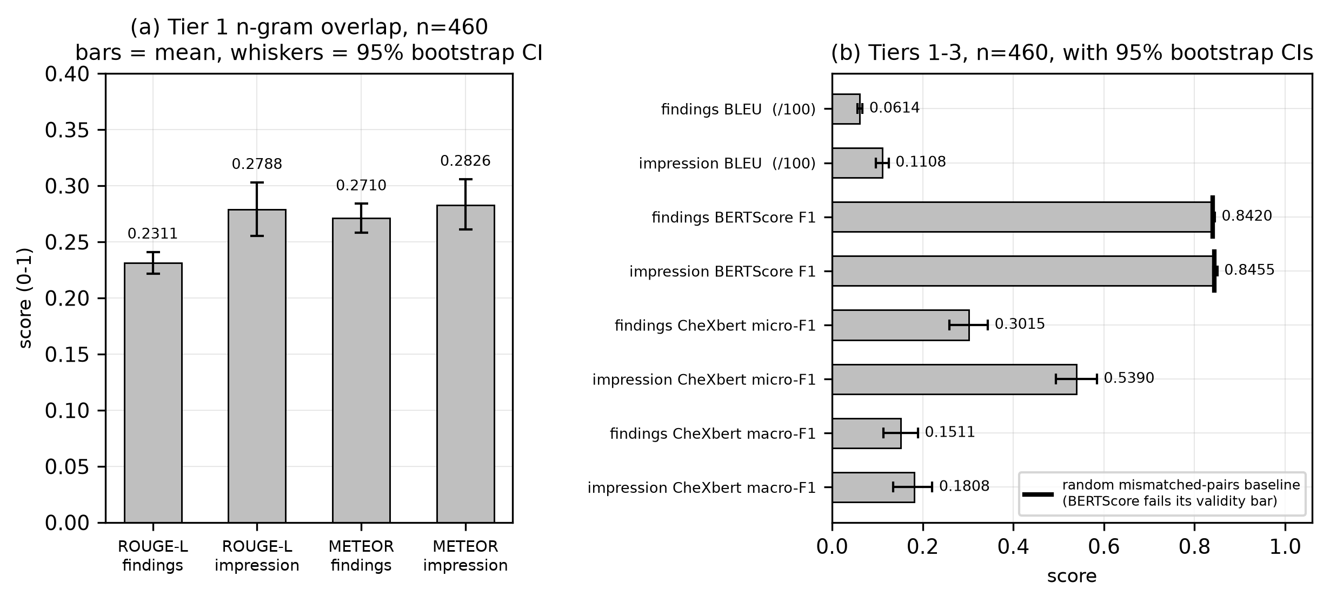
Figure 6.2: Phase 20 generation quality, Tiers 1–3, with 95% bootstrap confidence intervals — including the BERTScore random-baseline line that Tier 2 fails to clear.
Source: thesis final report/04_figures/fig02_phase20_generation_quality.png, built from tier1/tier2 bootstrap summaries, the random baseline file and tier3_chexbert_summary.json.

6.3.1 Tier 1 — n-gram overlap
Table 6.5: Phase 20 Tier 1: n-gram overlap against reference text. n = 460.
Source: ml/outputs/evaluation/generation/tier1_bootstrap_summary.csv.
Metric | n | Mean | 95% CI
findings BLEU | 460 | 6.137 | [5.615, 6.711]
findings ROUGE-L | 460 | 0.2311 | [0.2215, 0.2409]
findings METEOR | 460 | 0.2710 | [0.2583, 0.2839]
impression BLEU | 460 | 11.083 | [9.692, 12.493]
impression ROUGE-L | 460 | 0.2788 | [0.2552, 0.3030]
impression METEOR | 460 | 0.2826 | [0.2612, 0.3058]
These intervals are tight and the numbers are usable, but what they measure must not be overstated: n-gram overlap records lexical resemblance to a reference report, not clinical correctness. Two reports can share few words and mean the same thing, or share many and differ on the one finding that matters.

6.3.2 Tier 2 — BERTScore fails its own validity check
This is a metric-validity finding, and it is reported as a result rather than as a missing row.
Table 6.6: Phase 20 Tier 2: BERTScore against a random mismatched-pairs baseline. n = 460.
Source: tier2_bootstrap_summary.csv and tier2_bertscore_random_baseline.csv. Model: PubMedBERT, layer 9.
Section | F1 | 95% CI | Random mismatched-pairs baseline
findings | 0.8420 | [0.8394, 0.8447] | 0.8403
impression | 0.8455 | [0.8406, 0.8505] | 0.8432
A metric that scores randomly paired reports almost as highly as genuinely matched ones is not discriminating on this corpus. The validity bar was pre-registered, the tier failed it, and Tier 2 must not be reported as a quality result — here or anywhere. The finding is not that this system scores 0.84; it is that 0.84 means nothing here, because so does a random pairing. Having established this on Arm C, the same conclusion was re-checked in Phase 21 and stood, which is why BERTScore is absent from every later contrast. That exclusion predates the results it would otherwise have applied to, so it is not result-shopping.

6.3.3 Tier 3 — clinical labels, the valid instrument
Table 6.7: Phase 20 Tier 3: CheXbert clinical-label agreement. n = 460.
Source: ml/outputs/evaluation/generation/tier3_chexbert_summary.json.
Section | micro-F1 | macro-F1
findings | 0.3015 | 0.1511
impression | 0.5390 | 0.1808
findings, real − random baseline (macro-F1) | +0.0767 — excludes zero
Tier 3 clears the bar Tier 2 missed: the system’s findings agree with the reference labels significantly better than a random baseline does. The absolute values are nonetheless low, and this report does not dress them up. A macro-F1 of 0.1511 on findings is a weak clinical signal, and §6.12 states that plainly as a limitation.

6.3.4 The 17 structural failures — one root cause
All 17 failures trace to a single cause: the model inconsistently quoting label names inside the disclaimer field’s JSON string value, which broke parsing at that boundary. The response was not to patch the parser but to change the output format from JSON to delimiter markers, removing the nested-string boundary a stray quote can break — for that field and every other. 1,777 generations since have produced zero structural failures.
One qualification applies to that zero and to every other in this chapter: it means zero failed after retries, never zero needed a retry, because the attempt count is not recorded (§5.3.7).

6.3.5 The Fracture attribution failure, and what it revealed
This is the most consequential finding of Phase 20, and it was discovered by refusing to dismiss an anomaly as noise. In the per-label breakdown, Fracture had 18 reference-positive and 18 generated-positive cases — balanced, non-trivial support on both sides — and the two sets of 18 study identifiers were completely disjoint. An investigation followed, in the order most consequential for the project’s core claim.
- The headline — a grounding-attribution failure. For all 18 generated-positive cases, the real backend session behind each generation was located by exact text match and its real retrieved evidence rows were cross-referenced against the retrieved studies’ own report text. In 18 of 18, at least one fracture-mentioning study was present in the real top-5 retrieved evidence. This is not hallucination from nothing — it is worse in an important sense: the fracture belongs to a retrieved neighbour, not to the query patient, whose own reference report contains no fracture in any of the 18 cases. The offending neighbour is not reliably the top-ranked one either, appearing at rank 1 in some cases and rank 4 or 5 in others, meaning the system will incorporate an incidental finding from any retrieved neighbour, not only its closest match.
- A related recall gap. For the 18 reference-positive cases, the generated findings text was read directly: all 18 contain no fracture-related language whatsoever — not alternate phrasing the labeller missed, but complete absence. When retrieval happens not to surface a fracture-positive neighbour, the system has no basis to generate the finding.
- A minor, separately confirmed labeller bug. Re-reading the 18 reference texts found that 5 of the 18 are negations the labeller mislabelled as positive: three contain the identical phrase “No acute, displaced rib fractures” and two a close variant. This accounts for 5 of the 18, not the majority, and does not touch the generated-positive side at all.
What this revealed is the finding that redirected the project. Unlike the BLEU and BERTScore findings, this is a statement about the system, not about which metric can measure it. Image retrieval similarity does not guarantee that an incidental finding is specific to the query patient, and nothing in the generation step verified that a finding present in retrieved evidence belonged to the case being reported on before stating it as fact. Phase 22 is that mechanism measured at corpus scale.

6.4 Evidence-Mode Ablation (Phase 21)
Phase 21 asked whether full retrieved evidence produces better reports than voted labels alone, or than no retrieval-derived evidence at all. Three arms differed only in what the context builder assembles, switched by a configuration value rather than a code path.
Table 6.8: The three arms. Arm C is the v1.1 production configuration.
Source: 06_results/phase21_ablation.md; docs/methodology/phase21_ablation_architecture.md.
Arm | Evidence text | Voted labels | Disclaimer | Mode
A | ✗ | ✗ | ✓ | empty
B | ✗ | ✓ | ✓ | labels_only
C | ✓ | ✓ | ✓ | full
Arm B must never be described as “no retrieval”. Retrieval still executes in arm B; only its output is reduced to voted labels. The accurate description is retrieval-as-classifier, and it matters because arm B is the modern equivalent of the classify-then-template approach this project abandoned after Phase 0. C−B is therefore the direct empirical test of the retrieval-augmented design against a classification-based one. Even in arm A, retrieval still runs to create the session; only its output is discarded before context assembly.
Run integrity was complete: 100 attempted and 100 completed in every arm, 100 shared by all three, zero retrieval mismatches. At n=477, arms C and B both completed 477 of 477.
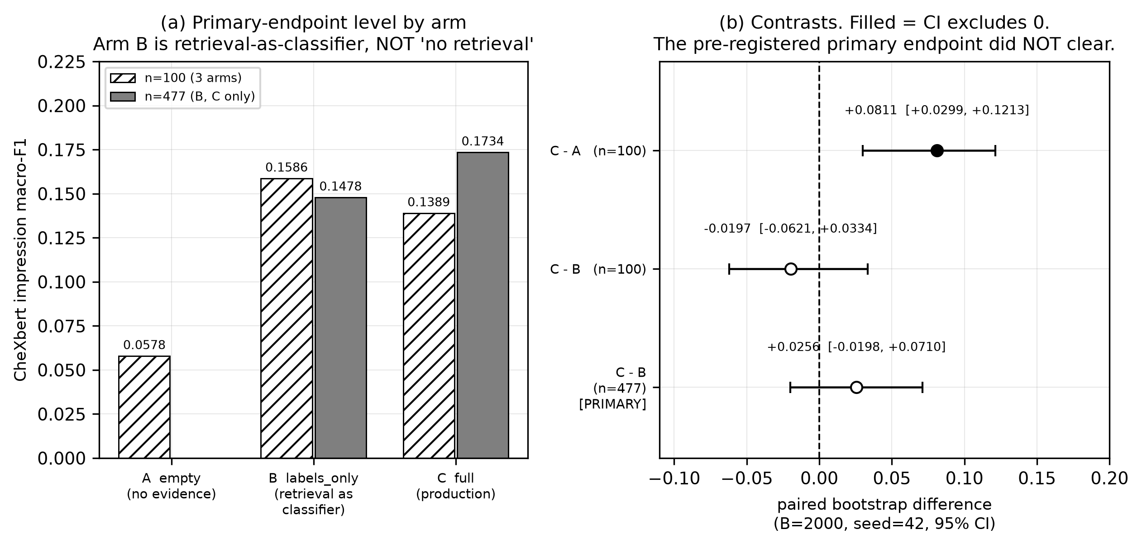
Figure 6.3: Phase 21 arms A/B/C on the primary endpoint and the three contrasts. The pre-registered C−B primary endpoint is hollow — its interval includes zero — at both sample sizes. The n=100 and n=477 bars are different case sets and are not comparable row-wise.
Source: thesis final report/04_figures/fig03_phase21_arms_primary.png, built from phase21_arm_contrasts.json and phase21_arm_contrasts_n477.json.

6.4.1 The primary endpoint did not clear
The endpoint was fixed in advance: clinical-label macro-F1 on the impression, arm C minus arm B, paired bootstrap, interval excluding zero in the positive direction.
Table 6.9: The pre-registered primary endpoint, at both sample sizes.
Source: ml/outputs/evaluation/phase21_arm_contrasts.json and phase21_arm_contrasts_n477.json.
n | Estimate | 95% CI | Excludes 0 | Verdict
100 | −0.0197 | [−0.0621, +0.0334] | no | did not clear
477 | +0.0256 | [−0.0198, +0.0710] | no | DID NOT CLEAR
The n=100 interval was 0.0955 wide and contained zero, values favouring B and values favouring C — it could not distinguish no effect from an effect this design could not resolve. The endpoint was extended to all 477 eligible cases by a rule fixed in advance, and by the same precedent as Phase 20’s extension. It still did not clear.
This is reported as a negative result, in full. No alternative metric, field or contrast was promoted to primary afterwards — the pre-registration forbade it in advance, and the ban was honoured.

6.4.2 The secondary contrasts, which all cleared
Table 6.10: Secondary C−B contrasts at n=477. Exploratory: a family, not independent confirmations.
Source: ml/outputs/evaluation/phase21_arm_contrasts_n477.json.
Metric | Estimate | 95% CI | Excludes 0
findings ROUGE-L | +0.0919 | [+0.0832, +0.1012] | yes
findings METEOR | +0.2265 | [+0.2151, +0.2376] | yes
findings CheXbert macro-F1 | +0.0587 | [+0.0165, +0.0978] | yes
impression ROUGE-L | +0.2145 | [+0.1906, +0.2403] | yes
impression METEOR | +0.2097 | [+0.1858, +0.2348] | yes
impression CheXbert macro-F1 (PRIMARY) | +0.0256 | [−0.0198, +0.0710] | no

6.4.3 The recall-driven decomposition and the length confound
Three properties of these numbers bound what may be concluded from them, and all three are stated because two of them cut against the adopted design.
The arm levels reveal a metric artefact, not a quality ordering. Arms B and A score higher micro-F1 than arm C while scoring far lower macro-F1 — at n=477, arm B reaches 0.6002 impression micro-F1 against arm C’s 0.5250, while arm C leads on macro-F1. The micro figure is dominated by the No Finding class. This is the phase’s first methodological finding: micro-F1 is unusable as a between-arm metric on this dataset, and it is precisely why the pre-registered endpoint was macro-averaged.
The length confound is real and is why the large secondary gains must be read carefully. The n-gram contrasts — METEOR at +0.2265 and +0.2097 — are very large, and arms differing in how much evidence text they receive also differ in how much they write. An n-gram metric rewards text that resembles a reference in surface form, and a longer, more clinically specific report will tend to score higher on it for reasons partly independent of correctness.
The one gain that length cannot explain is the clinical-label gain on findings: +0.0587 macro-F1, interval excluding zero. A clinical-label score does not reward text volume — it compares extracted finding sets, so writing more without being more correct does not raise it. This is the strongest evidence in the phase that full evidence does something beyond making reports longer, and it is on findings rather than on the impression that was pre-registered.
Arm A produced a degeneracy observation worth recording: it emitted one byte-identical string across all 100 cases. With no retrieval-derived evidence at all, the model has nothing case-specific to condition on and collapses to a single generic output. Arm A is additionally not a clean evidence contrast — with no labels available the prompt builder emits a different fallback sentence, so arm A’s prompt differs from arm C’s outside the evidence block as well as inside it. That fallback was deliberately not changed, because special-casing it would mean the ablation no longer measured the shipped system. This was named before any run, and C−A is reported at n=100 only, never on the same case set as the extended C−B.

6.4.4 What a null means, and what it does not
The symmetric reading is the honest one. The primary endpoint’s interval includes zero, so this phase did not demonstrate that full evidence improves impression-level clinical accuracy over retrieval-as-classifier. It equally did not demonstrate the opposite: the interval also contains substantial positive values, so a real effect this design could not resolve at n=477 is entirely consistent with the data. Section 6.9 explains why extending the sample further was not a route around this.
What the phase establishes, at the strength the evidence supports: full retrieved evidence beats retrieval-as-classifier on every n-gram metric and on findings-level clinical labels, with intervals excluding zero; on the one endpoint pre-registered as primary, the difference is positive but not distinguishable from zero at n=477. The design is supported on secondary evidence and unproven on its own primary endpoint, and this report says exactly that.
One deliverable of this phase was not produced, and it is recorded rather than omitted: the architecture specified a per-stage P50/P95 latency profile written to a named file. That directory does not exist and no such file exists anywhere in the repository. The stage-by-stage breakdown on which a resource-constrained deployment argument would ideally rest was never produced (§3.3.1).

6.5 Grounding Failure and Remediation (Phase 22)

6.5.1 The defect, as it was found
A live report contradicted itself. Its findings stated that the cardiomediastinal silhouette was unremarkable; its impression stated “Stable cardiomegaly with right mediastinal shift.” Investigation established three things about that single report. The impression was another patient’s impression, reproduced almost word for word from the top retrieved neighbour — that neighbour’s stored impression reads “1. Stable cardiomegaly with right mediastinal shift. 2. Stable interstitial markings and prominent bibasilar airspace opacities which [REDACTED] represent atelectasis”, and the generated text was that sentence pair with the numbering removed. The word “stable” referred to a prior study the patient did not have. And a fourth defect was present: a nodule placed in the right upper lung in findings became a right perihilar nodule in the recommendation — traceable to a different neighbour, rank 4. The report drew from at least two other patients’ reports.

6.5.2 Measured prevalence in v1.1
Table 6.11: Phase 22 diagnosis: prevalence of the three defects in v1.1, arm C, n=477.
Source: docs/phase22/diagnosis.md, via 06_results/phase22_diagnosis.md. The Phase 20 column is a separate-run observation and must never be differenced against arm C.
Measure | v1.1 arm C (n=477) | Phase 20 (n=460) | Note
Impressions with 5-gram overlap ratio 1.0 against a retrieved neighbour | 83 / 353 = 23.5% | not computable | Denominator is impressions of ≥ 5 tokens; 124 were shorter. Longest contiguous copied run: 42 tokens.
Reports using ≥ 1 of five temporal terms with no prior study | 167 / 477 = 35.0% | 97 / 460 = 21.1% | Every case in both harnesses had no prior study.
Strict internal contradiction (findings vs impression) | 22 / 477 = 4.6% | 9 / 460 = 2.0% | The loose asymmetry rate is 300/477 = 62.9% and is not a contradiction rate.
Of the copied impressions, those carrying a positive finding (harmful) | 22 / 83 = 26.5% | — | Harmful transplant rate against all scorable: 22/353 = 6.2%.
Transplant rate is not computable for Phase 20 at all — its per-case results carry no retrieved-identifier column and the neighbour identities for those 460 generations were never persisted. No substitute number is offered.
Two caveats bound how hard these numbers can be pushed. Temporal counts are lexical, from word-boundary regular expressions rather than adjudicated readings — “stable” has a non-temporal clinical sense — and a 20-case audit at a stated seed put matcher precision at 95%. And contradiction counts are labeller output, subject to the confirmed negation bug; ten of the 22 cases were read individually and are genuine, twelve were not.

6.5.3 The four root causes
Table 6.12: The four confirmed root causes. RC1–RC3 are independently sufficient; RC4 explains why none was caught.
Source: docs/phase22/diagnosis.md §3, each traced to file and line.
# | Root cause | Evidence
RC1 | No section-to-section grounding. One model call emits all seven fields as siblings of the evidence block; the impression is never conditioned on this report’s findings. Section regeneration was worse — it omitted the report’s own content and instructed the model not to consider other sections. | 22/477 strict contradictions; 10 of 11 Cardiomegaly cases in the findings-negative / impression-positive direction.
RC2 | Neighbour text is rendered verbatim with no attribution boundary and no anti-copying instruction. The only grounding rule forbade invention, and thereby rewarded copying. | 83/353 = 23.5% at overlap ratio 1.0; longest run 42 tokens.
RC3 | No prior-study state exists in the generation context, and no temporal restriction was applied. The prohibition existed only in the comparison path — that is, only where a prior study does exist. | 167/477 = 35.0%.
RC4 | The one semantic check could not represent this failure class, and gated nothing. It concatenates sections before inspection, so cross-section contradiction is unrepresentable; its unsupported-terms check flags only terms absent from evidence, so a transplanted finding is structurally exempt; it has no temporal check; and its result is never branched on. | —
RC2 and RC3 compound: a copied span imports its own temporal language. And RC2 is the same mechanism the Phase 20 Fracture investigation identified in 18 of 18 cases, now measured at corpus scale on the impression field rather than inferred from one label’s anomaly.
One methodological property of this diagnosis is worth recording: no fix was chosen and no fix code was written during it. Candidates were enumerated only, so that the fix could not be selected on knowledge of which would score best.

6.5.4 The fix
v1.2 changes the prompt in four ways and adds one service. (i) The evidence block is headed EVIDENCE — OTHER PATIENTS’ REPORTS (reference only), stating that the text is not this patient’s history and prohibiting the reproduction of sentences or the transfer of findings, measurements, laterality or devices. (ii) New section-support instructions: findings first; the impression a synthesis of this report’s findings; the recommendation preserving the findings’ location and laterality. (iii) A prior-study block stating that no prior exists and naming the forbidden temporal terms, sourced from the same configuration value the checker matches on. (iv) Section regeneration receives the report’s current findings.
Alongside these, a consistency service runs three checks — temporal, transplant and contradiction — and records what it found without altering anything the model wrote. That the service is observational is asserted by test: the same fake model output, generated with and without the service injected, produces byte-identical persisted content.
The prompt grew by exactly +338 tokens on every one of the 477 cases, peaking at 1,574 of 4,096 — so nothing is truncated.

6.5.5 Gate A: the pre-registered evaluation
477 cases were driven through the real API path, paired per study identifier against the stored v1.1 outputs, with both arms labelled by the same frozen instrument. Configuration parity with the earlier phase was verified live before generation. 477 of 477 completed, 0 failed.
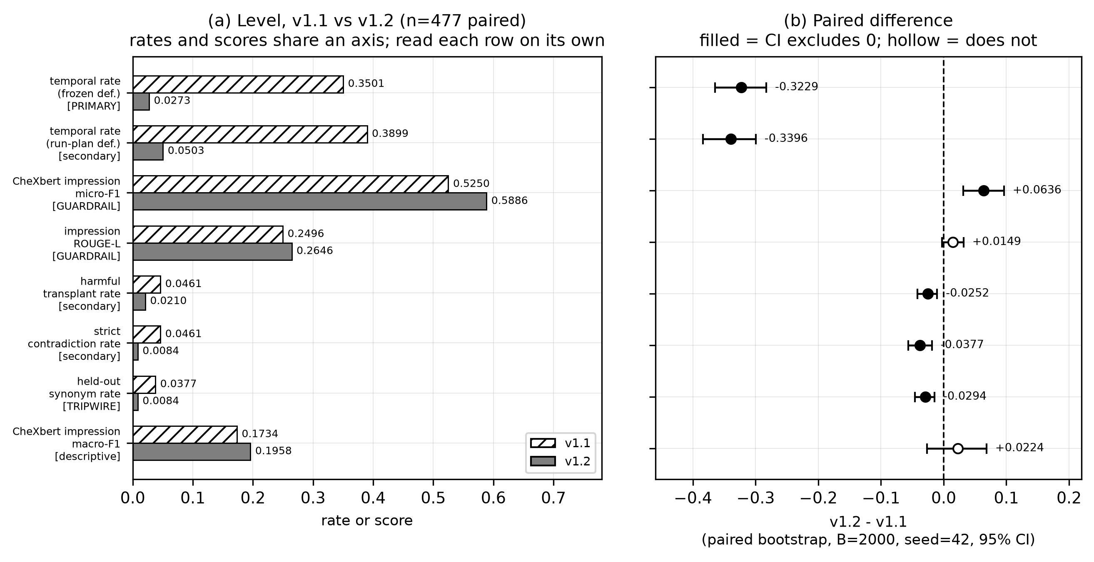
Figure 6.4: Phase 22 Gate A: every endpoint, v1.1 against v1.2, with paired confidence intervals. Rates and scores share one axis — each row must be read on its own, and the bars are not comparable across rows. The impression ROUGE-L guardrail marker is hollow.
Source: thesis final report/04_figures/fig04_phase22_gateA_endpoints.png, built from gate_a_endpoints.json and gate_a_results.md §3.1.1.
Table 6.13: Gate A: the three gating criteria. Paired, n=477.
Source: docs/phase22/gate_a_results.md §3.
Criterion | v1.1 | v1.2 | Diff | 95% CI | Verdict
1. Primary — temporal-term rate (frozen definition) | 0.3501 (167/477) | 0.0273 (13/477) | −0.3229 | [−0.3648, −0.2830] | PASS
secondary definition (9 terms, + recommendation) | 0.3899 (186/477) | 0.0503 (24/477) | −0.3396 | [−0.3836, −0.2998] | consistent
2. Clinical guardrail — impression micro-F1 (δ = 0.05) | 0.5250 | 0.5886 | +0.0636 | [+0.0314, +0.0961] | PASS
3. Supplementary guardrail — impression ROUGE-L (δ = 0.03) | 0.2496 | 0.2646 | +0.0149 | [−0.0024, +0.0317] | PASS
Two readings must be got right. The clinical guardrail was a non-inferiority bound, and the measurement is an improvement — but it is reported as clearing the bound, which is what was pre-registered. The supplementary guardrail’s interval includes zero, so it is not evidence of improvement; it shows only that textual drift is bounded well inside the margin, which is all that guardrail was for.
Table 6.14: Gate A secondary and descriptive endpoints. These do not gate.
Source: docs/phase22/gate_a_results.md §3.4.
Endpoint | v1.1 | v1.2 | Diff | 95% CI | Excludes 0
harmful transplant rate (strict) | 0.0461 (22/477) | 0.0210 (10/477) | −0.0252 | [−0.0419, −0.0105] | yes
strict contradiction rate | 0.0461 (22/477) | 0.0084 (4/477) | −0.0377 | [−0.0566, −0.0189] | yes
held-out synonym rate (tripwire) | 0.0377 (18/477) | 0.0084 (4/477) | −0.0294 | [−0.0461, −0.0147] | yes
impression macro-F1 | 0.1734 | 0.1958 | +0.0224 | [−0.0266, +0.0683] | no
The held-out tripwire did not fire, and this is the most important negative control in the project. Ten temporal synonyms were generated from the frozen document and never shown to the model, with a test asserting their absence from every prompt the backend can send. If the fix had merely taught the model to avoid five specific words, the held-out rate would have held steady or risen while the primary rate collapsed. Both fell. Under the reading rule fixed in advance, that is consistent with a real change in behaviour rather than word-avoidance.
The noise floor is the second control, and it is what makes the primary result defensible. The previous version was checked out in a separate worktree, served against a byte-verified copy of the same collection, and re-run on 100 pilot cases with identical settings. 67 of 100 outputs were not byte-identical — generation is materially non-deterministic — yet the primary endpoint’s own measurement moved 0.0 percentage points, 46/100 before and 46/100 after. The text varies while the endpoint is stable, so the −32-percentage-point primary result cannot be attributed to re-run noise.
Generation and consistency outcomes: 477/477 completed, 0 structural failures; consistency status partial 459, violations 17, clean 0, not_run 0. No report reads clean, exactly as the amendment predicts before Gate B. The retry count is 0 for every case, by construction.

6.5.6 The verdict, and why adoption is not final
Applied mechanically: criterion 1 PASS under both definitions; criterion 2 PASS at +0.0314; criterion 3 PASS at −0.0024. Adopt v1.2 on the three gating criteria: yes.
But adoption is not final, and every sentence in this report that mentions v1.2 carries that qualification. Two withhold triggers were pre-registered. The first — the held-out rate failing to fall while the primary collapses — did not fire. The second — a single clear grounding failure in the blinded manual read — remains open: the packet was built (40 reports, no version information, answer key held separately) and 0 of 2 readers have submitted. That trigger is a stop condition that overrides a clean pass on all three criteria. The correct statement of Gate A’s verdict is therefore “passes every automated criterion”, not “cleared for adoption”.
A real pre-registration defect is recorded rather than resolved quietly. The frozen document supported two incompatible readings of its own primary endpoint: one section named three report sections and a nine-term list, while its stated baseline figure had been computed over five terms and two sections. The run plan followed the wider definition without noticing that the quoted baseline came from the narrower one. The more conservative frozen definition is reported as primary, and the verdict is identical under both. The defect is disclosed because a pre-registration that is quietly reinterpreted after the fact provides none of the protection it exists to provide.

6.5.7 Post-hoc analysis: is the improvement just shorter text?
Nothing in this subsection was pre-registered. No number here is a criterion and the Gate A verdict is not revisited. These analyses are reported because several change how the results above should be read — in one case decisively, and in two cases against the fix.
The shortening is real. Findings word count fell from a median of 48 to 30 (−38%), and impressions from 9 to 5, with the long tail compressed from a maximum of 181 to 109. The obvious alternative explanation for every Gate A result is therefore that the system simply writes less. Four independent tests refute it.
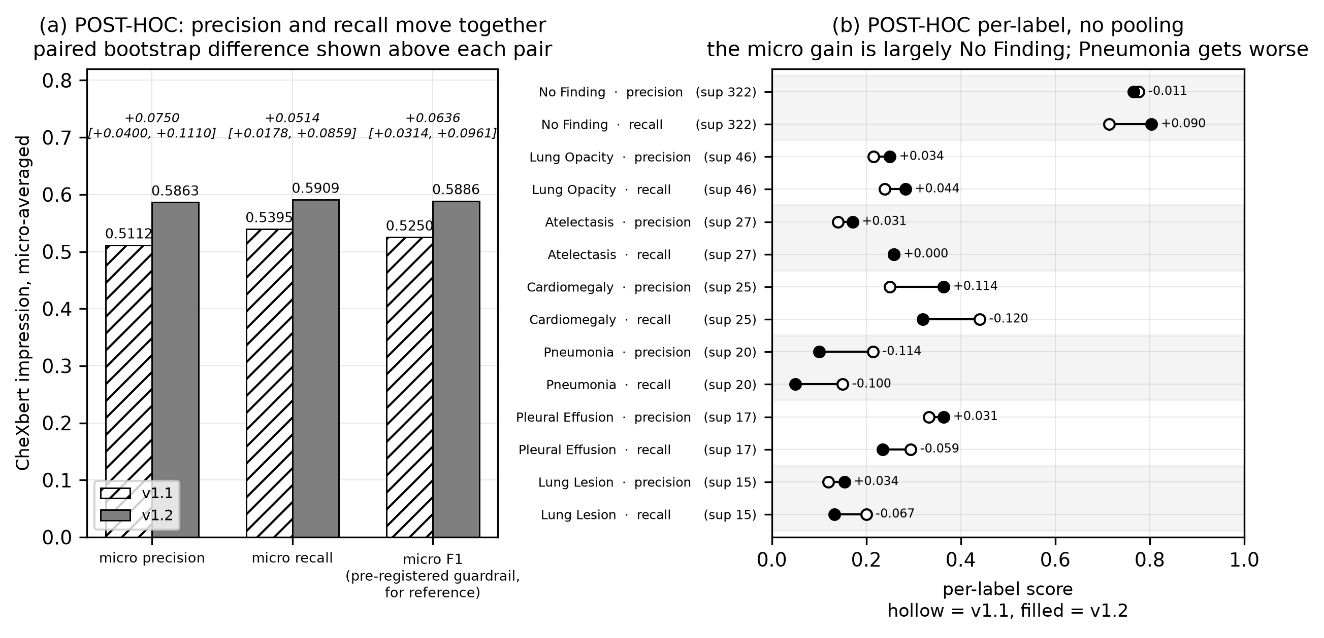
Figure 6.5: Phase 22 post-hoc micro precision and recall, and per-label detail with supports. Everything in this figure is post-hoc, not pre-registered. Seven of the fourteen labels have support below 10 and are omitted from the per-label panel as unreliable.
Source: thesis final report/04_figures/fig05_phase22_posthoc_micro_pr.png, built from the post-hoc output reproduced in gate_a_results.md §6.
- Precision and recall separately — the decisive test. Micro precision rose from 0.5112 to 0.5863, +0.0750 [+0.0400, +0.1110], and micro recall from 0.5395 to 0.5909, +0.0514 [+0.0178, +0.0859]. Both rose and both intervals exclude zero. If shortening were the mechanism, precision would rise (fewer assertions, fewer false positives) while recall fell (fewer assertions, fewer true positives caught). Recall rose instead. The system writes less and catches more of what the reference says. That is not what truncation looks like.
- It does not fall silent on real findings. Cases where the generated impression carries no positive label while the reference impression carries at least one: 56/477 in both versions — identical. v1.2’s impressions are empty of positive labels more often overall (338 → 365), but the extra silence falls entirely on cases where the reference is also negative.
- The temporal reduction is far larger than the length reduction. Restricted to findings alone, the temporal rate fell from 0.2872 (137/477) to 0.0126 (6/477), −0.2746 [−0.3145, −0.2348]. Findings length fell 38%; the findings temporal rate fell 96%. A 38% length cut cannot produce a 96% reduction unless temporal language were concentrated in exactly the removed text.
- The transplant improvement survives its denominator confound. The scorable denominator fell from 353 to 280 because v1.2 impressions are shorter, so part of the headline improvement might have been unscorability rather than less copying. Restricting to the 261 cases scorable in both arms removes the confound: 0.0805 (21/261) → 0.0383 (10/261), −0.0421 [−0.0728, −0.0153]. Harmful transplantation roughly halves on identical cases. The denominator shift inflated the headline figure but did not create it.

6.5.8 Two post-hoc findings that argue against the fix
A report presenting only the four results above would be reporting half of this analysis. Two findings cut the other way.
The micro-F1 gain is substantially a No Finding gain, and one real condition got worse. Per-label figures show No Finding — support 322, by far the largest — improving in recall from 0.714 to 0.804 and carrying the aggregate. Pneumonia is clearly worse: recall fell from 0.150 to 0.050 on a support of 20, with precision falling from 0.214 to 0.100. Cardiomegaly trades recall for precision. Seven of fourteen labels have support below 10 and their figures should not be read as estimates of anything. The per-label picture is not uniformly favourable, and this report does not present it as one.
A residual defect survives in the opposite direction to the one fixed. The v1.2 constraint forbids the impression asserting what the findings did not state; it says nothing about the reverse — an impression omitting what the findings did state — and that failure mode persists. In 27 of 477 reports (5.7%), the generated findings carry at least one positive condition while the generated impression carries none. This is threefold better than v1.1’s 90/477, unprompted, but 27 cases remain and they are a genuine internal inconsistency. Five were sampled at a stated seed and three of five are genuine omissions:
uid 951 Findings: "...Mild right basilar atelectasis and relative elevation
of the right hemidiaphragm are noted..."
Impression: "The chest X-ray is normal, with no evidence of active
cardiopulmonary disease."

uid 3461 Findings: "The lung opacities are seen throughout the lungs, with
more focal streaky bibasilar opacities..."
Impression: "No acute cardiopulmonary abnormality" <- worst case
The remaining two are arguably labeller artefacts, the positive label being a support device rather than a pathology, on a reference support of 2. This defect is covered by no check in v1.2 and measured by no endpoint. It is measured against the report’s own findings, not against the reference — the analysis above shows v1.2 does not miss reference findings more often — so it is self-inconsistency, not under-detection. Section 6.12 carries it as a limitation and §8.3 as future work.

6.5.9 The trigger case, re-tested
The report that started Phase 22 was re-run against v1.2 three times. Retrieval reproduced exactly — all five neighbours and all five similarities identical to those stored with the original, in the same rank order, on every run — so any difference in the generated text is attributable to the prompt and not to different evidence.
Table 6.15: The trigger case re-tested. n = 1 case, 3 runs, qualitative. This proves nothing about rates.
Source: 01_facts/trigger_case_retest.md. For rates, see Gate A at n=477.
Defect | v1.1 | v1.2 (3 runs)
Self-contradiction (Cardiomegaly) | present | absent 3/3
Transplant from neighbour #1 | overlap ratio 0.50, longest run 9 tokens | ratio 0.00 in 3/3, longest run 2 tokens
“Stable” with no prior study | 2 occurrences | 0 occurrences in 3/3
Nodule location mismatch | present | does not arise 3/3 — the nodule is omitted, not relocated
The last row is recorded carefully rather than claimed as a fix. The mismatch cannot arise in v1.2 because no nodule is mentioned at all. Without ground truth for this image — the uploaded file matches no dataset study by hash — there is no way to say whether omitting the nodule is correct or is the loss of a real finding. This is the same omission-direction behaviour measured at 27/477 above.

6.6 Accuracy Improvement Experiment (Phase 23)
Phase 23 asked whether a larger model or an explicit label checklist improves v1.2’s labelled accuracy. Four variants × 150 development cases = 600 generations. The development set was drawn from the validation split, never the test pool, and four independent checks confirmed zero intersection with the test pool or the knowledge base. The selection rule was fixed in the plan before any variant ran and applied mechanically by a script.
Table 6.16: Phase 23: the four variants. n = 150 each; all completed, zero structural failures.
Source: docs/phase23/dev_results.md, via 06_results/phase23_accuracy.md.
Variant | Model | Checklist | Completed | Mean s | p95 | Max
V0 (incumbent) | llama3:8b | off | 150/150 | 4.56 | 4.97 | 7.15
V1 | qwen2.5:14b | off | 150/150 | 7.37 | 8.76 | 10.76
V2 | llama3:8b | on | 150/150 | 4.58 | 4.98 | 7.76
V3 | qwen2.5:14b | on | 150/150 | 7.33 | 8.36 | 10.79
Table 6.17: Phase 23 clinical-label results. V0 leads on 23 of 24 cells.
Source: ml/outputs/evaluation/phase23_dev_{V0,V1,V2,V3}/, frozen evaluation path.
 | Impression macro-F1 | Impression micro-F1 | Findings macro-F1 | Findings micro-F1
V0 | 0.1227 | 0.6120 | 0.1032 | 0.3513
V1 | 0.0826 | 0.5325 | 0.0928 | 0.3271
V2 | 0.1160 | 0.5833 | 0.0980 | 0.3404
V3 | 0.0788 | 0.5017 | 0.0902 | 0.3123
The single exception in 24 cells is findings macro-precision, where V2 leads V0 by 0.0008 — far inside noise, and on the section the checklist does not target.
Both larger-model arms reintroduced self-contradiction that neither incumbent arm produced (2/150 against 0/150). The counts are small and nothing here is powered to distinguish them, but the guardrail was pre-registered as a comparison against the incumbent’s rate rather than as a significance test, and was applied as written.
The verdict, exactly as the script printed it: V0 qualifies; V1 fails on precision drop and contradiction; V2 fails on temporal rate; V3 fails both. Qualifying variants that strictly beat V0: none. Winner: V0 — the incumbent. Step 3 was not run.
One honesty note is recorded with the result: the guardrails did not decide this. They are reported because the plan requires it, but they were not load-bearing — no variant beat V0 on the primary endpoint, so the verdict holds even if every guardrail is ignored. Stating it the other way round would overstate their role.

6.6.1 The support limitation, and why the checklist hypothesis is not refuted
This development set is genuinely underpowered for the question it was built to answer, and that is stated rather than minimised. 13 of the 14 clinical labels have reference support below 10 on these 150 cases, and 10 labels score 0.000 for every variant, contributing an identical constant to all four macro averages. The macro-F1 ranking is effectively decided by three labels.
This does not invalidate the verdict, for a specific reason: the ranking is identical under micro-averaging, which is not support-fragile in the same way, and identical on findings as well as on the impression. A conclusion holding only on macro-F1 would deserve much more scepticism.
But it does mean the checklist hypothesis is not refuted. A checklist targeting under-calling would be expected to help precisely on rare findings — which is exactly where this development set could not detect an improvement. The correct conclusion is “no benefit was detected on this dev set”, not “the checklist does not work”. The plan was deliberately not changed to accommodate this, the limitation having been discovered after the run; it is recorded as the first thing to fix if the experiment is repeated.
What the phase does establish is worth stating positively: a larger model is not automatically a better one for this task. The 14-billion-parameter model is 1.85× the parameters, costs 61% more latency and 4,276 MiB more VRAM, and is worse on every accuracy metric measured — while reintroducing a defect the smaller model did not produce. And a negative result arrived cheaply and without touching the test set, which is what the development-set design was for.

6.7 Analysis of Design Solutions
Table 6.18: Which design choices the evidence supports, and which it does not.
Source: This chapter.
Design choice | Evidence status
Retrieval instead of classification | Supported. DenseNet121 scored R@5 0.5127, below the random baseline’s 0.5155, while BiomedCLIP cleared Gate 1 on both metrics. The strongest evidence in the project for any design decision.
BiomedCLIP as the encoder | Supported, with one comparison open. Gate 1 passed cleanly and Gate 3 was satisfied; the Recall@5 comparison against generic CLIP remains inconclusive.
Full evidence rather than labels alone | Supported on secondary evidence; unproven on the pre-registered primary endpoint. The findings-level clinical gain (+0.0587, interval excluding zero) is the one gain length cannot explain.
The v1.2 attribution boundary | Supported, pending a blinded read. −32 percentage points on the primary endpoint, both guardrails clear, the held-out tripwire silent, and the noise floor showing 0.0 pp movement. The shortening explanation is refuted on four independent tests.
llama3:8b over a larger model | Supported. 23 of 24 cells, at 61% less latency and 4,276 MiB less VRAM.
The label checklist | Not supported — and not refuted. No benefit detected; the dev set was underpowered exactly where a benefit would appear.
Macro-averaged endpoints | Supported as a methodological choice. Phase 21 showed micro-F1 ranking arms in the opposite order to macro-F1, being dominated by No Finding.
Advisory rather than blocking semantic validation | Not evaluated. No experiment compared blocking against advisory. The choice rests on a design argument (§5.3.6), not on evidence.
The observational consistency service | Partially supported. Detection works and costs ~0.2% of request latency. Its value is unevaluated, because nothing acts on a violation: 17/477 were acted on by nothing.
PHI masking before embedding | Supported for safety, unvalidated for detection. Mean cosine 0.992 pre/post, 0 of 50 flagged. Detection recall is unmeasurable on this dataset.
Bilingual generation | Unevaluated. No Bengali output has ever been measured.
Browser print over server-side PDF | Supported for delivery, verified for Bengali. 9 sections, 781 codepoints, conjuncts correct, no missing glyphs.
The optimisation actually performed on the selected design was Phase 23, and its outcome is worth stating precisely: the selected design was tested against two plausible improvements and retained because neither improved it. That is an optimisation that returned a null, not an absence of optimisation.

6.8 Final Design Adjustments
Two adjustments were made in response to evaluation results, and they point in opposite directions — which is what makes them worth reporting together.
The v1.2 remediation is the substantive final adjustment. It was not planned: it exists because a defect was observed in this system’s own output, diagnosed to four root causes, measured at corpus scale, fixed, and then evaluated under criteria fixed before the fix was run. The adjustment is adopted in the shipped code and not finally adopted as an evaluated claim, because the blinded read that could override the pass has not been performed. Both halves of that sentence are true simultaneously, and the report states both wherever v1.2 appears.
The Phase 23 decision to change nothing is the other adjustment. Having a pre-registered selection rule produce the incumbent is a real outcome of a real experiment: two plausible improvements were tested at a cost of 600 generations and neither qualified. The configuration flag for the rejected checklist ships set to false, with the prompt byte-identical to the evaluated one — so the evaluated system and the shipped system are the same system.
A third, smaller adjustment belongs here because it followed the same discipline: the partial consistency status. Review found that a report where only some checks ran, and those found nothing, was reporting itself clean — overstating assurance. Implementing the fix exposed a larger instance: the transplant check was being counted as run while structurally unable to report anything. The consequence is that every English report now reads partial, which is correct rather than unfortunate: one of three checks genuinely is not operational, and the previous behaviour asserted a completeness the system does not have. A dashboard that looks worse after an amendment is a dashboard that has started telling the truth. Four stored rows written under the earlier rule still read clean and were recorded rather than migrated.

6.9 Statistical Analysis

6.9.1 Bootstrap configuration
2,000 resamples, seed 42, percentile method, paired per study identifier, throughout. Phase 0 additionally stratified by class. The configuration was carried forward rather than re-chosen per phase, so no phase selected a procedure after seeing its data.

6.9.2 Why the macro-F1 interval does not narrow with n
This is a genuine statistical finding of the project and it constrains everything above. Extending the Phase 21 endpoint from 100 to 477 cases — a 4.77× increase — reduced the macro-F1 confidence interval width by 5%, against the 2.2× narrowing that independent sampling would predict.
What follows from it is important. A macro average over a long-tailed label distribution is dominated by the labels with the least support, and adding cases adds very few instances of those labels. The interval is therefore not primarily an expression of case-level sampling noise that more cases would reduce; it is an expression of rare-label scarcity. Collecting more cases from the same distribution is not a route around the Phase 21 null. A better-powered version of that experiment needs a case set enriched for rare findings, not simply a larger one. A related caution is recorded: the n=100 and n=477 macro-F1 figures are not the same estimand, and the two are presented side by side rather than as a convergence.

6.9.3 Micro against macro, and gameability
Micro-F1 pools every label decision and is dominated here by No Finding at a support of 322 of 477. Macro-F1 averages per-label scores, giving a rare finding the same weight as a common one. Phase 21 showed these two rank the arms in opposite directions: arms B and A score higher micro-F1 than arm C while scoring far lower macro-F1. An arm that reports fewer findings scores better on micro-F1 on a dataset where most studies are normal. Micro-F1 is therefore gameable on this dataset and is unusable as a between-arm metric, which is why every pre-registered endpoint was macro-averaged — and why the Phase 22 micro-F1 guardrail improvement is read in §6.5.8 alongside its per-label decomposition rather than on its own.

6.9.4 Non-determinism at temperature 0, and the noise floor
Generation is materially non-deterministic at temperature 0.0 with seed 42. Re-running identical code against a byte-verified identical collection on 100 pilot cases produced 33 byte-identical outputs and 67 differing.
The cause was diagnosed by measurement rather than assumption, and it has two independent parts. Temperature 0 selects the highest-probability token but does not pin the sampler’s starting state: with no seed, five identical requests produced two distinct reports, diverging inside the impression. With a seed pinned, five runs were byte-identical — but the seed alone is not sufficient, because the first inference after the model loads differs reproducibly from every later one. Across three unload-and-reload cycles the cold and warm outputs were the same two values every time: each state is perfectly reproducible, and they are reproducibly different from each other. Generation is therefore deterministic conditional on whether the model was resident, which is precisely the reported symptom — draft a report, return later, upload the same image, receive different words with nothing having changed. A seed and a keep-alive were both added, each addressing one half. The residual cold/warm boundary is warm-up state in the inference runtime and nothing at this layer can remove it.
A related historical fact is recorded because it bears on every generation this system has produced: for most of the project only two generation parameters were ever configured — the model and the temperature. Sampling parameters and the seed were never set anywhere in the codebase and silently took the runtime’s own defaults, unrecorded. Temperature 0.0 was the only reproducibility lever this system ever pulled, and it was not sufficient on its own.
The noise floor is what makes the Phase 22 result interpretable despite all this. The measured endpoint moved 0.0 percentage points across the re-run — 46/100 before, 46/100 after — while 67% of the text changed. Both halves matter: the text varies, so no claim in this report rests on exact output reproduction; the endpoint is stable, so the −32-percentage-point result cannot be attributed to re-run noise.

6.9.5 Structural failure rates across phases
Table 6.19: Structural failure rates in every phase that measured one. Never pooled — each states its own n.
Source: 06_results/performance_and_tests.md §6.
Phase | System | n | Structural failures
20 | v1.1 (JSON output) | 477 | 17 (3.6%) — all one root cause
21, all arms | v1.1 (delimiters) | 100 × 3 | 0
22 Gate A | v1.2 | 477 | 0
23, all variants | v1.2 | 150 × 4 | 0
Every zero above means zero failed after retries, not zero needed a retry (§5.3.7).

6.10 Comparisons and Relationships

6.10.1 Comparison with published work
The caveat comes before the comparison, because it governs it. A clinical-efficacy F1 reported by a published report-generation model and one reported here differ in at least four respects at once: the dataset (predominantly MIMIC-CXR against IU X-ray), the labeller configuration, the averaging convention (micro against macro), and the amount of training (hundreds of thousands of supervised examples against none). Four simultaneous differences do not produce a ranking, and any comparison of this kind is indicative only.
[TO CONFIRM: the specific CE precision, recall and F1 figures reported by R2Gen and its successor models, with the dataset and labeller configuration each used, must be read from the primary publications and inserted here. This project’s repository contains no bibliography file and no transcribed published figure, and reconstructing values from memory would violate the traceability rule this report is written under. No value is supplied from memory.]
The fair statement, and the only one this project’s evidence supports, is therefore a statement about feasibility under constraint rather than about competitive quality: this system reaches a clinical-label agreement range comparable to published work without performing any model training at all, on a dataset an order of magnitude smaller, running entirely on a single consumer GPU. Whether it is better or worse than any specific published system is a question this comparison cannot answer, and this report does not answer it.

6.10.2 Relationships between retrieval quality, evidence mode and report quality
Reading the phases together — as relationships rather than as pooled numbers — four statements hold.
- Retrieval quality bounds report quality, but does not determine it. Phase 0 established that BiomedCLIP retrieves clinically related cases better than chance or generic features. Phase 20 then established that good retrieval is not sufficient: in all 18 Fracture cases the retrieval was working, surfacing genuinely similar cases, and the failure was that the generation step had no mechanism to decide whether a retrieved finding belonged to this patient.
- More evidence in the prompt produces more clinically specific text, with a detectable but modest gain in clinical accuracy. Arm C beats retrieval-as-classifier on every n-gram metric and on findings-level labels, with the findings clinical gain being the one length cannot explain — while the impression-level clinical gain is not distinguishable from zero.
- More evidence also creates the attribution risk. Arm A, with no retrieval-derived evidence, cannot transplant a neighbour’s finding — it also collapses to one byte-identical string across 100 cases. The evidence that makes reports specific is the same evidence that can be copied; the fix was not less evidence but an explicit attribution boundary around it.
- Constraining the model improved accuracy rather than costing it. The intuition that tighter constraints trade accuracy for safety did not hold here: the clinical guardrail improved (+0.0636, interval excluding zero) alongside the −32-point reduction in ungrounded language, and post-hoc both precision and recall rose. The honest qualification is that the micro-F1 gain is substantially a No Finding gain and one real condition got worse.

6.11 Discussion

6.11.1 What the evidence supports
- That retrieval is the right architecture for this problem under these constraints. The classifier the proposal specified performs at or below chance on the retrieval task, and the retrieval design produces traceable evidence a classifier cannot.
- That a grounding defect in a generative clinical system can be found, diagnosed, fixed and measured — from an observation in one report, to four root causes, to corpus-scale prevalence, to a pre-registered evaluation showing a −32-percentage-point reduction on the primary endpoint with both guardrails clear.
- That the whole system runs on one consumer GPU at interactive latency: 7,125 MiB peak of 16,376, 4.50 s mean per report, with safety checking costing ~0.2% of the request.
- That privacy-preserving masking before embedding does not damage the representation: mean cosine 0.992 pre/post, 0 of 50 flagged.
- That pre-registration is practicable in a project of this size, and that it changes outcomes. It produced a null in Phase 21, a discarded metric in Phase 20, an incumbent winner in Phase 23, and a disclosed defect in its own protocol in Phase 22.

6.11.2 What the evidence does not support
- That full evidence improves impression-level clinical accuracy over retrieval-as-classifier. The pre-registered endpoint did not clear at either sample size.
- That the system is clinically accurate in absolute terms. Macro-F1 of 0.1511 on findings and 0.1808 on impression (Phase 20) are weak signals; the later phases improve on them but do not transform them.
- That v1.2 is adopted. It passes every automated criterion; the blinded read that could override that pass has not been performed.
- That the system is safe for clinical use. No clinician has evaluated any output, no regulatory process was entered, and 5.7% of reports carry a known internal inconsistency.
- That anything about the Bengali output is known. Nothing is.

6.11.3 What remains unknown
Three unknowns are structural rather than incidental, and each would require work this project did not do. Whether a clinician is faster or safer using this system is unknown, because none has used it — which makes every productivity and usability claim unevidenced, and is why §3.11.4 declines to give a cost–benefit figure. Whether the system performs on a Bangladeshi population is unknown, because every number here derives from one US-sourced corpus with a different disease prevalence. And whether the residual omission defect matters clinically is unknown: 27 of 477 reports state an abnormality and then call the study normal, and whether a reader catches that in practice is precisely the question a blinded read of the kind still pending would begin to answer.
One further unknown is worth naming because it is uncomfortable rather than technical. This project’s own instruments are imperfect in known ways — a labeller with a confirmed negation bug, a lexical temporal matcher at 95% precision, seven of fourteen labels below usable support — and every conclusion above is conditional on them. The appropriate response is the one taken throughout: state the instrument, state its known failure mode, and never claim precision the instrument cannot deliver.

6.12 Key Achievements and Limitations

6.12.1 Achievements, with their evidence
Table 6.20: Key achievements and the evidence for each.
Source: This chapter.
Achievement | Evidence
A complete, working, evidence-grounded reporting workspace | 26 API operations, 15 routes, 672 passing automated tests, an end-to-end flow exercised in a real browser.
An encoder choice made on pre-registered evidence, not assertion | Phase 0: Gate 1 passed on both metrics; Gate 3 satisfied on 11 of 15 classes (§6.2).
A grounding failure found in this system’s own output and remediated | 35.0% → 2.7% temporal; 4.6% → 0.8% contradiction; harmful transplant halved on a common denominator (§6.5).
Refutation of the obvious alternative explanation for that result | Four independent tests, including recall rising where truncation would lower it (§6.5.7).
Privacy-preserving masking that provably does not damage the representation | Mean cosine 0.992, 0/50 flagged (§4.4).
A design that runs on one consumer GPU | 7,125 MiB peak of 16,376; 4.50 s mean per report (§6.9, §3.3).
An evaluation discipline that survived its own negative results | A null primary endpoint reported as the headline; a metric discarded; an incumbent winner; a pre-registration defect disclosed.

6.12.2 Limitations
- Low absolute clinical accuracy. Macro-F1 of 0.1511 (findings) and 0.1808 (impression) in Phase 20. The system drafts usefully structured reports; it does not read radiographs accurately in absolute terms.
- The primary endpoint of the ablation did not clear. The central design claim — that full evidence beats labels alone on clinical accuracy — is unproven on the endpoint chosen to test it.
- English-only checking. All three consistency checks are English-only by construction. A Bengali report stores an empty checks-run list and reads not_run.
- Bengali is entirely unmeasured. Zero Bengali defect rates of any kind have ever been measured. Every harness generates English only. The bilingual feature is shipped and unevaluated, and no Bengali quality claim appears anywhere in this report.
- No clinician validation. No radiologist has evaluated any output or the interface. The blinded read is built and unperformed — 0 of 2 readers — and neither designated reader is a radiologist in any case.
- A single dataset from one institution in another country. Disease prevalence, reporting conventions and population differ from the intended deployment setting (§3.8.4).
- The omission defect remains: 27 of 477 reports (5.7%) state an abnormality in findings and call the study normal in the impression. No check covers it and no endpoint measures it.
- Detection without action. 17 of 477 recorded consistency violations were acted on by nothing; the clean state is unreachable because one check cannot emit a result. Gates B and C are unstarted.
- Features not implemented: licence verification, roles, server-side PDF, password reset, image explainability — each with its reason in §3.1.3.
- Instrument limitations bound every clinical number: a confirmed labeller negation bug, 7 of 14 labels below support 10, a lexical temporal matcher at 95% precision, and a discarded embedding metric.
- Non-determinism is characterised but not eliminated: 67 of 100 re-runs differ byte-for-byte.
- Reproducibility is qualified: no Python lockfile, an evaluation environment deliberately separate from production, and a documented case where persisted reproducibility metadata can reflect a later configuration than the one that ran.
This chapter has reported every evaluation this project performed, including the ones that returned nulls, the metric that failed its own validity check, the defect found in this system’s own output, and the remediation that has passed every automated criterion without yet being finally adopted. Chapter 7 is the user manual for the system as delivered.

Chapter 7 User Manual
This chapter is the operating manual for the system as delivered. It covers installation, then every real screen in the order a new user meets them, with what the user does and what the system shows. Every screenshot is of the current interface, captured from the running system on 2026-09-23; no screen is mocked up and no capability is illustrated that the system does not have. The chapter closes with an explicit list of what the manual must not promise.
What the system is. It drafts a chest X-ray report from five similar archived cases and hands it to a doctor to review, edit and sign. Every report carries the line: “Drafted from 5 archive cases, then reviewed and edited by the reporting radiologist. Not an autonomous diagnosis.” You remain the author.
Who can use it. There is one role: the doctor. There is no administrator account, no administrator screen and no role column in the database. A doctor may read any report but may write only their own; every write against another doctor’s report is refused.

7.1 Installation and Setup

7.1.1 Prerequisites
Table 7.1: What must be present before the system will start.
Source: 01_facts/environment.md §7.
Requirement | Detail
A CUDA-capable GPU | Developed and measured on an NVIDIA RTX 4070 Ti SUPER (16,376 MiB). The full stack peaks at 7,125 MiB, so roughly 8 GiB of free VRAM is the practical minimum.
Python 3.12.3 | For the backend and the machine-learning pipeline.
Node.js 24.18.0 and npm 11.16.0 | For the frontend.
Ollama | Version 0.34.2 produced every evaluation number; 0.34.3 is installed today.
The clinical labeller checkpoint | chexbert.pth (1.31 GB) must be fetched separately and placed at the configured path. It is not in the repository and must never be added to it — Stanford Docket S20-295 forbids redistribution. Without it the system still starts; the contradiction check is dropped and recorded as not run.

7.1.2 Setup, in order
# 1. Python environment
python -m venv .venv && .venv/Scripts/activate
pip install -r requirements.txt # NOTE: unpinned; see Ch. 5 §5.1.4

# 2. Models
ollama pull llama3:8b # digest 365c0bd3c000
# BiomedCLIP downloads on first embedder construction.
# chexbert.pth must be fetched separately (see above).

# 3. Database
cd backend && alembic upgrade head # head = 7f2a91c4d6e8

# 4. Backend (loads BiomedCLIP, EasyOCR and CheXbert at startup)
.venv/Scripts/python.exe -m uvicorn app.main:app --port 8000

# 5. Frontend
cd frontend && npm install && npm run dev # serves on :3000
The frontend must be served from port 3000 unless the allowed-origin setting is changed to match. The backend’s allowlist holds exactly one origin. Served from any other port, every action fails with “Failed to load report”, which does not name the real cause.

7.1.3 Verifying the stack is healthy
Open http://localhost:3000. The service health strip performs real reachability checks against four components — the API, Ollama, the vector store and the GPU — rather than reporting a static value. A healthy system reports all four reachable, and the system statistics screen reports the index size read from the vector store itself, which should be 2,462.
Everything runs locally. The upload screen states it: “Everything runs locally; nothing leaves the building.” There is no external API call anywhere in the request path.

7.2 Landing, Registration and Sign-in
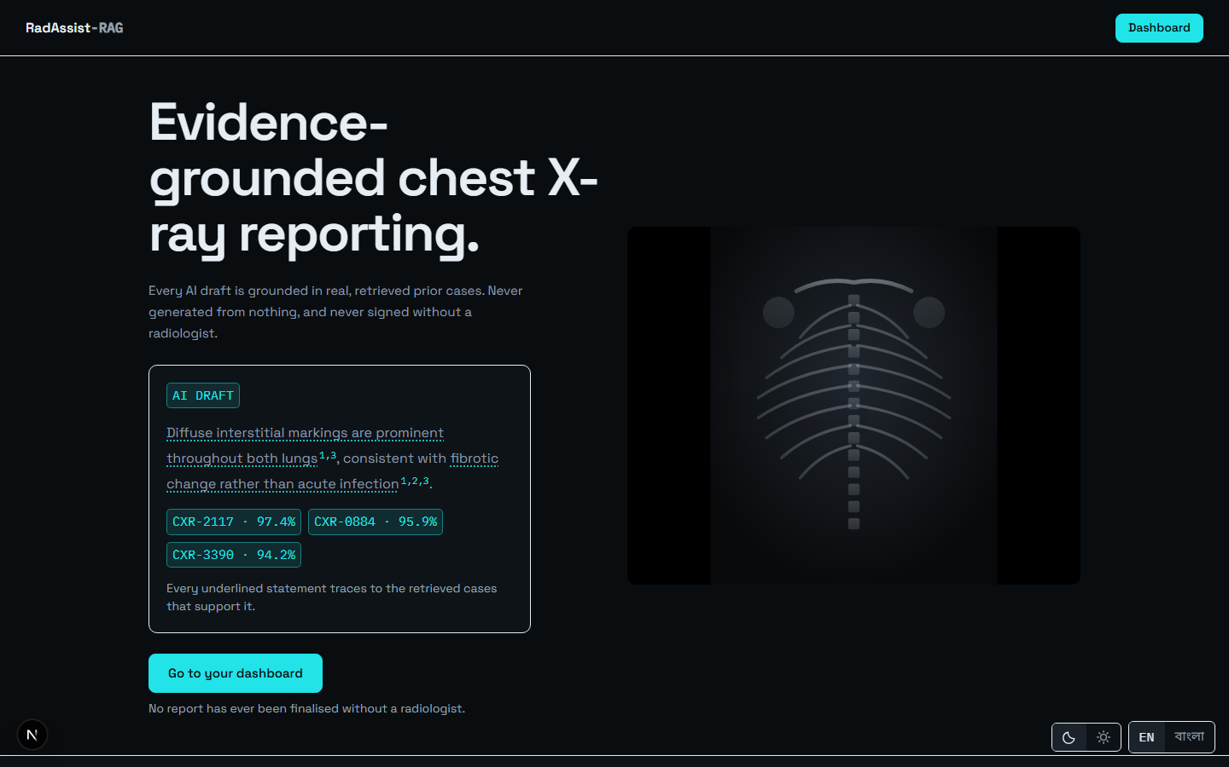
Figure 7.1: The public landing page — the first screen a new user meets.
Source: thesis final report/05_screenshots/01-landing-dark.png, captured 2026-09-23 at 1440×900 from the running system against a disposable copy of the development database.
From the landing page, choose Sign in or Register.
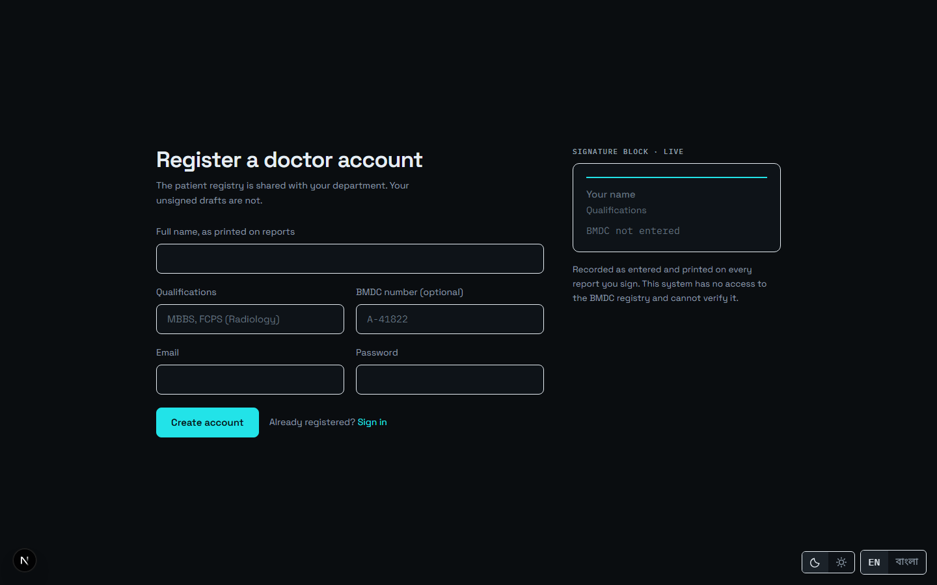
Figure 7.2: Doctor registration: full name, email, BMDC number and password.
Source: thesis final report/05_screenshots/02-registration-dark.png, captured 2026-09-23 at 1440×900 from the running system against a disposable copy of the development database.
Your BMDC number is recorded exactly as you type it and is never checked. The form says so itself: “This system has no access to the BMDC registry and cannot verify it.” The number is stored and printed on the report; it is not a verified credential, and nothing in the system treats it as one.
Passwords are stored as Argon2id hashes. There is no password reset facility — see §7.12.
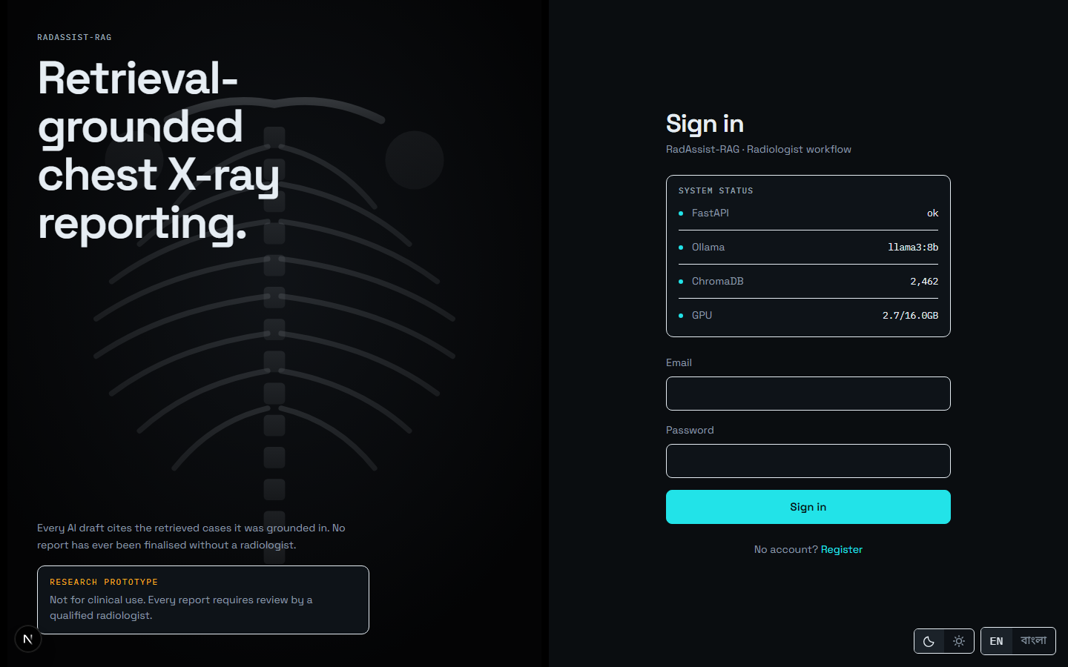
Figure 7.3: Sign in with email and password. A successful sign-in lands on the queue.
Source: thesis final report/05_screenshots/03-login-dark.png, captured 2026-09-23 at 1440×900 from the running system against a disposable copy of the development database.

7.3 The Queue — Your Worklist
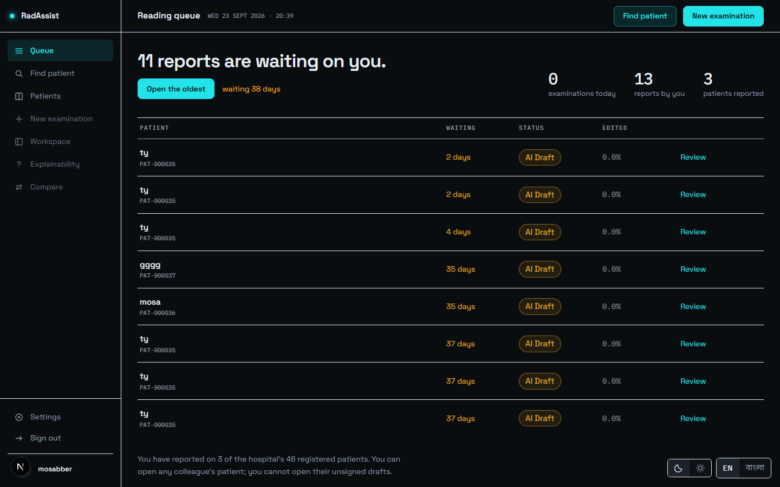
Figure 7.4: The queue: every report this doctor owns, newest first, each with its patient, date and status chip.
Source: thesis final report/05_screenshots/04-queue-dark.png, captured 2026-09-23 at 1440×900 from the running system against a disposable copy of the development database.
The queue is where signing in takes you. Each row carries a status chip — AI Draft, Doctor edited or Final — which is the report’s position in the authorship workflow rather than a quality indication. Clicking any row reopens that report.
The counts above the list are computed to agree with the list by construction: the examinations count joins to reports rather than to upload sessions, so a session abandoned before generation is not counted as an examination performed.

7.4 Finding or Creating a Patient
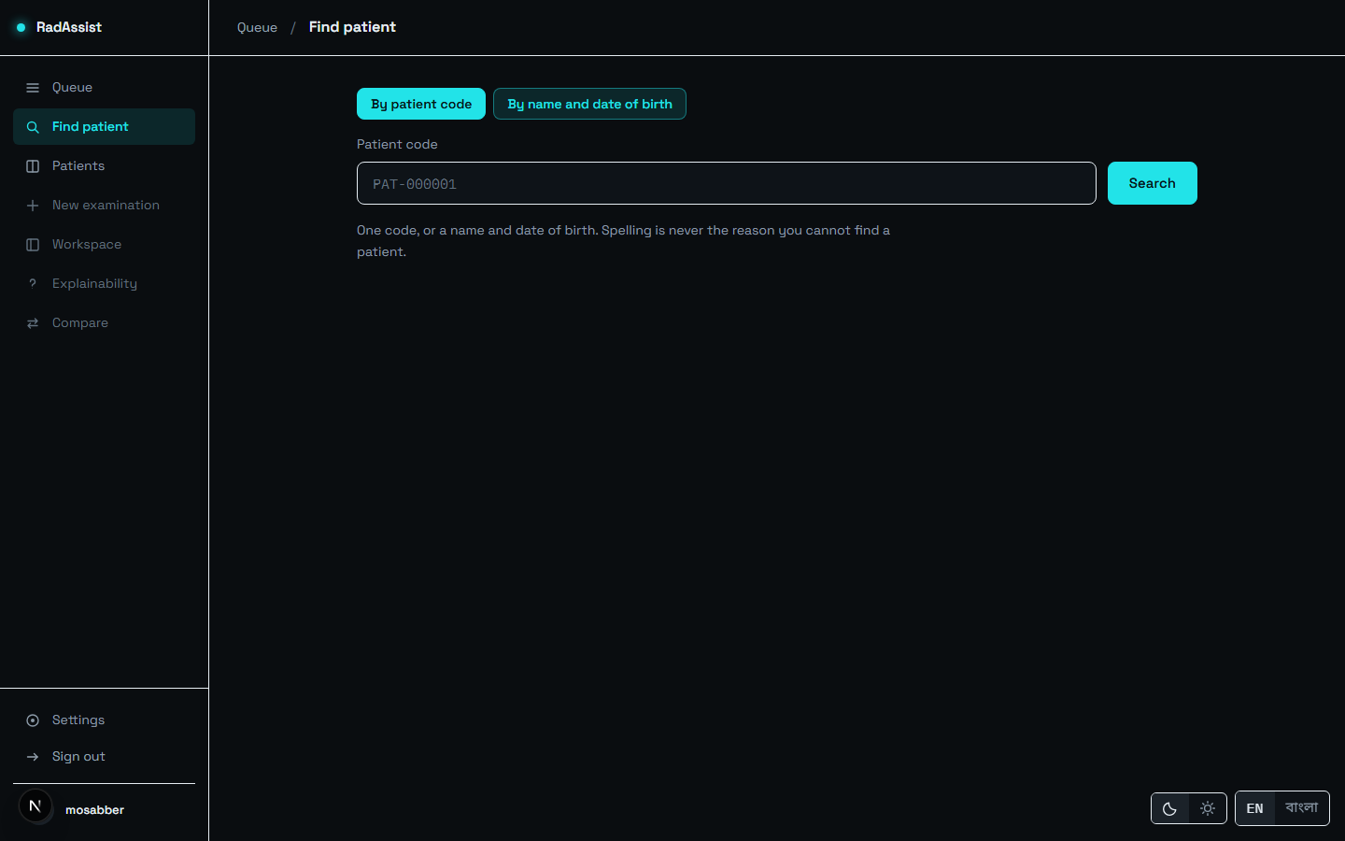
Figure 7.5: Find a patient by code or name before starting an examination.
Source: thesis final report/05_screenshots/05-find-patient-dark.png, captured 2026-09-23 at 1440×900 from the running system against a disposable copy of the development database.
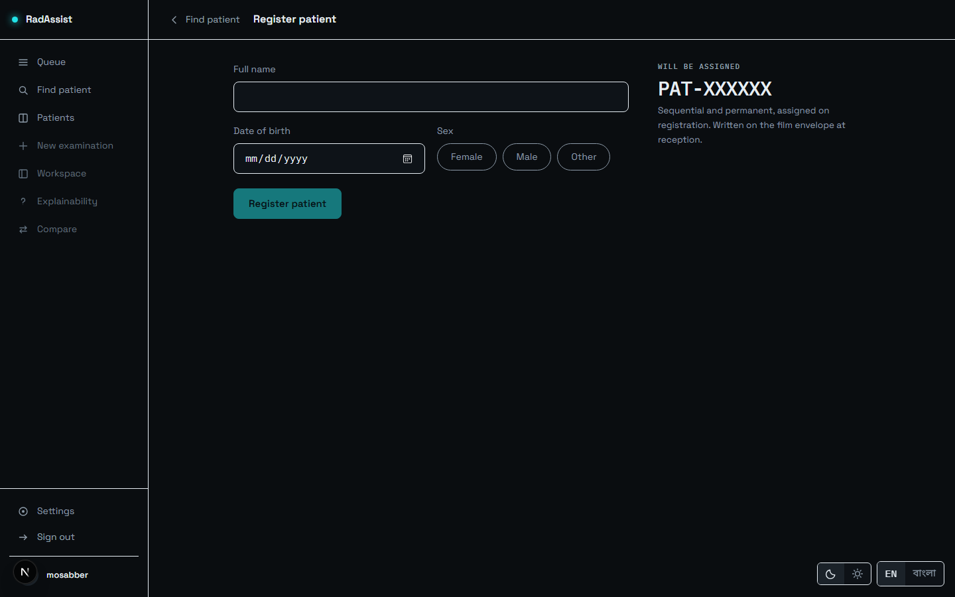
Figure 7.6: Registering a new patient: name, date of birth and gender. The system assigns the patient code.
Source: thesis final report/05_screenshots/07-register-patient-dark.png, captured 2026-09-23 at 1440×900 from the running system against a disposable copy of the development database.
Date of birth is bounded on both sides — in the input control and again in the backend — because an out-of-range year previously reached the date parser and produced an unhandled error rather than a field message.
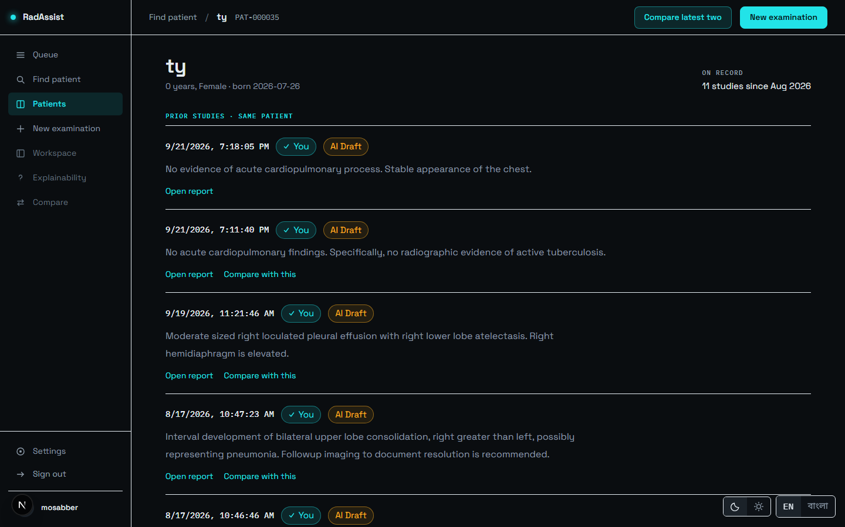
Figure 7.7: The patient profile: demographics and every prior study, in chronological order. This list is what makes comparison possible later.
Source: thesis final report/05_screenshots/08-patient-profile-dark.png, captured 2026-09-23 at 1440×900 from the running system against a disposable copy of the development database.
Patients are institutional, not owned: any authenticated doctor can find and open any patient. Ownership attaches to the work — the examinations and reports — not to the person.

7.5 New Examination — the Generate Step
This is step one of the three-step workspace: Generate → Report → Evidence.
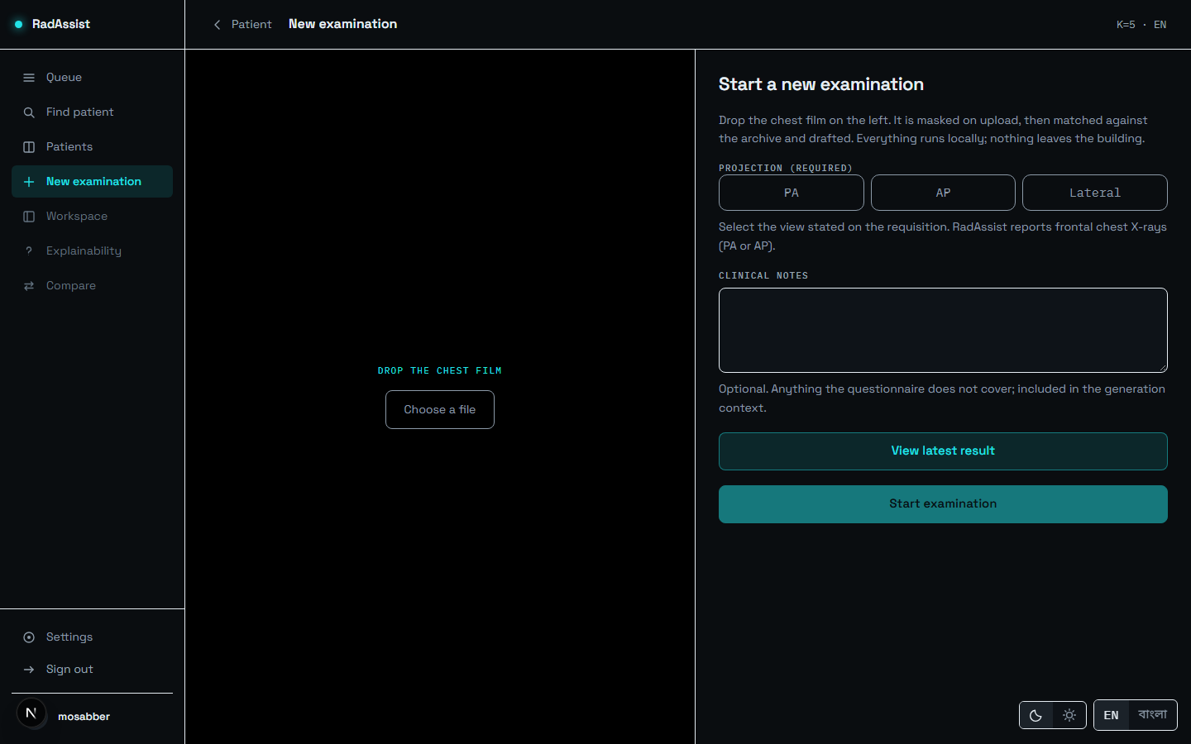
Figure 7.8: New examination: the film drop target before an image is chosen.
Source: thesis final report/05_screenshots/09-new-examination-dark.png, captured 2026-09-23 at 1440×900 from the running system against a disposable copy of the development database.
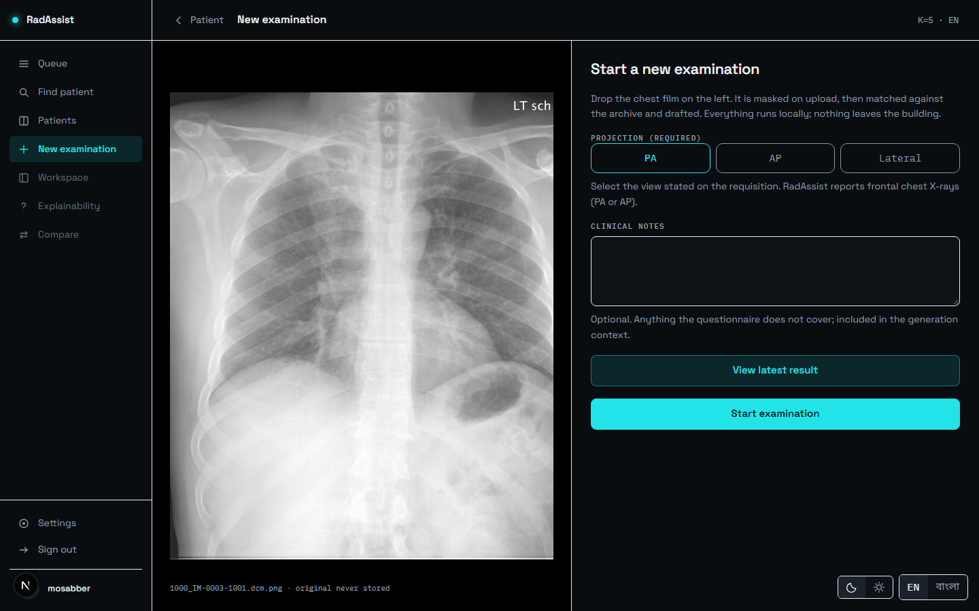
Figure 7.9: A film selected with the projection declared. Start examination stays disabled until a projection is picked.
Source: thesis final report/05_screenshots/10-upload-selected-dark.png, captured 2026-09-23 at 1440×900 from the running system against a disposable copy of the development database.
Declaring the projection is required, not optional: the control to begin stays disabled until PA, AP or Lateral is chosen. A lateral declaration is refused — the system reports frontal chest radiographs only — and it is refused before the image is masked, embedded or used to query anything.
Optional clinical notes may be typed here: “anything the questionnaire does not cover; included in the generation context.” A reveal slider shows the uploaded original beside the masked copy, drawn from a local browser object — the original is never uploaded or stored.
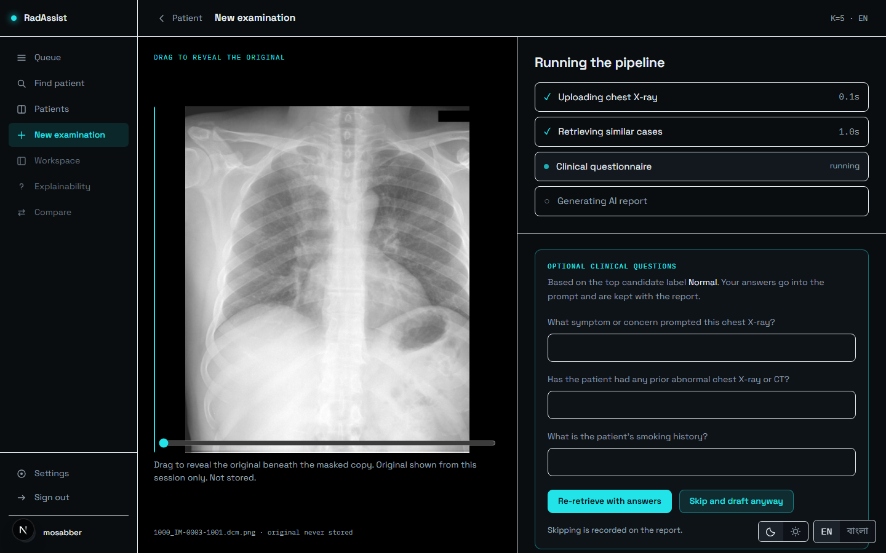
Figure 7.10: Generation in progress: four steps with live per-step timings — uploading, retrieving similar cases, clinical questionnaire, generating the report.
Source: thesis final report/05_screenshots/11-generate-in-progress-dark.png, captured 2026-09-23 at 1440×900 from the running system against a disposable copy of the development database.
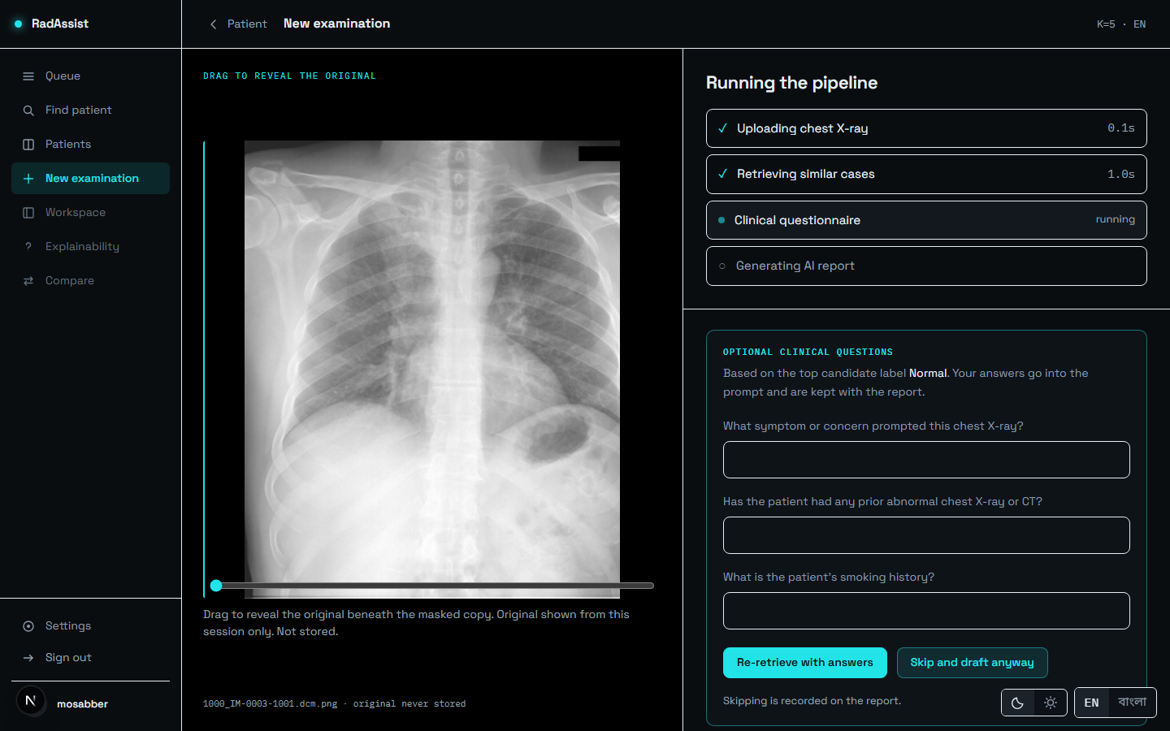
Figure 7.11: The clinical questionnaire, offered after retrieval. Its questions are conditioned on the retrieved findings. It can be skipped, and skipping can be made your default.
Source: thesis final report/05_screenshots/12-questionnaire-dark.png, captured 2026-09-23 at 1440×900 from the running system against a disposable copy of the development database.
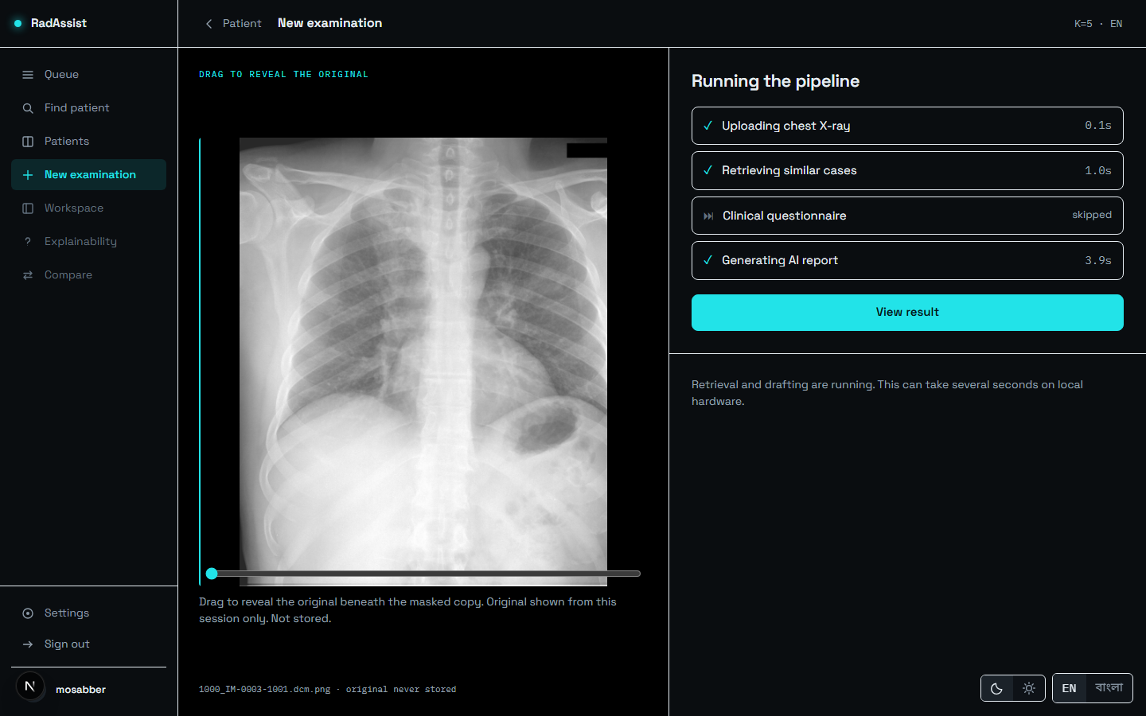
Figure 7.12: All four steps complete. In this captured run: upload 0.1 s, retrieval 1.0 s, questionnaire skipped, generation 3.9 s. This is one observation on one machine, not a benchmark — the measured distributions are in §6.9.
Source: thesis final report/05_screenshots/13-generate-complete-dark.png, captured 2026-09-23 at 1440×900 from the running system against a disposable copy of the development database.
The page does not navigate on its own. The per-step timings stay on screen until you press View result, so the pipeline’s behaviour is readable rather than appearing for a single frame.
What can go wrong at this step. A lateral film is rejected at admission. A film whose projection does not match what you declared is rejected after embedding. An image that is not a chest radiograph is refused by the modality gate. All three report on the retrieval step, and in every case both copies of the image are destroyed before the refusal returns.

7.6 The Report — Reviewing the Draft
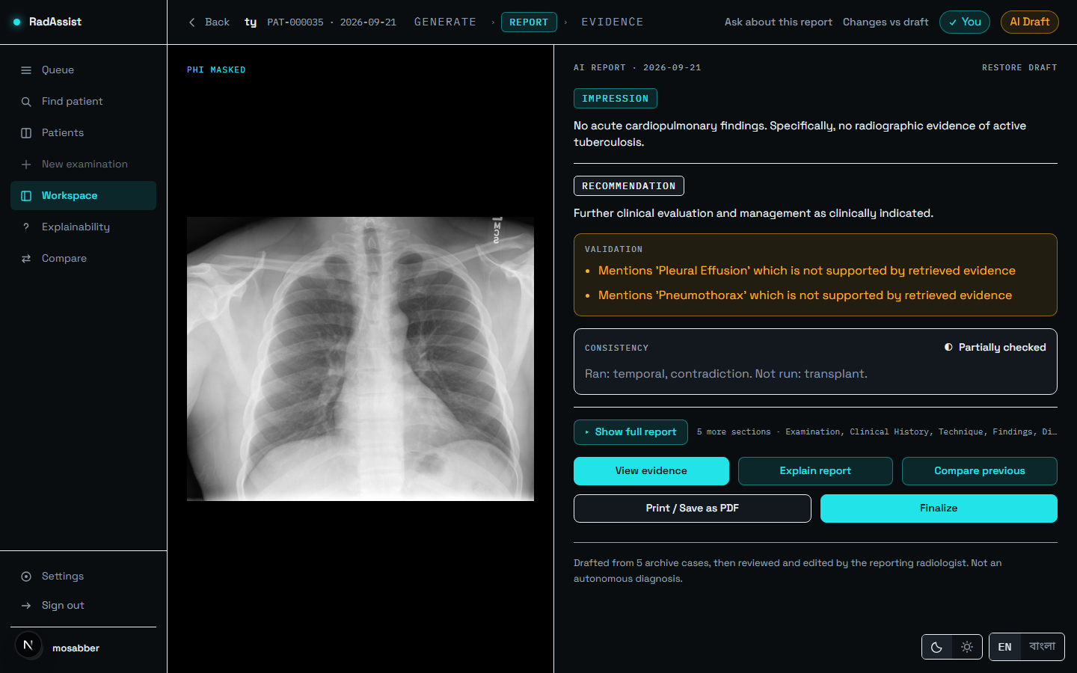
Figure 7.13: The report page. Summary first: impression and recommendation, the validation block and the consistency verdict are all visible without opening anything, with the masked film on the left.
Source: thesis final report/05_screenshots/14-result-partial-dark.png, captured 2026-09-23 at 1440×900 from the running system against a disposable copy of the development database.
Read the Impression and Recommendation first — the summary shows these two because they are the conclusions. The Validation box, where present, carries advisory warnings such as “Mentions ‘Pleural Effusion’ which is not supported by retrieved evidence.” The Consistency box carries one of three states you will actually see.

7.6.1 Reading the consistency verdict
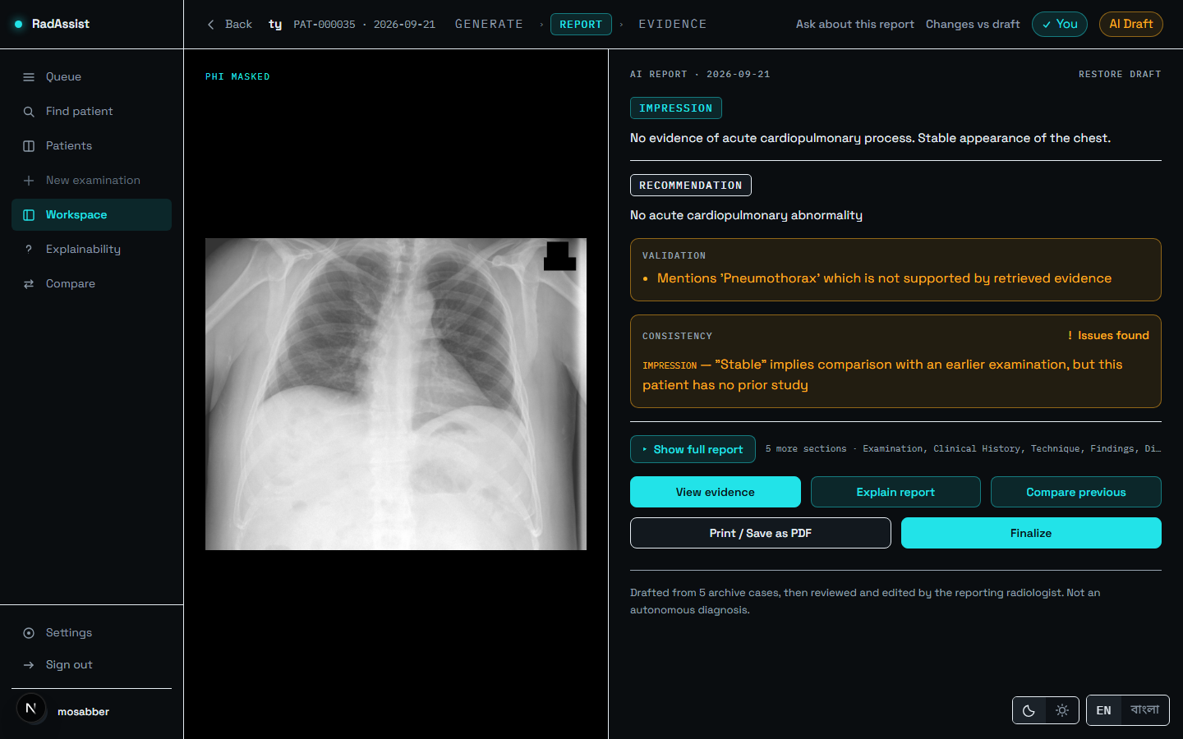
Figure 7.14: violations: a check found a problem — here a temporal-check violation on a report with no prior study. This is the actionable state.
Source: thesis final report/05_screenshots/15-result-violations-dark.png, captured 2026-09-23 at 1440×900 from the running system against a disposable copy of the development database.
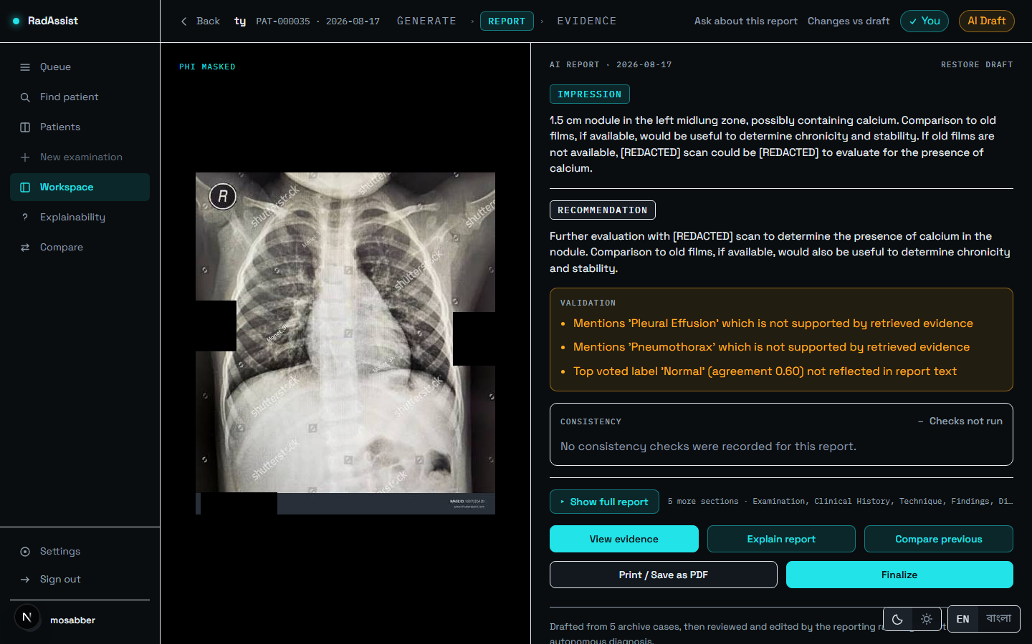
Figure 7.15: not_run: nothing was assessed. A pre-v1.2 report, shown with three validation warnings. This is not a pass.
Source: thesis final report/05_screenshots/16-result-warnings-dark.png, captured 2026-09-23 at 1440×900 from the running system against a disposable copy of the development database.
Table 7.2: The four consistency states and what each one licenses you to conclude.
Source: amendment_01_consistency_status.md §2; see §5.3.6.
State | What it means for you
Partially checked | Some applicable checks ran; at least one did not. The label names both halves: “Ran: temporal, contradiction. Not run: transplant.” This is not a pass. Every English report in this build reads this, because the transplant check has no calibrated threshold.
Violations | A check found a problem. Read the report with that specific concern in mind. Nothing is corrected automatically — the violation is recorded and acted on by nothing.
Checks not run | Nothing was assessed — a Bengali report, or a report generated before the checks existed. Not a pass.
Clean | The only genuine pass. Unreachable in this build, and you will not see it, because one of the three checks cannot yet report a result.

7.6.2 Editing and finalizing
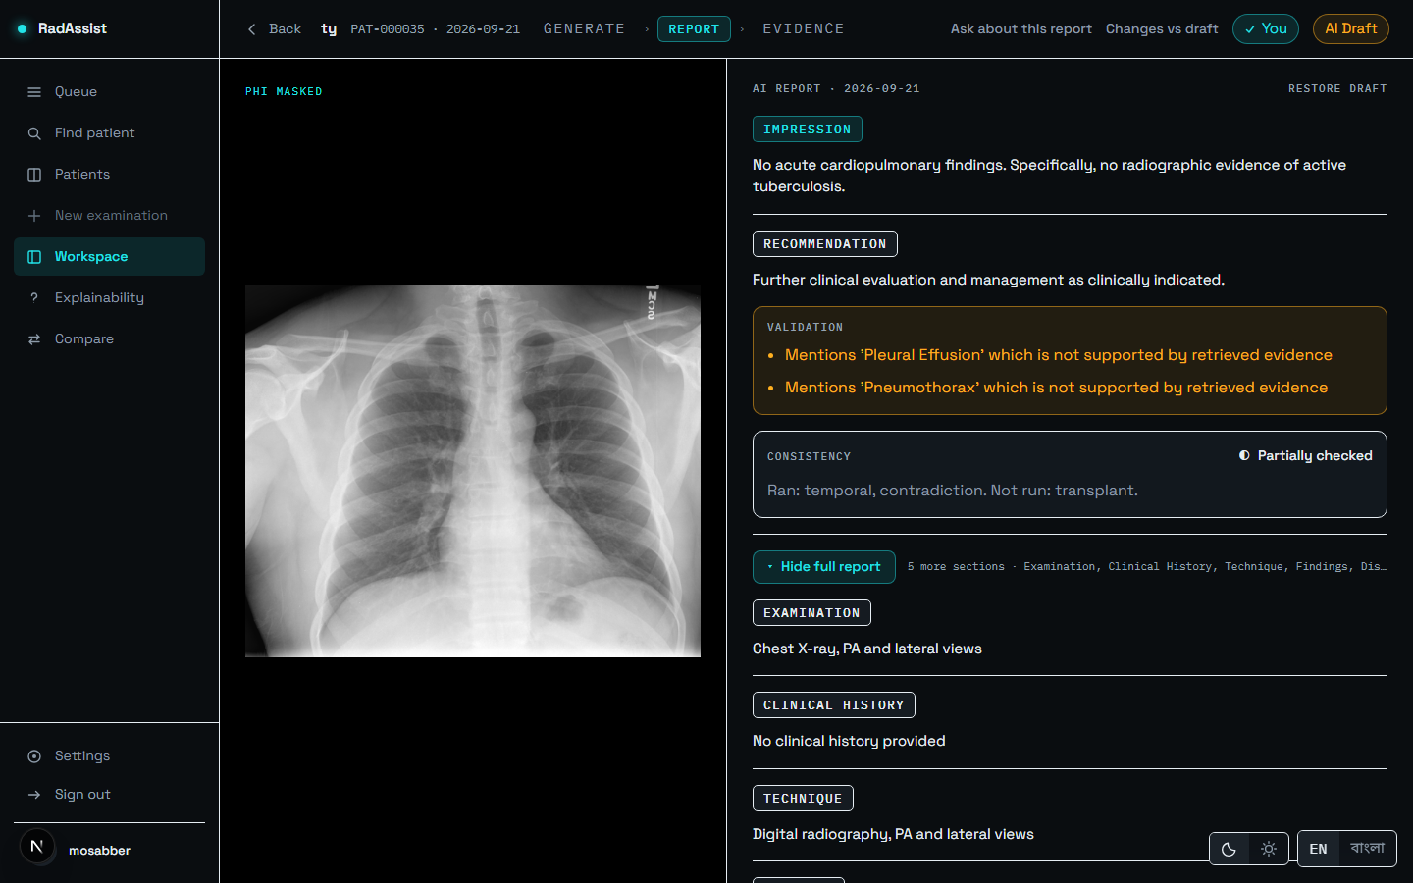
Figure 7.16: Show full report: all seven fields — Examination, Clinical History, Technique, Findings, Impression, Recommendation, Disclaimer.
Source: thesis final report/05_screenshots/18-full-report-expanded-dark.png, captured 2026-09-23 at 1440×900 from the running system against a disposable copy of the development database.
Five of the seven fields are editable directly; Examination and Disclaimer are set by the system. Editing a field moves the status chip to Doctor edited, and Changes vs draft shows a word-level comparison against the original AI draft. Any editable section can be regenerated individually, producing a candidate you accept or discard.
Press Finalize when the report is yours. Finalizing is a one-way door: after it, edits are refused, and deletion is refused too, because a signed report is an audit record.
A validation warning always describes the AI draft, never your edited text. Warnings are computed once, at generation, and are not recomputed when you edit — so a warning on a finalized report may describe text that no longer exists.

7.7 Evidence — What the Draft Was Built From
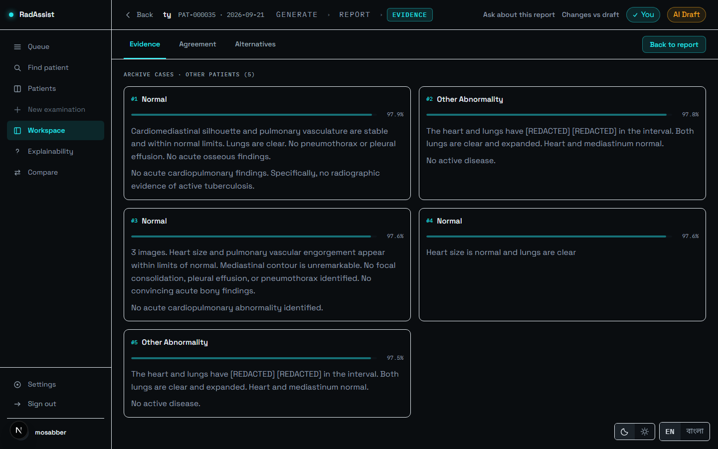
Figure 7.17: The Evidence tab: the five retrieved neighbour cases and their similarities.
Source: thesis final report/05_screenshots/19-evidence-tab-evidence-dark.png, captured 2026-09-23 at 1440×900 from the running system against a disposable copy of the development database.
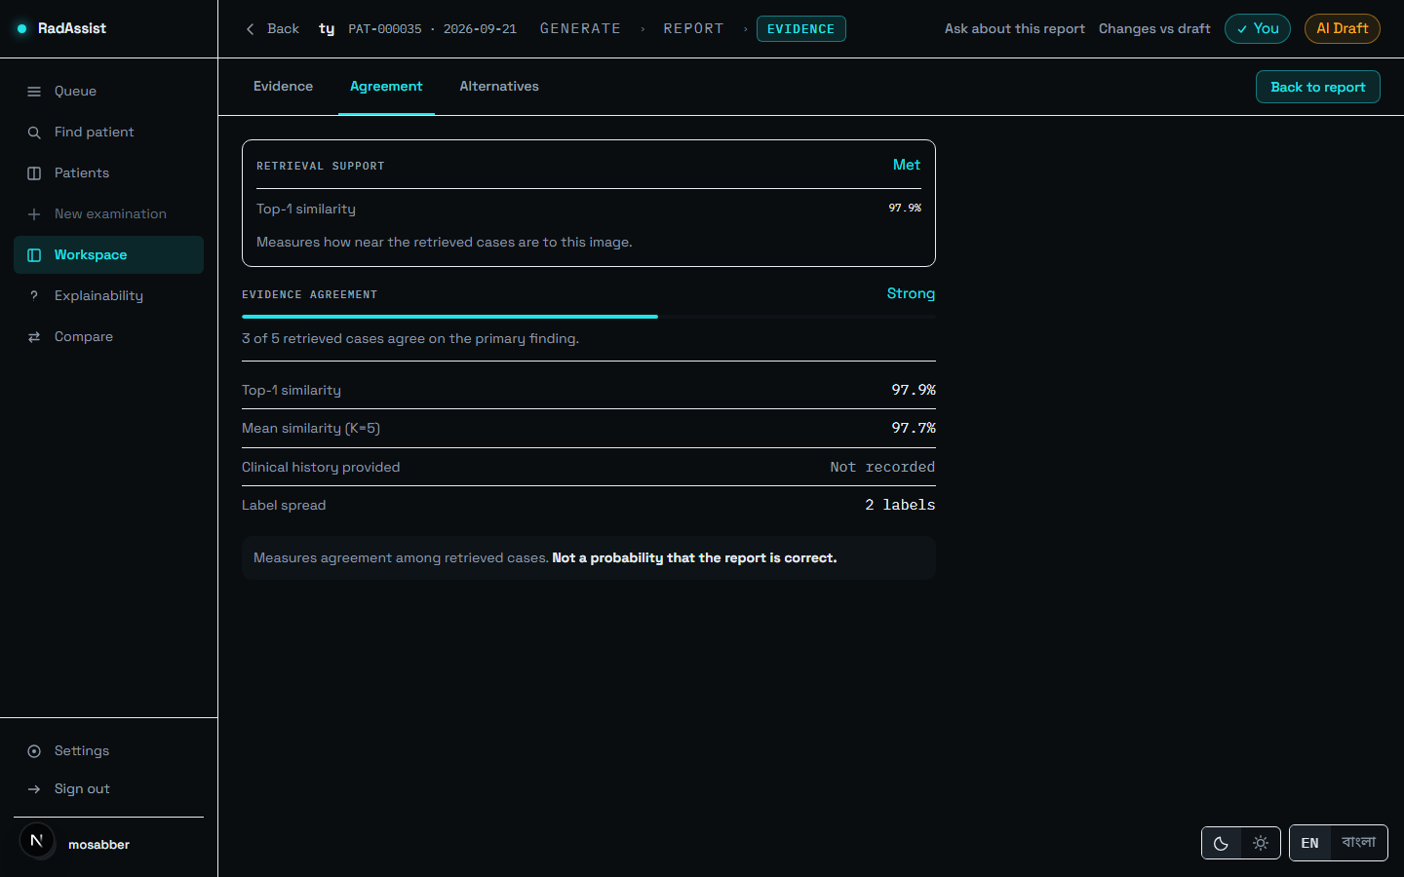
Figure 7.18: The Agreement tab: retrieval support, top-1 and mean similarity, and how many retrieved cases agree on the primary finding.
Source: thesis final report/05_screenshots/20-evidence-tab-agreement-dark.png, captured 2026-09-23 at 1440×900 from the running system against a disposable copy of the development database.
The agreement figure is not a confidence score, and the panel says so: “Measures agreement among retrieved cases. Not a probability that the report is correct.” Five cases can agree with one another and all be unlike the patient in front of you.
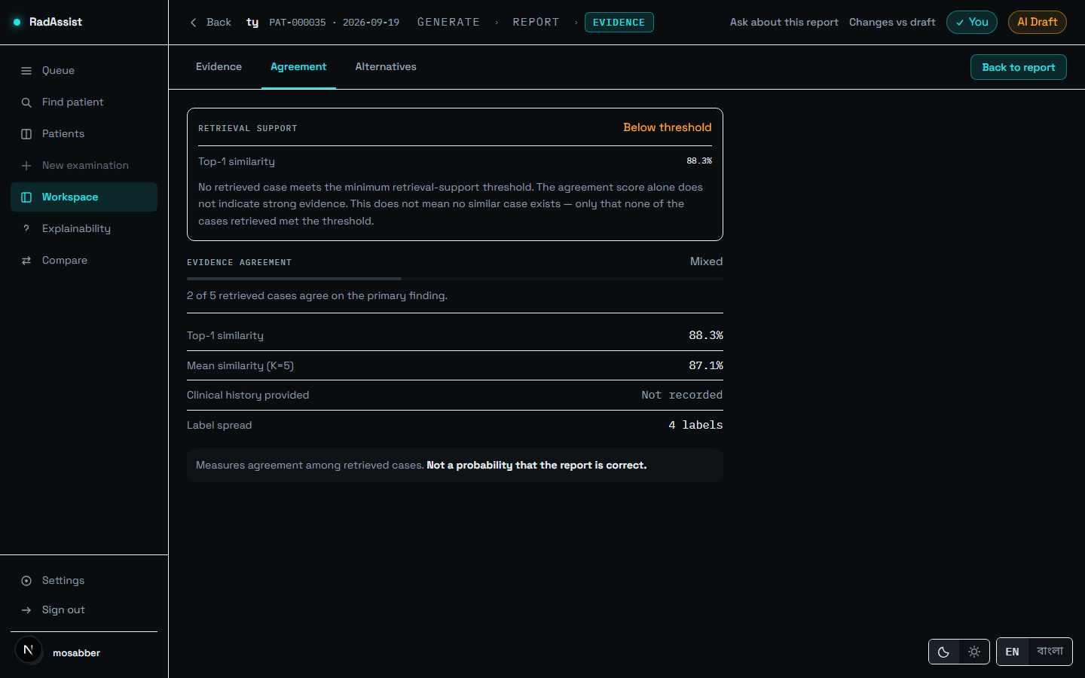
Figure 7.19: Retrieval support reading Below threshold, at a top-1 similarity of 88.3%. Treat the draft with extra care when you see this.
Source: thesis final report/05_screenshots/17-evidence-below-floor-dark.png, captured 2026-09-23 at 1440×900 from the running system against a disposable copy of the development database.
The notice states its own limit precisely: “No retrieved case meets the minimum retrieval-support threshold… This does not mean no similar case exists — only that none of the cases retrieved met the threshold.”
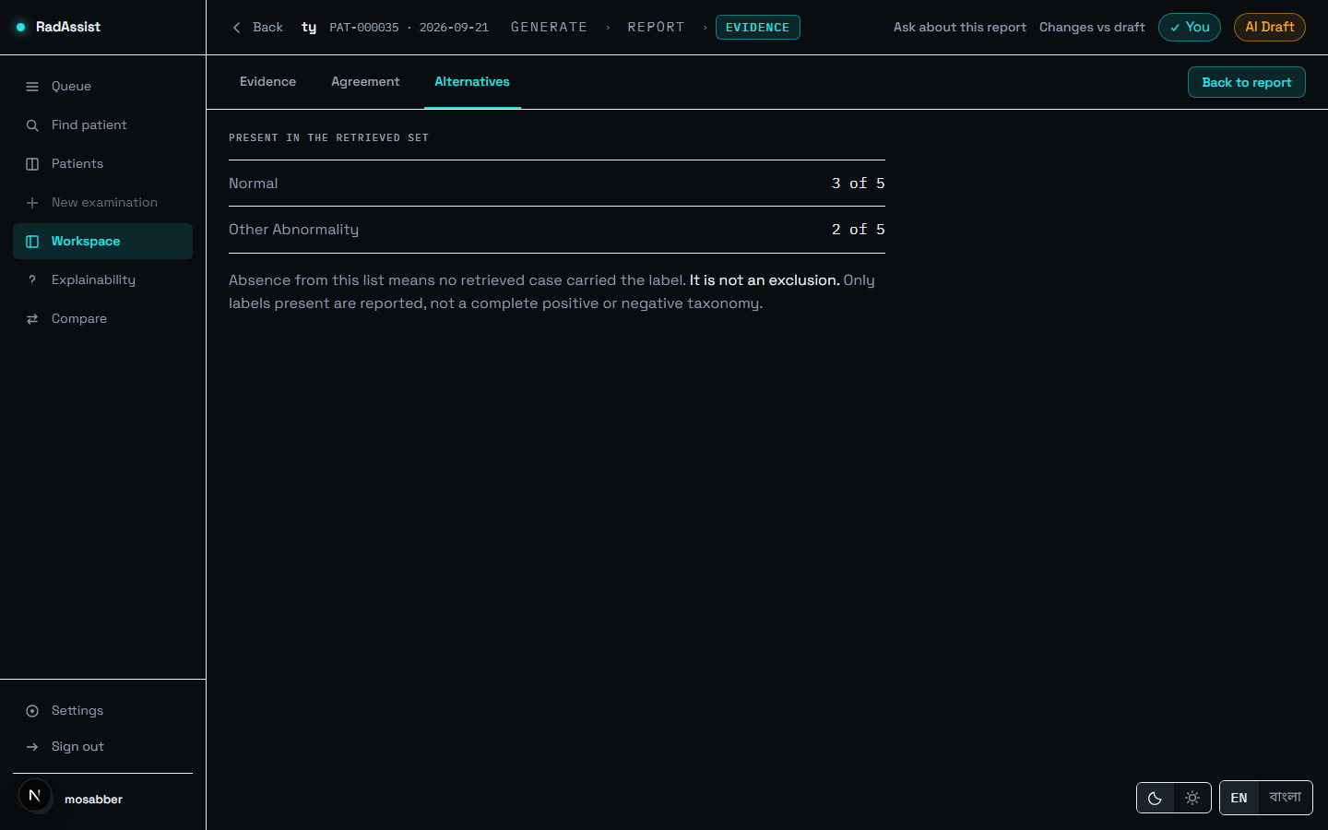
Figure 7.20: The Alternatives tab: the labels that did not win the vote.
Source: thesis final report/05_screenshots/21-evidence-tab-alternatives-dark.png, captured 2026-09-23 at 1440×900 from the running system against a disposable copy of the development database.
Moving between Report and Evidence makes no new request — both pages read the same fetched report, so navigation between them is immediate.

7.8 Explainability — Asking About the Draft
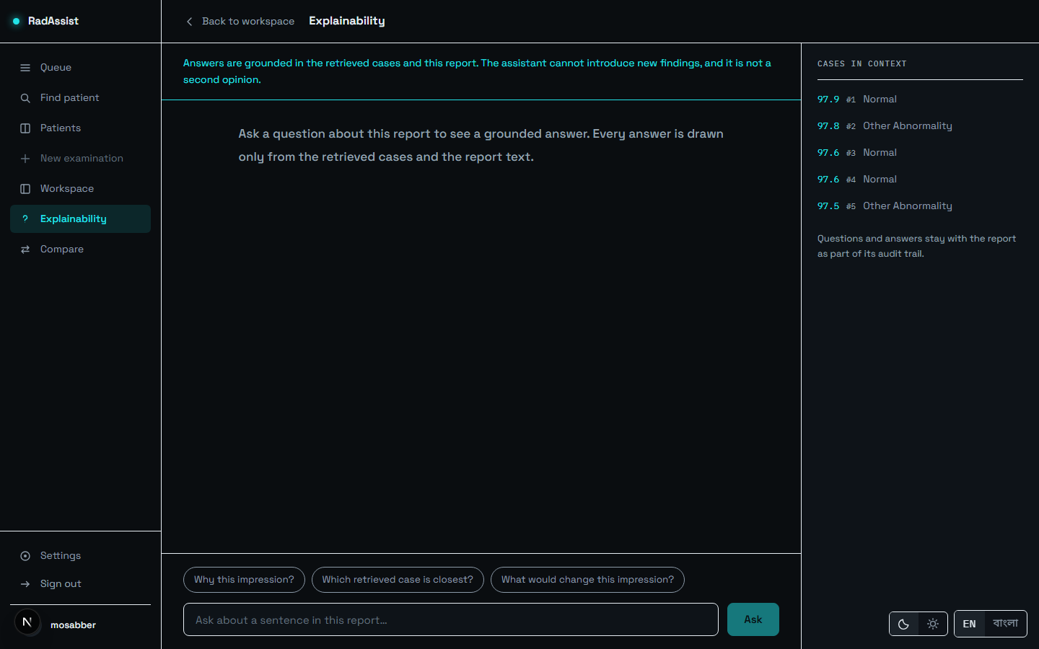
Figure 7.21: The explainability screen: suggested questions, and the cases in context with their similarities.
Source: thesis final report/05_screenshots/22-explainability-idle-dark.png, captured 2026-09-23 at 1440×900 from the running system against a disposable copy of the development database.
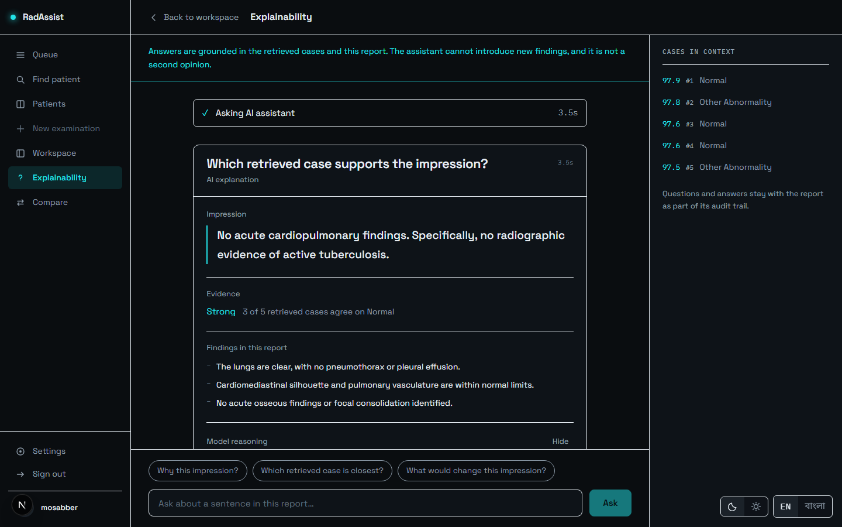
Figure 7.22: An answered question: the impression, the evidence strength, and the findings the answer rests on.
Source: thesis final report/05_screenshots/23-explainability-answered-dark.png, captured 2026-09-23 at 1440×900 from the running system against a disposable copy of the development database.
Pick a suggested question or type your own. Answers are grounded in the same evidence block the report used: “The assistant cannot introduce new findings, and it is not a second opinion.” Questions and answers stay with the report as part of its audit trail.
One limitation applies here and is stated rather than implied: the explainability prompt was changed by the v1.2 work and its output has never been evaluated by any endpoint in this project.

7.9 Compare — This Study Against a Prior
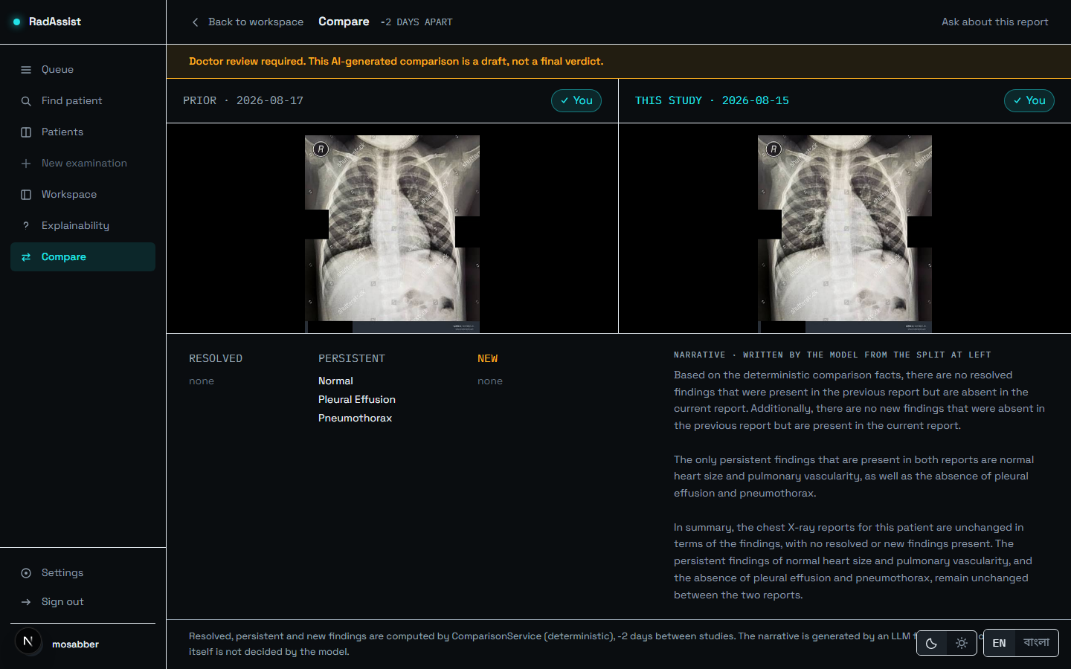
Figure 7.23: Comparison: both films side by side with their impressions, and the resolved / persistent / new split.
Source: thesis final report/05_screenshots/24-compare-dark.png, captured 2026-09-23 at 1440×900 from the running system against a disposable copy of the development database.
Comparison requires a prior report for the same patient, and any prior study may be chosen — not only the most recent. The three-column split of Resolved / Persistent / New is computed deterministically, and the narrative beneath it is written by the language model from that split only. The provenance line at the foot states which part is which: the change itself is not decided by the model.
A known defect is visible in this screenshot. The interval reads “-2 DAYS APART” — a negative value, because the prior study in the seeded capture data is dated after the current one. The system neither reorders nor rejects that ordering: the comparison is computed correctly but the guard against a reversed interval is missing.

7.10 Printing and Saving as PDF
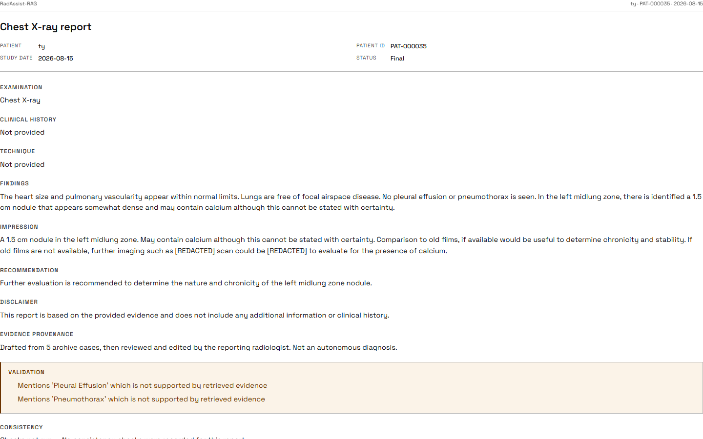
Figure 7.24: Print / Save as PDF: a one-page document with the header, all seven fields, and the validation and consistency blocks.
Source: thesis final report/05_screenshots/25-print-preview-dark.png, captured 2026-09-23 at 1440×900 from the running system against a disposable copy of the development database.
Press Print / Save as PDF, then choose Save as PDF in your browser. The printed document carries all seven fields regardless of what was open on screen, because it is built independently of the interface state rather than by re-styling the screen.
This is browser print. There is no server-side PDF generator — the file is produced by your browser, so its pagination and fonts are your browser’s. The control is labelled accordingly.
The validation warnings and the consistency verdict always print, in every state. The signature block prints only on a finalized report: a draft is not a signed document, and a name printed under one would claim otherwise on a page that outlives the screen.

7.11 Settings, Language and Theme
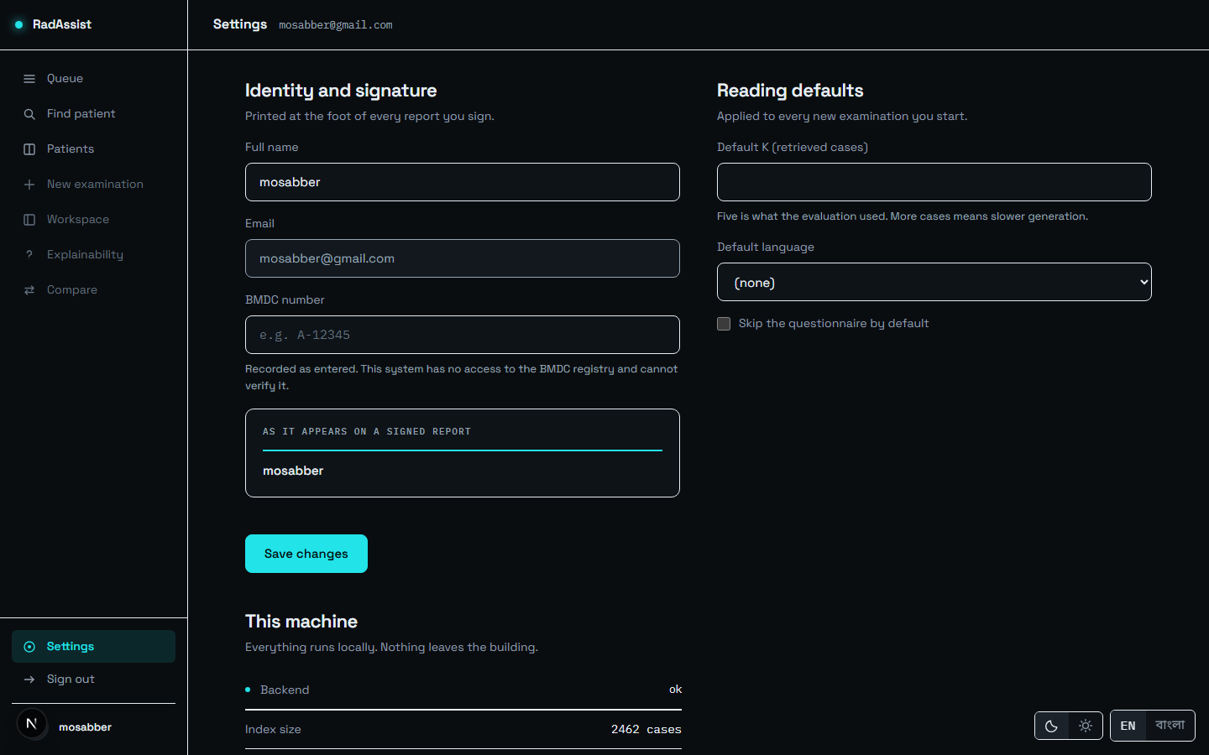
Figure 7.25: Settings: profile fields and workspace defaults. Settings is the profile screen — there is no separate profile route.
Source: thesis final report/05_screenshots/26-settings-profile-dark.png, captured 2026-09-23 at 1440×900 from the running system against a disposable copy of the development database.
Settings holds your name and BMDC number together with workspace defaults: how many neighbour cases to retrieve, your default language, and whether to skip the questionnaire. These become the defaults for every new examination — and they are genuinely honoured, which was not always true: an earlier build persisted preferences that nothing read, and two preferences whose promised behaviour did not exist were removed from the screen rather than left as inert controls.
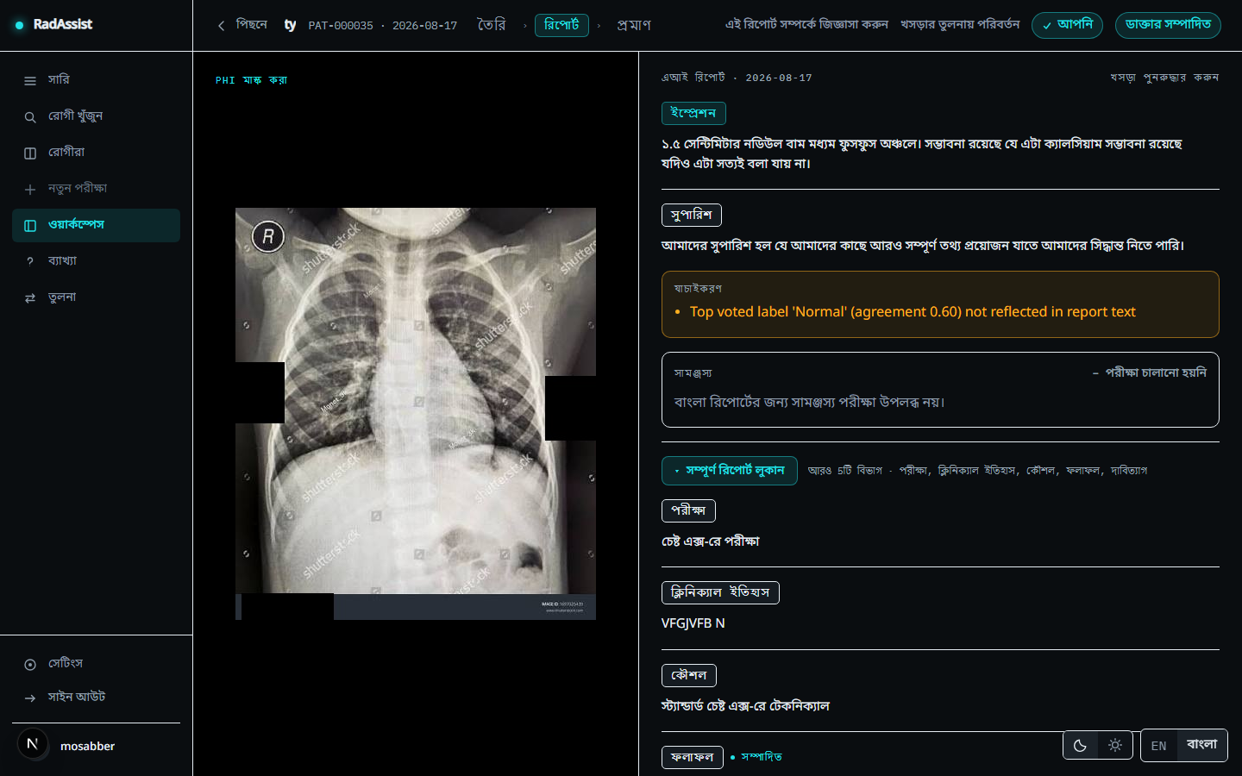
Figure 7.26: A Bengali report: the interface and the report body are both in Bengali, and the consistency block reads “checks not run” with the reason given in Bengali.
Source: thesis final report/05_screenshots/27-report-bengali-dark.png, captured 2026-09-23 at 1440×900 from the running system against a disposable copy of the development database.
The EN / বাংলা toggle is on every screen. Switching it changes the whole interface, and new reports are drafted in the selected language — generated directly in Bengali, not translated from English.
A Bengali report always reads “consistency checks not run”. All three checks are English-only, and the system is deliberate about showing this rather than showing nothing: a Bengali report showing a green tick — or showing nothing at all, which a clinician reads as “nothing wrong” — would convert an acknowledged coverage gap into an affirmative false assurance, which is worse than the gap itself.
A known gap is visible in Figure 7.26: the validation warning text is still in English on an otherwise fully Bengali screen, because those strings are composed by the backend rather than by the interface.
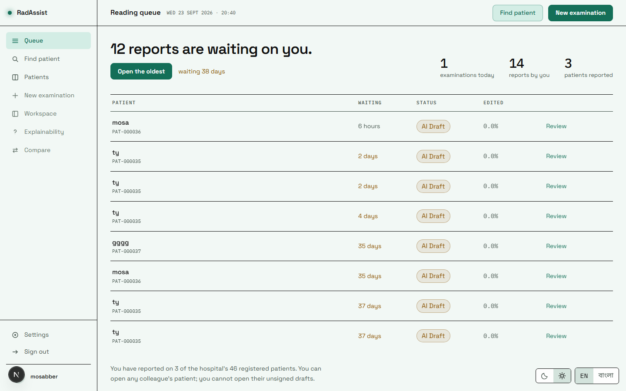
Figure 7.27: The queue in the light theme. Dark is the product’s native theme; light is a separately derived palette, not an inversion.
Source: thesis final report/05_screenshots/29-queue-light.png, captured 2026-09-23 at 1440×900 from the running system against a disposable copy of the development database.
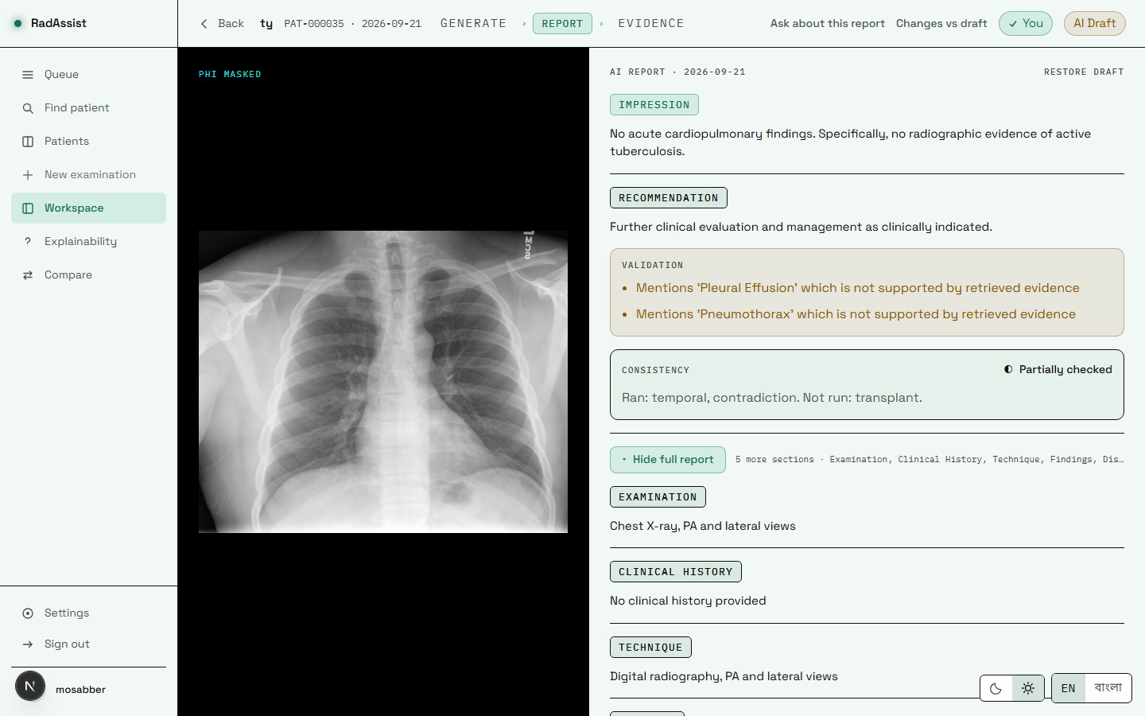
Figure 7.28: The report page in the light theme. Every colour pair was measured for contrast over its real backdrop in both themes.
Source: thesis final report/05_screenshots/31-result-partial-light.png, captured 2026-09-23 at 1440×900 from the running system against a disposable copy of the development database.
The moon/sun toggle sits beside the language toggle on every screen. The film panel stays black in both themes, because a radiograph is read against black and that is a clinical condition rather than a decorative choice.

7.12 What This Manual Must Not Promise
These are asked about often and do not exist in this build. They are listed here so the manual cannot be read as implying them.
Table 7.3: Capabilities the system does not have, and why.
Source: 07_manual/user_manual_outline.md §13; 01_facts/feature_catalogue.md §7.
Not available | Why
BMDC verification | No registry access. The number is stored exactly as typed and is never checked against anything.
An administrator role or screen | No role exists in the database. Access control is ownership only.
Server-side PDF export | Printing is the browser’s. No export endpoint and no PDF library exist.
Automatic correction of a consistency violation | Not built. Violations are recorded only — 17 of 477 in the evaluation run were acted on by nothing.
A “clean” consistency verdict | Unreachable until the transplant check’s threshold is calibrated.
Any Bengali quality guarantee | Never measured. No Bengali output has ever been evaluated in this project.
Password reset / forgot password | No reset-token storage and no mail transport. Self-registration performs no email verification either.
MRI, CT or lateral views | Frontal chest radiographs only, enforced at admission.
A diagnosis | The system is decision support. No output is a diagnosis, and no radiologist has validated any output it has produced.
This chapter has covered installation and every real screen of the delivered system, together with the capabilities it deliberately does not have. Chapter 8 concludes the report.

Chapter 8 Conclusion and Future Work
This chapter closes the report. It summarises what was built and measured, states the contributions this project makes and the impact they can reasonably be claimed to have, and sets out the work that should follow — in each case naming why that work was not done here.

8.1 Summary of the Work Done
This project set out to determine whether a retrieval-grounded, locally deployable chest X-ray reporting assistant could be built and honestly evaluated on the resources available to a student team, and whether the evidence would support the claims usually made for such systems. It produced three things: a working system, a body of evaluation evidence, and a defect found in its own output that was then diagnosed, fixed and re-measured.

8.1.1 The system
RadAssist is a complete, working clinical decision-support workspace. A doctor registers, opens a patient, uploads a frontal chest radiograph, and receives a structured seven-field draft report grounded in five real archived cases that the doctor can open and judge. They edit it, regenerate any section, ask questions about it, compare it against a prior study, sign it, and print it — in English or Bengali.
Behind that flow: 26 API operations across 12 routers, 36 service modules, 21 Protocol interfaces, 9 database tables reached through 15 migrations, 15 frontend routes, and 672 passing automated tests. The whole stack — an 8-billion-parameter language model, a frozen image encoder and a clinical labeller resident together with inference running — peaks at 7,125 MiB of 16,376 MiB on one consumer GPU and produces a report in 4.50 seconds on average across 477 cases. Nothing is trained: the encoder is frozen, the language model is used as distributed, and the labeller is a published checkpoint. Improving the system means changing a prompt, a threshold or the contents of the knowledge base.
The architecture is retrieval-based rather than classification-based, and that was an evidence-driven reversal of the original proposal rather than a preference. It is also the property from which everything else follows: because the system retrieves real cases instead of predicting a label, every statement in a draft has a source a reader can open.

8.1.2 The evaluation
Five evaluation phases ran under a pre-registered, gated discipline in which the decision rule was committed before any output existed to score — verifiable from commit order, not merely claimed. The discipline was applied symmetrically, and this is the part of the work the project is most willing to defend:
- Phase 0 adopted BiomedCLIP as the encoder on a four-way comparison with pre-registered gates — and reported that one of the two Gate 2 criteria was inconclusive rather than rounding up to a clean sweep. The comparison also showed the originally proposed classifier retrieving below the random baseline, which is what reversed the architecture.
- Phase 20 measured generation quality in three tiers and discarded one of them: BERTScore scored randomly paired reports at 0.8403 against 0.8420 for real ones, failing its own pre-registered validity bar. Discovering that a chosen instrument does not measure anything is a result, and it was reported as one.
- Phase 21 tested whether full retrieved evidence beats retrieval-as-classifier. Its pre-registered primary endpoint did not clear at either sample size — +0.0256 [−0.0198, +0.0710] at n=477 — and no secondary metric was promoted in its place, because the pre-registration forbade that in advance.
- Phase 22 diagnosed, fixed and re-measured the grounding defect described below.
- Phase 23 tested a larger model and an explicit label checklist against the incumbent on a development set held apart from the test pool. Neither improved it; the mechanically applied selection rule returned the incumbent, and Step 3 was correctly never run.

8.1.3 The defect, and its remediation
The most consequential work in this project began with a single report that contradicted itself. Its findings stated the cardiomediastinal silhouette was unremarkable; its impression asserted “Stable cardiomegaly with right mediastinal shift” — which turned out to be another patient’s impression, copied almost word for word from the top retrieved neighbour, with “stable” referring to a prior study that did not exist.
Rather than patch the instance, the project measured the mechanism. Across 477 reports, 35.0% used comparison language with no prior study, 23.5% of scorable impressions reproduced a neighbour’s impression at a 5-gram overlap ratio of 1.0, and 4.6% contradicted themselves between sections. Four root causes were confirmed, three of them independently sufficient; the fourth explained why none had been caught. The central insight is a correction to how the literature usually frames this failure: the retrieval was working. The neighbours were genuinely similar cases. The defect lay between retrieval and generation — a prompt that rendered other patients’ text with no attribution boundary and a grounding rule that forbade only invention, and thereby rewarded copying.
The fix was an explicit attribution boundary, a requirement that the impression follow this report’s findings, and a statement that no prior study exists. Measured under criteria fixed before the fix ran: comparison language fell 35.0% → 2.7%, self-contradiction 4.6% → 0.8%, and harmful transplantation roughly halved on a common denominator — while the clinical guardrail improved rather than degrading. The obvious alternative explanation, that the system simply writes less, was refuted on four independent tests, the decisive one being that recall rose where truncation would have lowered it.
Two things must be said in the same breath, and they are said throughout this report. The fix passes every automated criterion but is not finally adopted, because a pre-registered blinded manual read — a withhold trigger that overrides a clean pass — has not been performed. And a residual defect survives in the opposite direction: 27 of 477 reports (5.7%) state an abnormality in their findings and call the study normal in their impression. No check covers it and no endpoint measures it.

8.2 Key Contributions and Impact

8.2.1 Contributions
- A retrieval-grounded, bilingual reporting workspace that runs on one consumer GPU. The contribution is not any single component — all are public — but the demonstration that they compose into a complete, evidence-traceable clinical workflow within 7.1 GiB of VRAM and 4.5 seconds per report, with no external service and no patient data leaving the host. This addresses the infrastructure gap directly: the published state of the art in this area is benchmarked on GPU clusters, and a design that only works there is not deployable where it is most needed.
- Direct Bengali generation in a radiology reporting system. Reports are generated in Bengali rather than translated into it, so there is no translation pass to introduce drift. The contribution is delivered and must be stated with its limit attached: it has never been evaluated.
- A pre-registered evaluation discipline for a generative clinical system, and the negative results it produced. This is the contribution the project would defend most strongly. Generative systems produce many measurable quantities, and a criterion chosen after the numbers are visible is selection rather than evidence. Freezing criteria first is what makes a null meaningful — and this project produced several: a primary endpoint that did not clear, a metric discarded for failing its own validity bar, an optimisation experiment whose winner was the incumbent, and a defect disclosed in its own pre-registration protocol. Reporting these at the same weight as the positive results is itself the contribution.
- A diagnosis of grounded hallucination as an attribution failure rather than a retrieval-quality failure. The literature generally treats this failure mode as retrieval noise, to be fixed with better retrieval. This project shows a case where retrieval was working and the failure arose from the absence of an attribution boundary between the retrieved text and the generated text — and then demonstrates that adding that boundary reduces the defect by roughly 32 percentage points without the accuracy cost such constraints are assumed to carry. The methodological contribution sits alongside it: a held-out synonym tripwire, whose terms were never shown to the model, distinguishes a real behavioural change from mere word-avoidance, and a noise-floor measurement showing 67% output variation with 0.0 percentage points of endpoint movement establishes that the result is not re-run noise.
- Privacy-preserving masking placed before embedding, with its safety measured and its limits stated. Masking runs before the encoder, so the vector the system judges and stores derives from pixels the system is willing to keep; the filename is read once for its extension and never retained. The embedding impact was measured at a mean cosine similarity of 0.992. Equally a contribution is the refusal to overstate it: detection recall is unmeasurable on a dataset with no burned-in-PHI ground truth, and the masking rate is reported as pipeline evidence rather than as a detection metric.
- A worked account of safety requirements surviving from architecture into interface. A frozen requirement that an unchecked state must never resemble a pass is implemented as four separate renderers rather than one parameterised by a colour lookup — because the parameterised version is the one a later edit quietly breaks. The visible consequence is that every English report reads “partially checked”, which is correct rather than unfortunate: one of three checks genuinely is not operational, and the earlier behaviour asserted a completeness the system does not have.

8.2.2 Impact, stated at the strength the evidence supports
What can be claimed. The project demonstrates that an evidence-grounded reporting assistant is technically feasible on hardware a district-level facility could own, that its marginal cost per report involves no third party, and that such a system can be evaluated rigorously enough for its failures to become visible and fixable. For a setting where films can be acquired but not promptly reported, a locally deployable drafting tool that keeps a qualified reader as the author addresses the constrained step rather than the abundant one.
What cannot be claimed, and is not. No clinical impact has been demonstrated. No radiologist has used this system or evaluated any output it has produced. Absolute clinical accuracy is low — macro-F1 of 0.1511 on findings and 0.1808 on impression in Phase 20 — and 5.7% of reports carry a known internal inconsistency. No cost–benefit figure is offered, because the two quantities it would need (the baseline cost of reporting, and the time a clinician actually saves) were never measured. And no regulatory process was entered: the system must not be used for clinical care in its current form.
The honest summary of impact is therefore that this project produced a credible feasibility demonstration and an unusually complete evidence trail, not a deployable clinical product. The distance between those two is the subject of §8.3.

8.3 Recommendations for Future Enhancements
The items below are ordered by what most constrains a claim this project would otherwise want to make. Each states why it was not done here.

8.3.1 Complete the evidence before extending the system
Table 8.1: Work that unblocks a claim the current evidence cannot support.
Source: 08_admin/open_items.md; §6.5, §6.12.
# | Work | Why it was not done now | What it unblocks
1 | The blinded manual read. Two readers score 40 blinded reports with no version information, against a separately held answer key. | The packet was built and 0 of 2 readers submitted. It requires reader time the project ran out of, not engineering. | The adoption claim for v1.2. This is a pre-registered withhold trigger that overrides a clean pass on all three gating criteria, so until it is done the correct statement remains “passes every automated criterion”, not “cleared for adoption”.
2 | A clinician validation study. A qualified radiologist evaluates output quality and the interface, with a stated protocol and sample size. | No clinician was available to the project, and no feedback instrument or protocol exists. The one round of external testing recorded was a software QA pass, not a clinical one. | Every usability and clinical-utility claim, and the cost–benefit estimate §3.11.4 declines to give. It would also supply the clinically-informed review the label taxonomy has always been stated to need.
3 | Bengali evaluation. Any defect or accuracy rate for Bengali output. | Every harness hardcodes English, and all three consistency checks are English-only by construction. Extending them is a real piece of work, not a configuration change. | Any Bengali quality claim whatsoever. The feature is shipped and unmeasured; at present the thesis can describe it but cannot vouch for it.

8.3.2 Finish the safety mechanism that was deliberately left observational
- Gate B — calibrate the transplant threshold. The check currently computes its scores and can emit no violation, which is why no English report can read clean. It was not done because calibrating it needs a labelled set the project does not have, and passing a number now would be inventing one. The calibration input already exists: the per-case transplant scores from the 477-case evaluation run were written precisely for this purpose.
- Gate C — act on a violation. Today a recorded violation is acted on by nothing: 17 of 477 were recorded and none was corrected. This was deliberate rather than unfinished — the evaluation’s scope was explicitly observational, so that detection could be measured separately from action, and being retry-free is precisely what keeps its primary endpoint clean of the circularity in which the same detector both triggers a retry and scores the outcome. A retry budget exists in configuration and is read by no service. Gate C should follow Gate B, because a retry triggered by an uncalibrated check would fire on noise.
- Cover the omission defect. The current constraint forbids the impression asserting what the findings did not state; it says nothing about the reverse, and 27 of 477 reports omit from the impression an abnormality their own findings assert. No check covers it and no endpoint measures it. It was not done because it was discovered in the post-hoc analysis after the evaluation had run, and adding a check to the system being evaluated would have invalidated the comparison.
- Record the structural retry attempt count. Every “zero structural failures” in this report means zero failed after retries, never zero needed a retry, because the attempt count is discarded. It was deliberately not bundled into the remediation work, so that an open, unscoped decision would not be settled implicitly by a fix that was ready to evaluate. A known confound is already recorded: retried attempts use a different prompt, so attempt counts would not be exchangeable observations even once recorded.
- Surface the consistency verdict beyond the report page. All four states now render on the report screen, but the verdict does not appear in the queue or in any list view, so a doctor scanning their worklist cannot see which reports carry a violation. This was simply not reached before the project ended.

8.3.3 Strengthen the evidence base
- Larger and more diverse datasets, and a knowledge base matched to the deployment population. Every number in this report derives from a single US-sourced corpus of 3,851 studies, applied to a Bangladeshi deployment context with different disease prevalence — tuberculosis being the clearest example, rare enough in the source corpus to be routed into a catch-all class. This was not done because no other paired image-and-report dataset was available to the project. The architecture makes this unusually tractable: because nothing is trained, replacing the knowledge base does not require retraining anything — but it does require re-validating, which is the actual work.
- A rare-finding-enriched evaluation set. This project established that macro-F1 confidence intervals do not narrow as 1/√n on a long-tailed label distribution — extending from 100 to 477 cases reduced the interval width by 5% against a predicted 2.2×. Collecting more cases from the same distribution is therefore not a route around the Phase 21 null. A properly powered re-run needs a case set enriched for rare findings. The same limitation explains why the label-checklist hypothesis is not refuted: the development set could not detect improvement precisely where the checklist would be expected to help.
- The per-stage latency profile. A P50/P95 breakdown per pipeline stage was specified and never produced — the file and its directory do not exist. The whole-request figures that do exist come from other phases and other instruments. This is the measurement a resource-constrained deployment argument should ideally rest on.

8.3.4 Extend the system
Table 8.2: System enhancements, and why each was out of scope here.
Source: §3.1.3; 01_facts/feature_catalogue.md §7.
Enhancement | Why not now
Validated image explainability — for example attention rollout over the vision transformer. | Deferred on ethical grounds, not technical ones. A saliency map is read as the system looked here, inviting trust proportional to its apparent precision. This project has no localisation ground truth — the dataset provides report text and labels, not bounding boxes — so any map could be displayed but not validated. The prerequisite is localisation ground truth; the map is the easy part.
DICOM and PACS integration; HL7/FHIR messaging. | Explicitly out of scope. The system accepts PNG and JPEG through a browser. This is the single largest piece of work between the prototype and a clinically usable deployment, since no radiology department transfers images by file upload.
Server-side PDF export. | Would require a renderer, a template language, a document store and — the genuinely hard part — a server-side Bengali font stack. Browser print reaches paper without any of it, and the control is honestly labelled as browser print.
Multi-user roles and RBAC. | No role column exists; access control is ownership only. Nothing in the delivered single-reader system needed an actor above that, which is why no administrator appears in the use-case model either. A departmental deployment would need it.
Concurrency and a server-backed database. | The deployment is single-process with synchronous routes and SQLite, and no load test was ever run. Since one GPU hosts one language model serving one generation at a time, concurrent generation would serialise rather than scale. Adequate for a single-reader workstation; not for a department.
Cloud or multi-site deployment. | Deployment packaging was out of scope: no containers, no reverse proxy, no TLS, no process manager, no secrets management, no CI/CD, and the signing secret resolves to a development placeholder in every measurement recorded. A cloud deployment would also forfeit the property that no patient data leaves the building — the strongest privacy claim this design makes.
BMDC verification, password reset, general audit trail. | No registry is reachable; no mail transport or reset-token storage exists; and only report-edit and upload-rejection events are logged, with no login, read or export events anywhere. Each is small individually and all three are prerequisites for real-world use.

8.3.5 A closing note on method
If one practice from this project is worth carrying forward, it is the one that produced its least comfortable results: write down what will count as success before running the thing that might not succeed. It cost this project a headline — the central design claim remains unproven on the endpoint chosen to test it — and it is the reason the rest of the evidence can be believed. A system that reports only its successes tells a reader nothing about which of its claims are load-bearing. This one reports a null primary endpoint, a discarded metric, an optimisation that changed nothing, a defect found in its own output, and a defect in its own pre-registration. That record is not a weakness in the work; it is the part of the work that makes the remainder trustworthy.

References

Works cited in this report
Entries [1]–[19] are carried forward from the P1/P2 bibliography and are reproduced as recorded there.
[1] Y. Gu, R. Tinn, H. Cheng, M. Lucas, N. Usuyama, X. Liu, T. Naumann, J. Gao, and H. Poon, “Domain-Specific Language Model Pretraining for Biomedical Natural Language Processing,” ACM Transactions on Computing for Healthcare, vol. 3, no. 1, pp. 1–23, 2021.
[2] K. Singhal, S. Azizi, T. Tu, S. S. Mahdavi, J. Wei, H. W. Chung, et al., “Large Language Models Encode Clinical Knowledge,” arXiv preprint arXiv:2212.13138, 2022.
[3] M. Jeong, J. Sohn, M. Sung, and J. Kang, “Improving Medical Reasoning Through Retrieval and Self-Reflection with Retrieval-Augmented Large Language Models,” Bioinformatics, vol. 40, no. suppl_1, pp. i119–i129, 2024.
[4] P. Lewis, E. Perez, A. Piktus, F. Petroni, V. Karpukhin, N. Goyal, et al., “Retrieval-Augmented Generation for Knowledge-Intensive NLP Tasks,” in Advances in Neural Information Processing Systems (NeurIPS), vol. 33, pp. 9459–9474, 2020.
[5] G. Xiong, Q. Jin, Z. Lu, and A. Zhang, “Benchmarking Retrieval-Augmented Generation for Medicine,” in Findings of the Association for Computational Linguistics: ACL 2024, pp. 6233–6251, 2024.
[6] X. Zhao, S. Liu, S. Y. Yang, and C. Miao, “MedRAG: Enhancing Retrieval-Augmented Generation with Knowledge Graph-Elicited Reasoning for Healthcare Copilot,” in Proceedings of the ACM Web Conference 2025, pp. 4442–4457, 2025.
[7] G. Gurung, R. Shah, and D. P. Jaiswal, “Software Development Life Cycle Models—A Comparative Study,” International Journal of Scientific Research in Computer Science, Engineering and Information Technology, vol. 6, no. 4, pp. 30–37, 2020.
[8] S. Kim, “MedBioRAG: Semantic Search and Retrieval-Augmented Generation with Large Language Models for Medical and Biological QA,” arXiv preprint arXiv:2512.10996, 2025.
[9] P. Sharma, M. Suehling, T. Flohr, and D. Comaniciu, “Artificial Intelligence in Diagnostic Imaging: Status Quo, Challenges, and Future Opportunities,” Journal of Thoracic Imaging, vol. 35, pp. S11–S16, 2020.
[10] M. Abo El-Enen, S. Saad, and T. Nazmy, “A Survey on Retrieval-Augmentation Generation (RAG) Models for Healthcare Applications,” Neural Computing and Applications, vol. 37, no. 33, pp. 28191–28267, 2025.
[11] S. Liang, L. Zhang, H. Zhu, W. Wang, Y. He, and D. Zhou, “RGAR: Recurrence Generation-Augmented Retrieval for Factual-Aware Medical Question Answering,” arXiv preprint arXiv:2502.13361, 2025.
[12] Y. Miura, Y. Zhang, E. Tsai, C. Langlotz, and D. Jurafsky, “Improving Factual Completeness and Consistency of Image-to-Text Radiology Report Generation,” in Proceedings of NAACL-HLT, pp. 5288–5304, 2021.
[13] J. He, B. Zhang, H. Rouhizadeh, Y. Chen, R. Yang, J. Lu, et al., “Retrieval-Augmented Generation in Biomedicine: A Survey of Technologies, Datasets, and Clinical Applications,” arXiv preprint arXiv:2505.01146, 2025.
[14] P. Zhao, H. Zhang, Q. Yu, Z. Wang, Y. Geng, F. Fu, et al., “Retrieval-Augmented Generation for AI-Generated Content: A Survey,” Data Science and Engineering, pp. 1–29, 2026.
[15] R. Rosenbacke, Å. Melhus, M. McKee, and D. Stuckler, “How Explainable Artificial Intelligence Can Increase or Decrease Clinicians’ Trust in AI Applications in Health Care: Systematic Review,” JMIR AI, vol. 3, p. e53207, 2024.
[16] B. M. De Vries, G. J. Zwezerijnen, G. L. Burchell, F. H. van Velden, C. W. Menke-van der Houven van Oordt, and R. Boellaard, “Explainable Artificial Intelligence (XAI) in Radiology and Nuclear Medicine: A Literature Review,” Frontiers in Medicine, vol. 10, p. 1180773, 2023.
[17] F. Neha, D. Bhati, and D. K. Shukla, “Retrieval-Augmented Generation (RAG) in Healthcare: A Comprehensive Review,” AI, vol. 6, no. 9, p. 226, 2025.
[18] S. N. Saw, Y. Y. Yan, and K. H. Ng, “Current Status and Future Directions of Explainable Artificial Intelligence in Medical Imaging,” European Journal of Radiology, vol. 183, p. 111884, 2025.
[19] D. A. Weinert and A. M. Rauschecker, “Enhancing Large Language Models with Retrieval-Augmented Generation: A Radiology-Specific Approach,” Radiology: Artificial Intelligence, vol. 7, no. 3, p. e240313, 2025.

Sources for the components and datasets this system uses
[TO CONFIRM — this applies to every entry [20]–[25] below. This project’s repository contains no bibliography file and no transcribed citation for any of the components or datasets it uses: a repository-wide search for *.bib, references* and citation* returns nothing outside virtual environments. The entries below name the correct artefact in each case — the model identifier, dataset and licence are all recorded in the repository and verified in Chapter 5 — but their bibliographic details have not been verified against the primary publications and must be checked before submission. They are listed rather than omitted because two of them carry obligations: the clinical labeller’s licence requires its citation, and the dataset’s terms were never transcribed at all.]
[20] A. Smit, S. Jain, P. Rajpurkar, A. Pareek, A. Y. Ng, and M. P. Lungren, “CheXbert: Combining Automatic Labelers and Expert Annotations for Accurate Radiology Report Labeling Using BERT,” 2020. — Citation required by licence. Stanford Academic Software License Agreement, Docket S20-295, dated 2020-10-15, mandates citation of this work in any publication using the labeller. [TO CONFIRM: venue and page numbers.]
[21] D. Demner-Fushman et al., “Preparing a collection of radiology examinations for distribution and retrieval,” Journal of the American Medical Informatics Association, 2016. — The IU/Indiana chest X-ray collection, the sole dataset used in this project. [TO CONFIRM: authors, volume, issue, pages. The dataset licence text, DOI and formal citation were never recorded in this repository (§3.3.3).]
[22] S. Zhang et al., “BiomedCLIP: a multimodal biomedical foundation model pretrained from fifteen million scientific image-text pairs,” arXiv preprint arXiv:2303.00915. — The frozen image encoder, used as hf-hub:microsoft/BiomedCLIP-PubMedBERT_256-vit_base_patch16_224. [TO CONFIRM: full author list, year and current publication status. No licence or citation for BiomedCLIP is recorded in this repository.]
[23] Meta AI, “The Llama 3 Herd of Models,” arXiv preprint arXiv:2407.21783, 2024. — The generation model, used as llama3:8b (Ollama digest 365c0bd3c000, Q4_0, 8.0B parameters). Governed by the META LLAMA 3 COMMUNITY LICENSE AGREEMENT (release date 2024-04-18), which ships inside the model and is not stored in this repository. [TO CONFIRM: authorship attribution and citation form.]
[24] J. Irvin et al., “CheXpert: A Large Chest Radiograph Dataset with Uncertainty Labels and Expert Comparison,” 2019. — Cited in Chapter 2 as the origin of the chest X-ray labelling task that the labeller used here extends. [TO CONFIRM: venue, volume and pages.]
[25] Z. Chen et al., “Generating Radiology Reports via Memory-driven Transformer” (R2Gen), 2020. — Cited in Chapter 2 as representative of trained end-to-end report generation. [TO CONFIRM: venue and pages. Its reported clinical-efficacy scores are deliberately not quoted anywhere in this report, because no transcribed figure exists in this project and reconstructing one from memory would breach the traceability rule this report is written under (§2.2.1, §6.10).]

Primary project sources
Every quantitative claim in this report is traceable to an artefact in the project repository or its assembled evidence packet. The principal sources are listed here so a reader can locate any figure.
[P1] docs/methodology/development_log.md — the chronological record of every decision, its rationale and its validation evidence, 14,422 lines.
[P2] thesis final report/01_facts/ — the consolidated fact sheet, changelog, decision log, environment record, timeline and feature catalogue.
[P3] thesis final report/02_backend/backend_architecture.md — the backend deep dive; its API table is generated from the live OpenAPI schema of a running instance.
[P4] thesis final report/06_results/ — one file per evaluation phase, each stating its own n and citing the result file every number came from.
[P5] thesis final report/08_admin/ — known defects (in the system, in the instruments, and in the record) and the nine open items.

